# **QGroundControl User Guide**

*QGroundControl* provides full flight control and vehicle setup for PX4 or ArduPilot powered vehicles. It provides easy and straightforward usage for beginners, while still delivering high end feature support for experienced users.

**Key Features:**

* Full setup/configuration of ArduPilot and PX4 Pro powered vehicles.
* Flight support for vehicles running PX4 and ArduPilot (or any other autopilot that communicates using the MAVLink protocol).
* Mission planning for autonomous flight.
* Flight map display showing vehicle position, flight track, waypoints and vehicle instruments.
* Video streaming with instrument display overlays.
* Support for managing multiple vehicles.
* QGC runs on Windows, OS X, Linux platforms, iOS and Android devices.

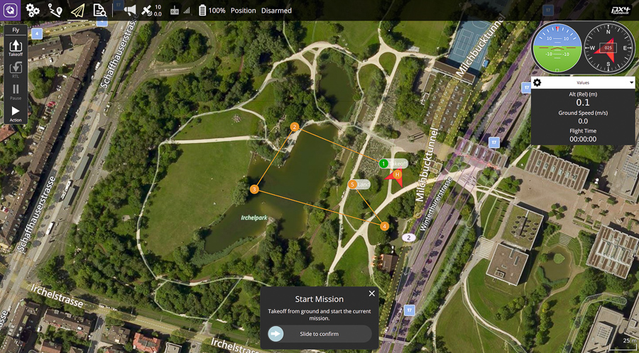

This guide is an active work in progress. The information provided should be correct, but you may find missing information or incomplete pages.

Information about *QGroundControl* development, architecture, contributing, and translating can be found in the [Developers Guide](https://dev.qgroundcontrol.com/en/).

# **QGroundControl Quick Start**

Getting *QGroundControl* up and running is quick and easy:

1. [Download and install](https://docs.qgroundcontrol.com/en/getting_started/download_and_install.html) the application.
2. Start *QGroundControl*.
3. Attach your vehicle to the ground station device via USB, through a telemetry radio, or over WiFi. *QGroundControl* should detect your vehicle and connect to it automatically.

That's it! If the vehicle is ready to fly, *QGroundControl* should display [Fly View](https://docs.qgroundcontrol.com/en/FlyView/FlyView.html) as shown below (otherwise it will open [Setup View](https://docs.qgroundcontrol.com/en/SetupView/SetupView.html)).

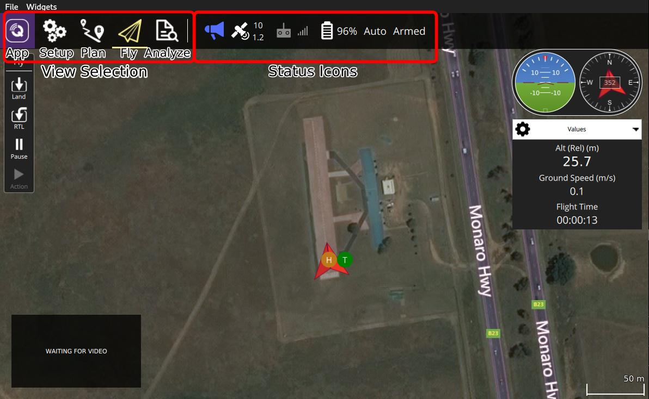

A good way to become familiar with *QGroundControl* is to start experimenting:

* Use the [toolbar](https://docs.qgroundcontrol.com/en/toolbar/toolbar.html) to switch between the main views:
  + [Settings](https://docs.qgroundcontrol.com/en/SettingsView/SettingsView.html): Configure the *QGroundControl* application.
  + [Setup](https://docs.qgroundcontrol.com/en/SetupView/SetupView.html): Configure and tune your vehicle.
  + [Plan](https://docs.qgroundcontrol.com/en/PlanView/PlanView.html): Create autonomous missions.
  + [Fly](https://docs.qgroundcontrol.com/en/FlyView/FlyView.html): Monitor you vehicle(s) while flying, including streaming video.
* Click the *Status icons* on the toolbar to find out the status of the connected vehicle.

While the UI is fairly intuitive, this documentation can also be referenced to find out more.

# **Download and Install**

The sections below can be used download the [current stable release](https://docs.qgroundcontrol.com/en/releases/release_notes.html) of *QGroundControl* for each platform.

See [QGC Install/Config Problems](https://docs.qgroundcontrol.com/en/Support/troubleshooting_qgc.html) if you have any problem running *QGroundControl* after installation!

## **System Requirements**

QGC should run well on any modern computer or mobile device. Performance will depend on the system environment, 3rd party applications, and available system resources. More capable hardware will provide a better experience. A computer with at least 8Gb RAM, an SSD, Nvidia or AMD graphics and an i5 or better CPU will be suitable for most applications.

For the best experience and compatibility, we recommend you the newest version of your operating system.

## **Windows**

Install *QGroundControl* for Windows Vista or later:

1. Download [QGroundControl-installer.exe](https://s3-us-west-2.amazonaws.com/qgroundcontrol/latest/QGroundControl-installer.exe).
2. Double click the executable to launch the installer.

The Windows installer creates 3 shortcuts: **QGroundControl**, **GPU Compatibility Mode**, **GPU Safe Mode**. Use the first shortcut unless you experience startup or video rendering issues. For more information see [QGC Install/Config Problems > Windows: UI Rendering/Video Driver Issues](https://docs.qgroundcontrol.com/en/Support/troubleshooting_qgc.html#opengl_troubleshooting).

## **Mac OS X**

Install *QGroundControl* for macOS 10.10 or later:

1. Download [QGroundControl.dmg](https://s3-us-west-2.amazonaws.com/qgroundcontrol/latest/QGroundControl.dmg).
2. Double-click the .dmg file to mount it, then drag the *QGroundControl* application to your *Application* folder.

## **Ubuntu Linux**

Ubuntu comes with a serial modem manager that interferes with any robotics related use of a serial port (or USB serial). Before installing *QGroundControl* you should remove the modem manager and grant yourself permissions to access the serial port. You also need to install *GStreamer* in order to support video streaming.

Before installing *QGroundControl* for the first time:

1. On the command prompt enter:sudo usermod -a -G dialout $USERsudo apt-get remove modemmanager -ysudo apt install gstreamer1.0-plugins-bad gstreamer1.0-libav -y
2. Logout and login again to enable the change to user permissions.

To install *QGroundControl* for Ubuntu Linux 16.04 LTS or later:

1. Download [QGroundControl.AppImage](https://s3-us-west-2.amazonaws.com/qgroundcontrol/latest/QGroundControl.AppImage).
2. Install (and run) using the terminal commands:chmod +x ./QGroundControl.AppImage./QGroundControl.AppImage (or double click)

## **Android**

Install *QGroundControl* for Android 5.1 or later:

1. Open the Google Play Store [QGroundControl link](https://play.google.com/store/apps/details?id=org.mavlink.qgroundcontrol).
2. Follow the installation instructions.

## **iOS**

*QGroundControl* for iOS is in beta. It can only be installed as a [daily build](https://docs.qgroundcontrol.com/en/releases/daily_builds.html).

Install *QGroundControl* for iOS 8.0 or later:

1. Follow the instructions for [Installing iOS Daily Beta](https://docs.qgroundcontrol.com/en/releases/daily_builds.html).

## **Old Stable Releases**

Old stable releases can be found on [GitHub](https://github.com/mavlink/qgroundcontrol/releases/).

## **Daily Builds**

Daily builds can be [downloaded from here](https://docs.qgroundcontrol.com/en/releases/daily_builds.html).

# [Toolbar/Menu](https://docs.qgroundcontrol.com/en/)

# **Main Toolbar**

The main menu/tool bar provides access to the different application views, and high level status information for connected vehicles. The menu is the same in all views except for "PlanView" (which has a single icon to take you back to "Fly" view).

## **View-select icons**

The following icons are used to switch between the main *Views*. These are displayed even if no vehicle is connected.

[**Settings**](https://docs.qgroundcontrol.com/en/SettingsView/SettingsView.html)   
Configure the *QGroundControl* application.

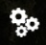[**Setup**](https://docs.qgroundcontrol.com/en/SetupView/SetupView.html)   
Configure and tune your vehicle.

+

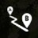[**Plan**](https://docs.qgroundcontrol.com/en/PlanView/PlanView.html)   
Create autonomous missions.

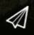[**Fly**](https://docs.qgroundcontrol.com/en/FlyView/FlyView.html)   
Monitor you vehicle(s) while flying, including streaming video.

[**Analyze**](https://docs.qgroundcontrol.com/en/analyze_view/)   
Download logs, geotag images from a survey mission, access the MAVLink console.

## **Status icons**

Status icons are displayed when *QGroundControl* is connected to a vehicle. These show the high level status of the vehicle, and can be clicked to see more detailed information.

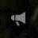**Vehicle Messages**   
Click to show a dropdown of messages from the vehicle. This will change to a Yield sign if there are critical messages.

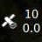**GPS Status**   
Shows you satellite count and curent hdop.

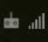**RC RSSI**   
RS signal strength information.

**Telemetry RSSI**   
Telemetry signals strength information.

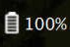**Battery**   
Remaining battery percent.

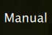**Flight Mode**   
Current flight mode. Click to change flight mode.

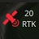**RTK GPS Survey-In Status**   
Shows you progress of RTK GPS Survey-In process

# **Fly View**

The Fly View is used to command and monitor the vehicle when flying.

You can use it to:

* Run an automated [pre-flight checklist](https://word-edit.officeapps.live.com/we/wordeditorframe.aspx?ui=ko-KR&rs=ko-KR&hid=2mWOPQhL50mMEjYL5cj+yw.0&WOPISrc=https%3A%2F%2Fwopi.onedrive.com%2Fwopi%2Ffiles%2FD12DB2555512DF7%213518&wdnd=1&wdPreviousSession=0e43a0ac-2186-4d7b-a50e-5c8de0ff7e7d&wdNewAndOpenCt=1555562078658&wdo=4&wdOrigin=wacFileNew&wdPreviousCorrelation=09861a00-356b-4040-8a89-e153d9da8134&wde=docx&sc=host%3D%26qt%3DFolders&mscc=1&wdp=0#preflight_checklist).
* Control missions: [start](https://word-edit.officeapps.live.com/we/wordeditorframe.aspx?ui=ko-KR&rs=ko-KR&hid=2mWOPQhL50mMEjYL5cj+yw.0&WOPISrc=https%3A%2F%2Fwopi.onedrive.com%2Fwopi%2Ffiles%2FD12DB2555512DF7%213518&wdnd=1&wdPreviousSession=0e43a0ac-2186-4d7b-a50e-5c8de0ff7e7d&wdNewAndOpenCt=1555562078658&wdo=4&wdOrigin=wacFileNew&wdPreviousCorrelation=09861a00-356b-4040-8a89-e153d9da8134&wde=docx&sc=host%3D%26qt%3DFolders&mscc=1&wdp=0#start_mission), [continue](https://word-edit.officeapps.live.com/we/wordeditorframe.aspx?ui=ko-KR&rs=ko-KR&hid=2mWOPQhL50mMEjYL5cj+yw.0&WOPISrc=https%3A%2F%2Fwopi.onedrive.com%2Fwopi%2Ffiles%2FD12DB2555512DF7%213518&wdnd=1&wdPreviousSession=0e43a0ac-2186-4d7b-a50e-5c8de0ff7e7d&wdNewAndOpenCt=1555562078658&wdo=4&wdOrigin=wacFileNew&wdPreviousCorrelation=09861a00-356b-4040-8a89-e153d9da8134&wde=docx&sc=host%3D%26qt%3DFolders&mscc=1&wdp=0#continue_mission), [pause](https://word-edit.officeapps.live.com/we/wordeditorframe.aspx?ui=ko-KR&rs=ko-KR&hid=2mWOPQhL50mMEjYL5cj+yw.0&WOPISrc=https%3A%2F%2Fwopi.onedrive.com%2Fwopi%2Ffiles%2FD12DB2555512DF7%213518&wdnd=1&wdPreviousSession=0e43a0ac-2186-4d7b-a50e-5c8de0ff7e7d&wdNewAndOpenCt=1555562078658&wdo=4&wdOrigin=wacFileNew&wdPreviousCorrelation=09861a00-356b-4040-8a89-e153d9da8134&wde=docx&sc=host%3D%26qt%3DFolders&mscc=1&wdp=0#pause), [stop](https://word-edit.officeapps.live.com/we/wordeditorframe.aspx?ui=ko-KR&rs=ko-KR&hid=2mWOPQhL50mMEjYL5cj+yw.0&WOPISrc=https%3A%2F%2Fwopi.onedrive.com%2Fwopi%2Ffiles%2FD12DB2555512DF7%213518&wdnd=1&wdPreviousSession=0e43a0ac-2186-4d7b-a50e-5c8de0ff7e7d&wdNewAndOpenCt=1555562078658&wdo=4&wdOrigin=wacFileNew&wdPreviousCorrelation=09861a00-356b-4040-8a89-e153d9da8134&wde=docx&sc=host%3D%26qt%3DFolders&mscc=1&wdp=0#stop_mission) and [resume](https://word-edit.officeapps.live.com/we/wordeditorframe.aspx?ui=ko-KR&rs=ko-KR&hid=2mWOPQhL50mMEjYL5cj+yw.0&WOPISrc=https%3A%2F%2Fwopi.onedrive.com%2Fwopi%2Ffiles%2FD12DB2555512DF7%213518&wdnd=1&wdPreviousSession=0e43a0ac-2186-4d7b-a50e-5c8de0ff7e7d&wdNewAndOpenCt=1555562078658&wdo=4&wdOrigin=wacFileNew&wdPreviousCorrelation=09861a00-356b-4040-8a89-e153d9da8134&wde=docx&sc=host%3D%26qt%3DFolders&mscc=1&wdp=0#resume_mission).
* Guide the vehicle to [arm](https://word-edit.officeapps.live.com/we/wordeditorframe.aspx?ui=ko-KR&rs=ko-KR&hid=2mWOPQhL50mMEjYL5cj+yw.0&WOPISrc=https%3A%2F%2Fwopi.onedrive.com%2Fwopi%2Ffiles%2FD12DB2555512DF7%213518&wdnd=1&wdPreviousSession=0e43a0ac-2186-4d7b-a50e-5c8de0ff7e7d&wdNewAndOpenCt=1555562078658&wdo=4&wdOrigin=wacFileNew&wdPreviousCorrelation=09861a00-356b-4040-8a89-e153d9da8134&wde=docx&sc=host%3D%26qt%3DFolders&mscc=1&wdp=0#arm)/[disarm](https://word-edit.officeapps.live.com/we/wordeditorframe.aspx?ui=ko-KR&rs=ko-KR&hid=2mWOPQhL50mMEjYL5cj+yw.0&WOPISrc=https%3A%2F%2Fwopi.onedrive.com%2Fwopi%2Ffiles%2FD12DB2555512DF7%213518&wdnd=1&wdPreviousSession=0e43a0ac-2186-4d7b-a50e-5c8de0ff7e7d&wdNewAndOpenCt=1555562078658&wdo=4&wdOrigin=wacFileNew&wdPreviousCorrelation=09861a00-356b-4040-8a89-e153d9da8134&wde=docx&sc=host%3D%26qt%3DFolders&mscc=1&wdp=0#disarm)/[emergency stop](https://word-edit.officeapps.live.com/we/wordeditorframe.aspx?ui=ko-KR&rs=ko-KR&hid=2mWOPQhL50mMEjYL5cj+yw.0&WOPISrc=https%3A%2F%2Fwopi.onedrive.com%2Fwopi%2Ffiles%2FD12DB2555512DF7%213518&wdnd=1&wdPreviousSession=0e43a0ac-2186-4d7b-a50e-5c8de0ff7e7d&wdNewAndOpenCt=1555562078658&wdo=4&wdOrigin=wacFileNew&wdPreviousCorrelation=09861a00-356b-4040-8a89-e153d9da8134&wde=docx&sc=host%3D%26qt%3DFolders&mscc=1&wdp=0#emergency_stop), [takeoff](https://word-edit.officeapps.live.com/we/wordeditorframe.aspx?ui=ko-KR&rs=ko-KR&hid=2mWOPQhL50mMEjYL5cj+yw.0&WOPISrc=https%3A%2F%2Fwopi.onedrive.com%2Fwopi%2Ffiles%2FD12DB2555512DF7%213518&wdnd=1&wdPreviousSession=0e43a0ac-2186-4d7b-a50e-5c8de0ff7e7d&wdNewAndOpenCt=1555562078658&wdo=4&wdOrigin=wacFileNew&wdPreviousCorrelation=09861a00-356b-4040-8a89-e153d9da8134&wde=docx&sc=host%3D%26qt%3DFolders&mscc=1&wdp=0#takeoff)/[land](https://word-edit.officeapps.live.com/we/wordeditorframe.aspx?ui=ko-KR&rs=ko-KR&hid=2mWOPQhL50mMEjYL5cj+yw.0&WOPISrc=https%3A%2F%2Fwopi.onedrive.com%2Fwopi%2Ffiles%2FD12DB2555512DF7%213518&wdnd=1&wdPreviousSession=0e43a0ac-2186-4d7b-a50e-5c8de0ff7e7d&wdNewAndOpenCt=1555562078658&wdo=4&wdOrigin=wacFileNew&wdPreviousCorrelation=09861a00-356b-4040-8a89-e153d9da8134&wde=docx&sc=host%3D%26qt%3DFolders&mscc=1&wdp=0#land), [change altitude](https://word-edit.officeapps.live.com/we/wordeditorframe.aspx?ui=ko-KR&rs=ko-KR&hid=2mWOPQhL50mMEjYL5cj+yw.0&WOPISrc=https%3A%2F%2Fwopi.onedrive.com%2Fwopi%2Ffiles%2FD12DB2555512DF7%213518&wdnd=1&wdPreviousSession=0e43a0ac-2186-4d7b-a50e-5c8de0ff7e7d&wdNewAndOpenCt=1555562078658&wdo=4&wdOrigin=wacFileNew&wdPreviousCorrelation=09861a00-356b-4040-8a89-e153d9da8134&wde=docx&sc=host%3D%26qt%3DFolders&mscc=1&wdp=0#change_altitude), [go to](https://word-edit.officeapps.live.com/we/wordeditorframe.aspx?ui=ko-KR&rs=ko-KR&hid=2mWOPQhL50mMEjYL5cj+yw.0&WOPISrc=https%3A%2F%2Fwopi.onedrive.com%2Fwopi%2Ffiles%2FD12DB2555512DF7%213518&wdnd=1&wdPreviousSession=0e43a0ac-2186-4d7b-a50e-5c8de0ff7e7d&wdNewAndOpenCt=1555562078658&wdo=4&wdOrigin=wacFileNew&wdPreviousCorrelation=09861a00-356b-4040-8a89-e153d9da8134&wde=docx&sc=host%3D%26qt%3DFolders&mscc=1&wdp=0#goto) or [orbit](https://word-edit.officeapps.live.com/we/wordeditorframe.aspx?ui=ko-KR&rs=ko-KR&hid=2mWOPQhL50mMEjYL5cj+yw.0&WOPISrc=https%3A%2F%2Fwopi.onedrive.com%2Fwopi%2Ffiles%2FD12DB2555512DF7%213518&wdnd=1&wdPreviousSession=0e43a0ac-2186-4d7b-a50e-5c8de0ff7e7d&wdNewAndOpenCt=1555562078658&wdo=4&wdOrigin=wacFileNew&wdPreviousCorrelation=09861a00-356b-4040-8a89-e153d9da8134&wde=docx&sc=host%3D%26qt%3DFolders&mscc=1&wdp=0#orbit) a particular location, and [return/RTL](https://word-edit.officeapps.live.com/we/wordeditorframe.aspx?ui=ko-KR&rs=ko-KR&hid=2mWOPQhL50mMEjYL5cj+yw.0&WOPISrc=https%3A%2F%2Fwopi.onedrive.com%2Fwopi%2Ffiles%2FD12DB2555512DF7%213518&wdnd=1&wdPreviousSession=0e43a0ac-2186-4d7b-a50e-5c8de0ff7e7d&wdNewAndOpenCt=1555562078658&wdo=4&wdOrigin=wacFileNew&wdPreviousCorrelation=09861a00-356b-4040-8a89-e153d9da8134&wde=docx&sc=host%3D%26qt%3DFolders&mscc=1&wdp=0#rtl).
* Switch between a map view and a video view (if available)
* Display video, mission, telemetry, and other information for the current vehicle, and also switch between connected vehicles.

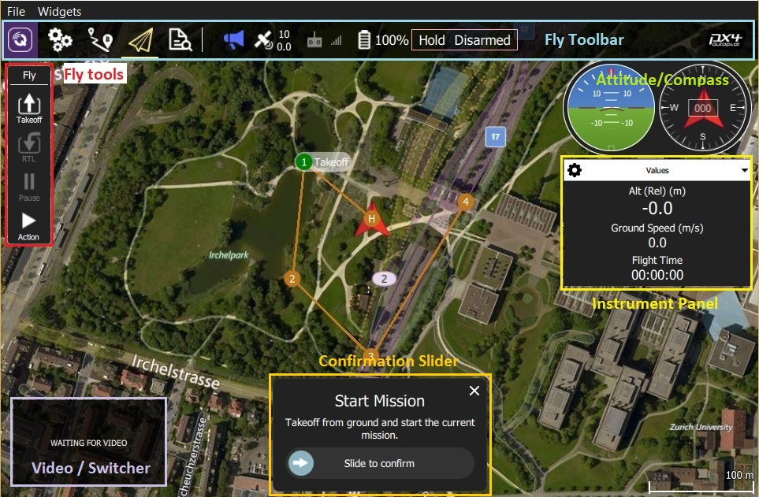

**UI Overview**

The screenshot above shows the main elements of the fly view:

**Map:** Displays the positions of all connected vehicles and the mission for the current vehicle.

* + You can drag the map to move it around (the map automatically re-centres after a certain amount of time).
  + Once flying, you can click on the map to set a [Go to](https://word-edit.officeapps.live.com/we/wordeditorframe.aspx?ui=ko-KR&rs=ko-KR&hid=2mWOPQhL50mMEjYL5cj+yw.0&WOPISrc=https%3A%2F%2Fwopi.onedrive.com%2Fwopi%2Ffiles%2FD12DB2555512DF7%213518&wdnd=1&wdPreviousSession=0e43a0ac-2186-4d7b-a50e-5c8de0ff7e7d&wdNewAndOpenCt=1555562078658&wdo=4&wdOrigin=wacFileNew&wdPreviousCorrelation=09861a00-356b-4040-8a89-e153d9da8134&wde=docx&sc=host%3D%26qt%3DFolders&mscc=1&wdp=0#goto) or [Orbit at](https://word-edit.officeapps.live.com/we/wordeditorframe.aspx?ui=ko-KR&rs=ko-KR&hid=2mWOPQhL50mMEjYL5cj+yw.0&WOPISrc=https%3A%2F%2Fwopi.onedrive.com%2Fwopi%2Ffiles%2FD12DB2555512DF7%213518&wdnd=1&wdPreviousSession=0e43a0ac-2186-4d7b-a50e-5c8de0ff7e7d&wdNewAndOpenCt=1555562078658&wdo=4&wdOrigin=wacFileNew&wdPreviousCorrelation=09861a00-356b-4040-8a89-e153d9da8134&wde=docx&sc=host%3D%26qt%3DFolders&mscc=1&wdp=0#orbit) location.
* **Fly Toolbar:** Key status information for sensors (GPS, battery, RC control), and vehicle state (Flight mode, Armed/Disarmed status).
  + Select the sensor indicators to view more detail.
  + Press the *Flight mode* text (e.g. "Hold") to select a new mode. Not every mode may be available.
  + Press the *Armed/Disarmed* text to toggle the armed state. If flying you can press this text to *Emergency Stop*.
* **Fly tools:** You can use these to:
  + Toggle between takeoff/land.
  + Pause/restart the current operation (e.g. landing, or the mission).
  + Safety return (also known as RTL or Return).
  + The *Action* button offers other appropriate options for the current state (these overlay the *Confirmation Slider*). Actions include changing the altitude or continuing a mission.
  + Enable the [preflight checklist](https://word-edit.officeapps.live.com/we/wordeditorframe.aspx?ui=ko-KR&rs=ko-KR&hid=2mWOPQhL50mMEjYL5cj+yw.0&WOPISrc=https%3A%2F%2Fwopi.onedrive.com%2Fwopi%2Ffiles%2FD12DB2555512DF7%213518&wdnd=1&wdPreviousSession=0e43a0ac-2186-4d7b-a50e-5c8de0ff7e7d&wdNewAndOpenCt=1555562078658&wdo=4&wdOrigin=wacFileNew&wdPreviousCorrelation=09861a00-356b-4040-8a89-e153d9da8134&wde=docx&sc=host%3D%26qt%3DFolders&mscc=1&wdp=0#preflight_checklist) (tool option disabled by default).
* [**Instrument Panel**](https://word-edit.officeapps.live.com/we/wordeditorframe.aspx?ui=ko-KR&rs=ko-KR&hid=2mWOPQhL50mMEjYL5cj+yw.0&WOPISrc=https%3A%2F%2Fwopi.onedrive.com%2Fwopi%2Ffiles%2FD12DB2555512DF7%213518&wdnd=1&wdPreviousSession=0e43a0ac-2186-4d7b-a50e-5c8de0ff7e7d&wdNewAndOpenCt=1555562078658&wdo=4&wdOrigin=wacFileNew&wdPreviousCorrelation=09861a00-356b-4040-8a89-e153d9da8134&wde=docx&sc=host%3D%26qt%3DFolders&mscc=1&wdp=0#instrument_panel)**:** A multi-page widget that displays vehicle information including: telemetry, camera, video, system health, and vibration.
* [**Video/Switcher**](https://word-edit.officeapps.live.com/we/wordeditorframe.aspx?ui=ko-KR&rs=ko-KR&hid=2mWOPQhL50mMEjYL5cj+yw.0&WOPISrc=https%3A%2F%2Fwopi.onedrive.com%2Fwopi%2Ffiles%2FD12DB2555512DF7%213518&wdnd=1&wdPreviousSession=0e43a0ac-2186-4d7b-a50e-5c8de0ff7e7d&wdNewAndOpenCt=1555562078658&wdo=4&wdOrigin=wacFileNew&wdPreviousCorrelation=09861a00-356b-4040-8a89-e153d9da8134&wde=docx&sc=host%3D%26qt%3DFolders&mscc=1&wdp=0#video_switcher)**:** Toggle between video or map in a window.
  + Press the element to switch *Video* and *Map* to foreground.
  + *QGroundControl* supports RTP and RTSP video streaming over your vehicles UDP connection. It also support directly connected UVC device support. QGC video support is further discussed in the [Video README](https://github.com/mavlink/qgroundcontrol/blob/master/src/VideoStreaming/README.md).
* **Confirmation Slider:** Context sensitive slider to confirm requested actions. Slide to start operation. Press **X** to cancel.

There are a number of other elements that are not displayed by default/are only displayed in certain conditions. For example, the multi-vehicle selector is only displayed if you have multiple vehicles, and the preflight checklist tool button is only displayed if the appropriate setting is enabled.

+

**Instrument Panel**

## The instrument panel is a multi-page widget that displays information about the current vehicle, including: telemetry, camera, video, system health, and vibration information.

The default page displays vehicle telemetry - use the drop down menu on the to right to select the other options.

**Values (Telemetry)**

The values page shows telemetry information; by default the altitude (relative to the home location) and the ground speed.

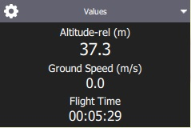

You can configure what information is display by pressing the small gear icon on the top left of the panel. Each value can be displayed in normal or "large" size (large size shows just one value per row in the page, while normal shows 2).

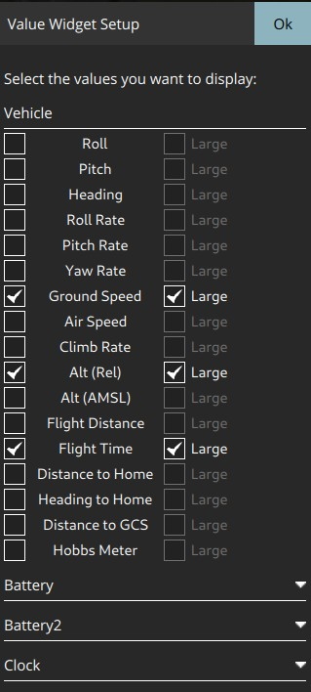

**Camera**

The camera page is used to configure and control the camera. For a camera connected directly to the Flight Controller the only available option is camera triggering:

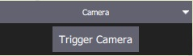

When connected to camera that supports the [MAVLink Camera Protocol](https://mavlink.io/en/services/camera.html) you can additionally configure and use other camera services that it makes available. For example, if your camera supports video mode you will be able to switch between still image capture and video mode, and start/stop recording.

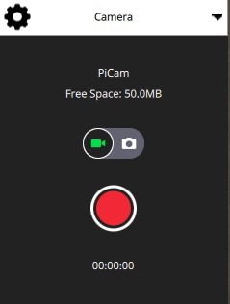

Advanced settings can be changed via the gear icon at the top left of the page.

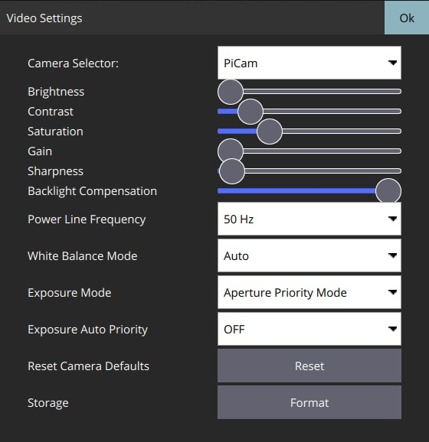

Most of the settings that are displayed depend on the camera (they are defined in its [MAVLink Camera Definition File](https://mavlink.io/en/services/camera_def.html)). A few common settings at the end are hard-coded: Photo Mode (Single/Time Lapse), Photo Interval (if Time Lapse), Reset Camera Defaults (sends a reset command to the camera), Format (storage)

**Video Stream**

The video page is used to enable/disable video streaming. When enabled, you can start/stop the video stream, enable a grid overlay, change how the image fits the screen, and record the video locally with QGC.

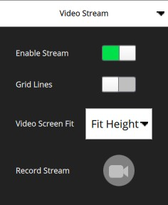

**Health**

The health page shows you the health of the systems within your vehicle. *QGroundControl* will switch to this page automatically if any systems change to unhealthy.

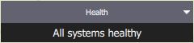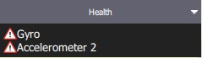

**Vibration**

The vibration page shows current vibration levels and clip counts.

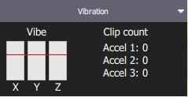

**Actions/Tasks**

The following sections describe how to perform common operations/tasks in the Fly View.

Many of the available options depend on both the vehicle type and its current state.

**Pre Flight Checklist**

An automated preflight checklist can be used to run through standard checks that the vehicle is configured correctly and it is safe to fly.

To you the checklist, first enable the tool by navigating to [Application Settings > General > Fly View](https://word-edit.officeapps.live.com/SettingsView/General.html) and selecting the **Use preflight checklist** checkbox. The tool will then be added to the *Flight Tools*. Press it to open the checklist:

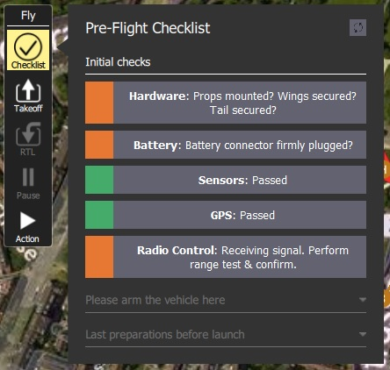

Once you have performed each test, select it on it in the UI to mark it as complete.

**Arm**

Generally *QGroundControl* does not require you to arm the vehicle explicitly; this is done for you if you start a mission or takeoff.

Arming a vehicle starts the motors in preparation for takeoff.

To arm the vehicle, select **Disarmed** in the *Fly Toolbar* and then use the confirmation sider.

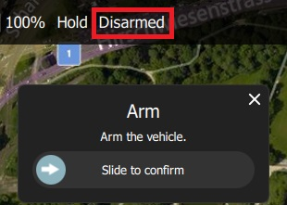

Vehicles usually disarm automatically if you do not take off after a few seconds.

**Disarm**

Disarming the vehicle stops the motors (making the vehicle safe). To disarm the vehicle select **Armed** in the *Fly Toolbar* when the vehicle is **landed**.

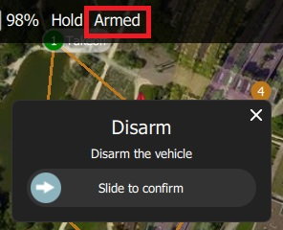

Disarming the vehicle while it is flying is called an [Emergency Stop](https://word-edit.officeapps.live.com/we/wordeditorframe.aspx?ui=ko-KR&rs=ko-KR&hid=2mWOPQhL50mMEjYL5cj+yw.0&WOPISrc=https%3A%2F%2Fwopi.onedrive.com%2Fwopi%2Ffiles%2FD12DB2555512DF7%213518&wdnd=1&wdPreviousSession=0e43a0ac-2186-4d7b-a50e-5c8de0ff7e7d&wdNewAndOpenCt=1555562078658&wdo=4&wdOrigin=wacFileNew&wdPreviousCorrelation=09861a00-356b-4040-8a89-e153d9da8134&wde=docx&sc=host%3D%26qt%3DFolders&mscc=1&wdp=0#emergency_stop)

**Emergency Stop**

Emergency stop is effectively the same as disarming the vehicle while you are flying. Your vehicle will crash!

To disarm the vehicle select **Armed** in the *Fly Toolbar* when the vehicle is flying.

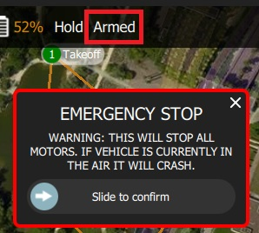

**Takeoff**

If you are starting a mission for a multicopter *QGroundControl* will automatically perform the takeoff step.

To takeoff (when landed):

* + - 1. Press the **Takeoff** button in the *Fly Tools* (this will toggle to a **Land** button after taking off).
      2. Optionally set the takeoff altitude in the right-side vertical slider.
      3. Confirm takeoff using the slider.

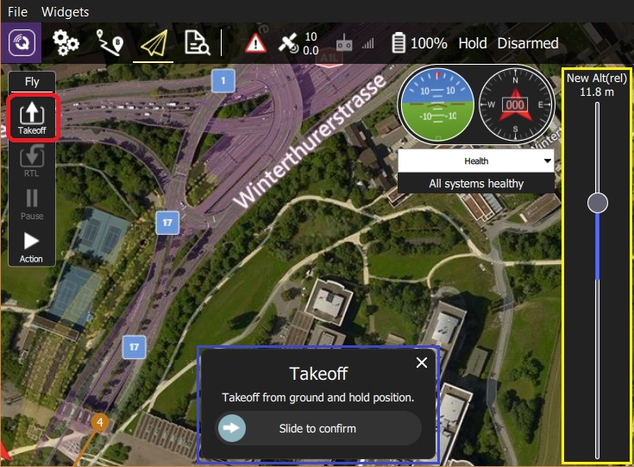

**Land**

You can land at the current position at any time while flying:

1. Press the **Land** button in the *Fly Tools* (this will toggle to a **Land** button when landed).
2. Confirm landing using the slider.

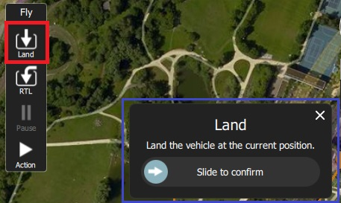

**RTL/Return**

Return to the home position at any time while flying:

1. Press the **RTL** button in the *Fly Tools*.
2. Confirm RTL using the slider.



The vehicle may also land at the home position, depending on its type and configuration.

**Change Altitude**

You can change altitude while flying, except when in a mission

1. Press the **Action** button on the *Fly Tools*
2. Select the *Change Altitude* action from the dialog.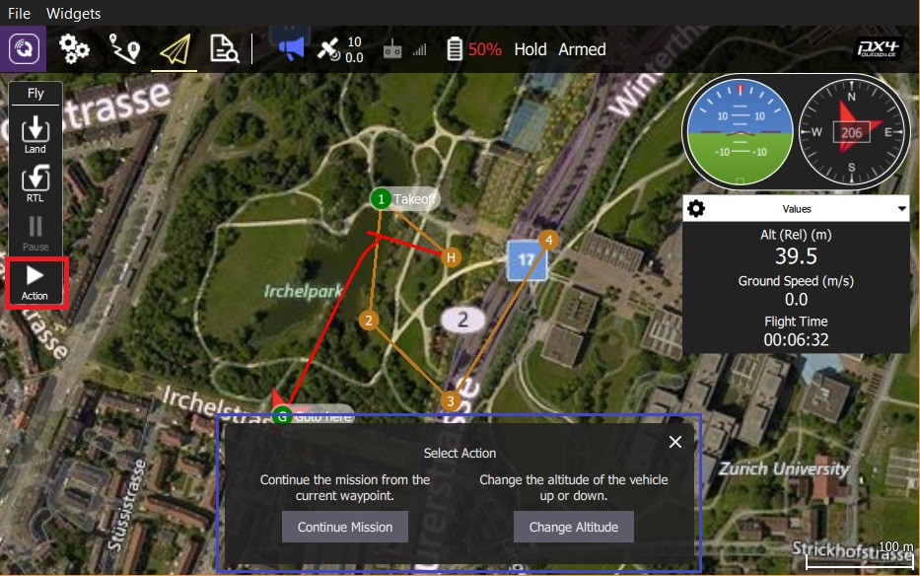
3. Move the vertical slider to the desired altitude, then drag the confirmation slider to start the action.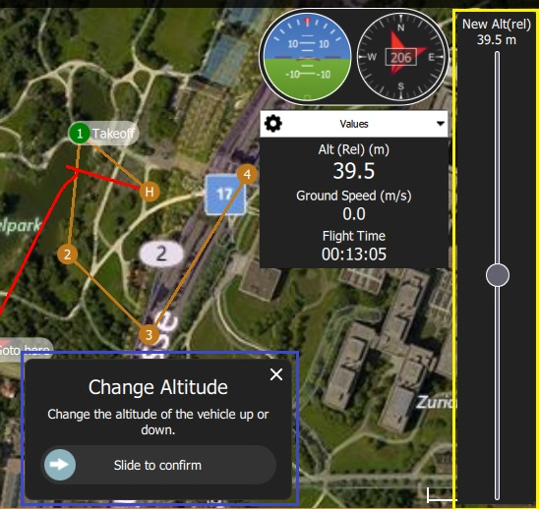

**Goto Location**

After taking off you can specify that you want to fly to a particular location.

1. Press the map where you want the vehicle to move and select **Go to location** on the popup.

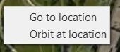

1. The location will be displayed on the map, along with a confirmation slider.

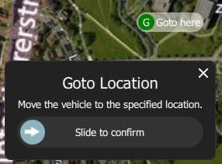

1. When you're ready, drag the slider to start the operation (or press the **X** icon to cancel it).

**Orbit Location**

After taking off you can specify that you want to orbit a particular location.

1. Press on the map (near the centre of your desired orbit) and select **Orbit at location** on the popup.



1. The proposed orbit will be displayed on the map, along with a confirmation sider.

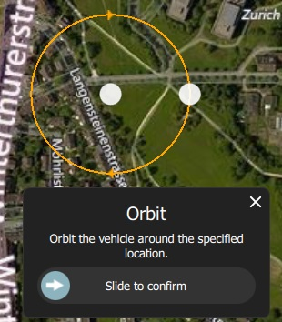

* + Select and drag the central marker to move the orbit location.
  + Select and drag the dot on the outer circle to change the orbit radius

1. When you're ready, drag the slider to start the operation (or press the **X** icon to cancel it).

**Pause**

You can pause most operations, including taking off, landing, RTL, missions, Orbit at location. The vehicle behaviour when paused depends on the vehicle type; typically a multicopter will hover, and a fixed wing vehicle will circle.

You cannot pause a *Goto location* operation.

To pause:

1. Press the **Pause** button in the *Fly Tools*.
2. Optionally set a new altitude using the right-side vertical slider.
3. Confirm the pause using the slider.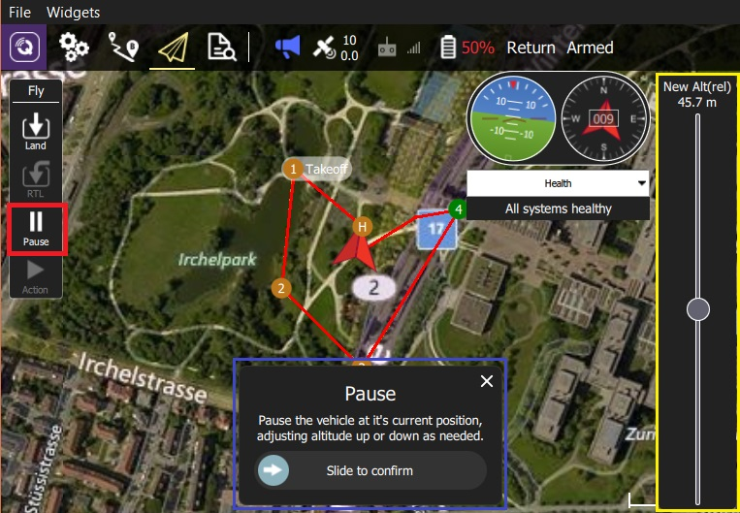

**Missions**

**Start Mission**

You can start a mission when the vehicle is landed (the start mission confirmation slider is often displayed by default).

To start a mission from landed:

1. Press the **Action** button on the *Fly Tools*
2. Select the *Start Mission* action from the dialog.

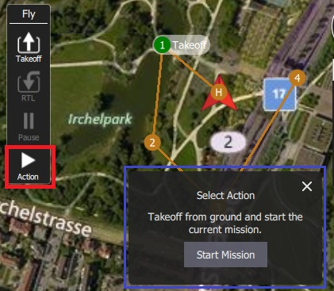

1. (to display the confirmation slider)
2. When the confirmation slider appears, drag it to start the mission.

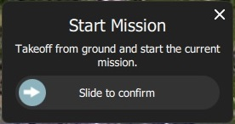

**Continue Mission**

You can *continue* mission from the *next* waypoint when you're flying (the *Continue Mission* confirmation slider is often displayed by default after you takeoff).

Continue and [Resume mission](https://word-edit.officeapps.live.com/we/wordeditorframe.aspx?ui=ko-KR&rs=ko-KR&hid=2mWOPQhL50mMEjYL5cj+yw.0&WOPISrc=https%3A%2F%2Fwopi.onedrive.com%2Fwopi%2Ffiles%2FD12DB2555512DF7%213518&wdnd=1&wdPreviousSession=0e43a0ac-2186-4d7b-a50e-5c8de0ff7e7d&wdNewAndOpenCt=1555562078658&wdo=4&wdOrigin=wacFileNew&wdPreviousCorrelation=09861a00-356b-4040-8a89-e153d9da8134&wde=docx&sc=host%3D%26qt%3DFolders&mscc=1&wdp=0#resume_mission) are different! Continue is used to restart a mission that has been paused, or where you have taken off, so you've already missed a takeoff mission command. Resume mission is used when you've used a RTL or landed midway through a mission (e.g. for a battery change) and then wish to continue the next mission item (i.e. it takes you to where you were up to in the mission, rather than continuing from you place in the mission).

You can continue the current mission while (unless already in a mission!):

1. Press the **Action** button on the *Fly Tools*
2. Select the *Continue Mission* action from the dialog.
3. Drag the confirmation slider to continue the mission.

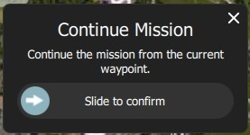

#### Resume Mission

*Resume Mission* is used to resume a mission after performing an [RTL/Return](https://word-edit.officeapps.live.com/we/wordeditorframe.aspx?ui=ko-KR&rs=ko-KR&hid=2mWOPQhL50mMEjYL5cj+yw.0&WOPISrc=https%3A%2F%2Fwopi.onedrive.com%2Fwopi%2Ffiles%2FD12DB2555512DF7%213518&wdnd=1&wdPreviousSession=0e43a0ac-2186-4d7b-a50e-5c8de0ff7e7d&wdNewAndOpenCt=1555562078658&wdo=4&wdOrigin=wacFileNew&wdPreviousCorrelation=09861a00-356b-4040-8a89-e153d9da8134&wde=docx&sc=host%3D%26qt%3DFolders&mscc=1&wdp=0#rtl) or [Land](https://word-edit.officeapps.live.com/we/wordeditorframe.aspx?ui=ko-KR&rs=ko-KR&hid=2mWOPQhL50mMEjYL5cj+yw.0&WOPISrc=https%3A%2F%2Fwopi.onedrive.com%2Fwopi%2Ffiles%2FD12DB2555512DF7%213518&wdnd=1&wdPreviousSession=0e43a0ac-2186-4d7b-a50e-5c8de0ff7e7d&wdNewAndOpenCt=1555562078658&wdo=4&wdOrigin=wacFileNew&wdPreviousCorrelation=09861a00-356b-4040-8a89-e153d9da8134&wde=docx&sc=host%3D%26qt%3DFolders&mscc=1&wdp=0#land) from within a mission (in order, for example, to perform a battery change).

If you are performing a battery change, **do not** disconnect QGC from the vehicle after disconnecting the battery. After you insert the new battery *QGroundControl* will detect the vehicle again and automatically restore the connection.

After landing you will be prompted with a *Flight Plan complete* dialog, which gives you the option to remove the plan from the vehicle, leave it on the vehicle, or to resume the mission from the last waypoint that was traveled through.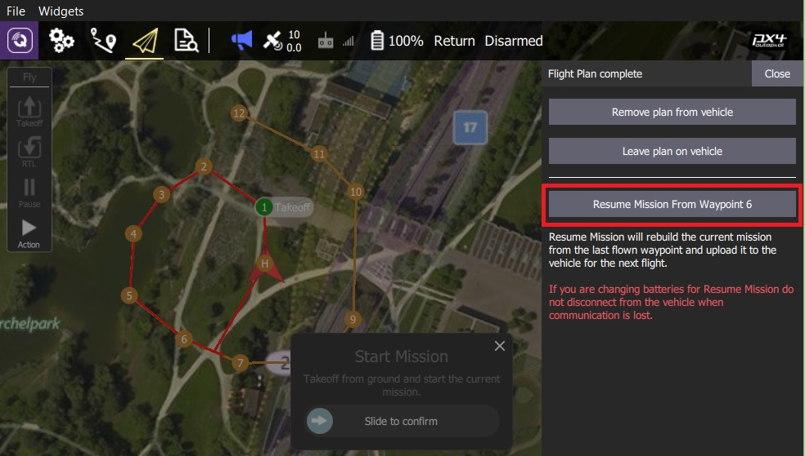

If you select to resume the mission, then *QGroundControl* will rebuild the mission and upload it to the vehicle. Then use the *Start Mission* slider to continue the mission.

The image below shows the mission that was rebuilt after the Return shown above.

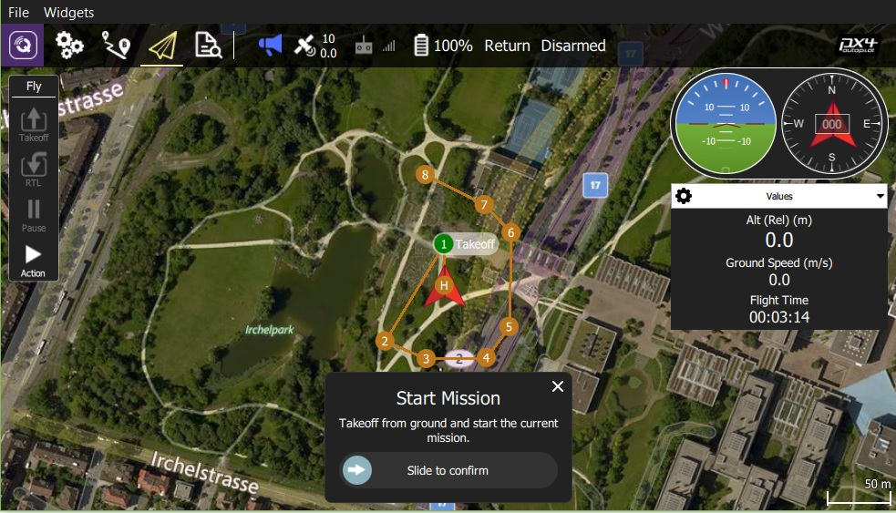

A mission cannot simply resume from the last mission item that the vehicle executed, because there may be multiple items at the last waypoint that affect the next stage of the mission (e.g. speed commands or camera control commands). Instead *QGroundControl* rebuilds the mission, starting from the last mission item flown, and automatically prepending any relevant commands to the front of the mission.

**Remove Mission Prompt After Landing**

You will be prompted to remove the mission from the vehicle after the mission completes and the vehicle lands and disarms. This is meant to prevent issues where stale missions are unknowingly left on a vehicle, potentially resulting in unexpected behavior

**Display Video**

When video streaming is enabled, *QGroundControl* will display the video stream for the currently selected vehicle in the "video switcher window" at the bottom left of the map. You can press the switcher anywhere to toggle *Video* and *Map* to foreground (below we show the video in the foreground).

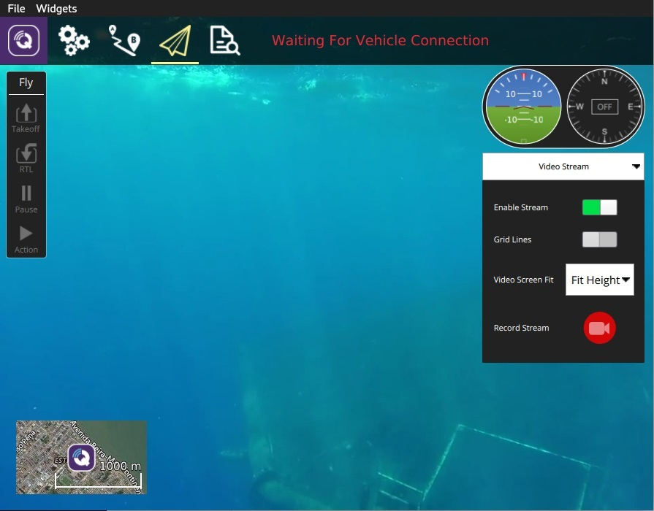

Video streaming is configured/enabled in [Application Settings > General tab > Video](https://word-edit.officeapps.live.com/SettingsView/General.html#video).

You can further configure video display using controls on the switcher:

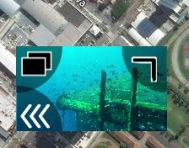

* Resize the switcher by dragging the icon in the to right corner.
* Hide the switcher by pressing the toggle icon in the lower left.
* Detach the video switcher window by pressing on the icon in its top left corner (once detached, you can move and resize the window just like any other in your OS). If you close the detached window the switcher will re-lock to the QGC Fly view.

**Record Video**

If supported by the camera and vehicle, *QGroundControl* can start and stop video recording on the camera itself. *QGroundControl* can also record the video stream and save it locally.

Video stored on the camera may be of much higher quality, but it is likely that your ground station will have a much larger recording capacity.

**Record Video Stream (on GCS)**

Video stream recording is controlled on the [video stream instrument page](https://word-edit.officeapps.live.com/we/wordeditorframe.aspx?ui=ko-KR&rs=ko-KR&hid=2mWOPQhL50mMEjYL5cj+yw.0&WOPISrc=https%3A%2F%2Fwopi.onedrive.com%2Fwopi%2Ffiles%2FD12DB2555512DF7%213518&wdnd=1&wdPreviousSession=0e43a0ac-2186-4d7b-a50e-5c8de0ff7e7d&wdNewAndOpenCt=1555562078658&wdo=4&wdOrigin=wacFileNew&wdPreviousCorrelation=09861a00-356b-4040-8a89-e153d9da8134&wde=docx&sc=host%3D%26qt%3DFolders&mscc=1&wdp=0#video_instrument_page). Press the red circle to start recording a new video (a new video file is created each time the circle is pressed); the circle will change into a red square while recording is in progress.



Video stream recording is configured in the [Application Settings > General tab](https://word-edit.officeapps.live.com/SettingsView/General.html):

* [Video Recording](https://word-edit.officeapps.live.com/SettingsView/General.html#video-recording) - specifies the recording file format and storage limits.
* Videos are saved in Matroska format (.mkv) by default. This format is relatively robust against corruption in case of errors.
* [Miscellaneous](https://word-edit.officeapps.live.com/SettingsView/General.html#miscellaneous) - Streamed video is saved under the **Application Load/Save Path**.

The stored video includes just the video stream itself. To record video with QGroundControl application elements displayed, you should use separate screen recording software.

**Record Video on Camera**

Start/stop video recording *on the camera itself* using the [camera instrument page](https://word-edit.officeapps.live.com/we/wordeditorframe.aspx?ui=ko-KR&rs=ko-KR&hid=2mWOPQhL50mMEjYL5cj+yw.0&WOPISrc=https%3A%2F%2Fwopi.onedrive.com%2Fwopi%2Ffiles%2FD12DB2555512DF7%213518&wdnd=1&wdPreviousSession=0e43a0ac-2186-4d7b-a50e-5c8de0ff7e7d&wdNewAndOpenCt=1555562078658&wdo=4&wdOrigin=wacFileNew&wdPreviousCorrelation=09861a00-356b-4040-8a89-e153d9da8134&wde=docx&sc=host%3D%26qt%3DFolders&mscc=1&wdp=0#camera_instrument_page). First toggle to video mode, then select the red button to start recording.



**Plan View**

The *Plan View* is used to plan *autonomous missions* for your vehicle, and upload them to the vehicle. Once the mission is [planned](https://word-edit.officeapps.live.com/we/wordeditorframe.aspx?ui=ko-KR&rs=ko-KR&hid=2mWOPQhL50mMEjYL5cj+yw.0&WOPISrc=https%3A%2F%2Fwopi.onedrive.com%2Fwopi%2Ffiles%2FD12DB2555512DF7%213518&wdnd=1&wdPreviousSession=0e43a0ac-2186-4d7b-a50e-5c8de0ff7e7d&wdNewAndOpenCt=1555562078658&wdo=4&wdOrigin=wacFileNew&wdPreviousCorrelation=09861a00-356b-4040-8a89-e153d9da8134&wde=docx&sc=host%3D%26qt%3DFolders&mscc=1&wdp=0#plan_mission) and sent to the vehicle, you switch to the [Fly View](https://word-edit.officeapps.live.com/FlyView/FlyView.html) to fly the mission.

It is also use to configure the [GeoFence](https://word-edit.officeapps.live.com/we/PlanGeoFence.html) and [Rally Points](https://word-edit.officeapps.live.com/we/PlanRallyPoints.html) if these are supported by the firmware.

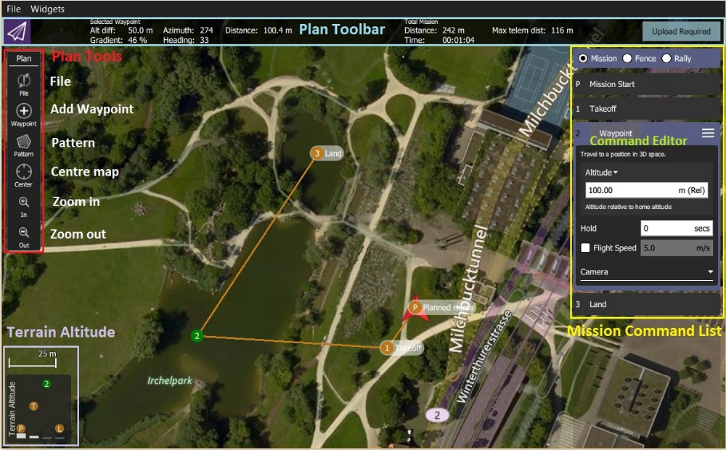

**UI Overview**

The [screenshot above](https://word-edit.officeapps.live.com/we/wordeditorframe.aspx?ui=ko-KR&rs=ko-KR&hid=2mWOPQhL50mMEjYL5cj+yw.0&WOPISrc=https%3A%2F%2Fwopi.onedrive.com%2Fwopi%2Ffiles%2FD12DB2555512DF7%213518&wdnd=1&wdPreviousSession=0e43a0ac-2186-4d7b-a50e-5c8de0ff7e7d&wdNewAndOpenCt=1555562078658&wdo=4&wdOrigin=wacFileNew&wdPreviousCorrelation=09861a00-356b-4040-8a89-e153d9da8134&wde=docx&sc=host%3D%26qt%3DFolders&mscc=1&wdp=0#plan_screenshot) shows a simple mission plan that starts with a takeoff at the [Planned Home](https://word-edit.officeapps.live.com/we/wordeditorframe.aspx?ui=ko-KR&rs=ko-KR&hid=2mWOPQhL50mMEjYL5cj+yw.0&WOPISrc=https%3A%2F%2Fwopi.onedrive.com%2Fwopi%2Ffiles%2FD12DB2555512DF7%213518&wdnd=1&wdPreviousSession=0e43a0ac-2186-4d7b-a50e-5c8de0ff7e7d&wdNewAndOpenCt=1555562078658&wdo=4&wdOrigin=wacFileNew&wdPreviousCorrelation=09861a00-356b-4040-8a89-e153d9da8134&wde=docx&sc=host%3D%26qt%3DFolders&mscc=1&wdp=0#planned_home) position (H), flies through three waypoints, and then lands on the last waypoint (i.e. waypoint 3).

The main elements of the UI are:

* **Map:** Displays the numbered indicators for the current mission, including the [Planned Home](https://word-edit.officeapps.live.com/we/wordeditorframe.aspx?ui=ko-KR&rs=ko-KR&hid=2mWOPQhL50mMEjYL5cj+yw.0&WOPISrc=https%3A%2F%2Fwopi.onedrive.com%2Fwopi%2Ffiles%2FD12DB2555512DF7%213518&wdnd=1&wdPreviousSession=0e43a0ac-2186-4d7b-a50e-5c8de0ff7e7d&wdNewAndOpenCt=1555562078658&wdo=4&wdOrigin=wacFileNew&wdPreviousCorrelation=09861a00-356b-4040-8a89-e153d9da8134&wde=docx&sc=host%3D%26qt%3DFolders&mscc=1&wdp=0#planned_home). Click on the indicators to select them (for editing) or drag them around to reposition them.
* **Plan Toolbar:** Status information for the currently selected waypoint relative to the previous waypoint, as well as statistics for the entire mission (e.g. horizontal distance and time for mission).
  + Max telem dist is the distance between the [Planned Home](https://word-edit.officeapps.live.com/we/wordeditorframe.aspx?ui=ko-KR&rs=ko-KR&hid=2mWOPQhL50mMEjYL5cj+yw.0&WOPISrc=https%3A%2F%2Fwopi.onedrive.com%2Fwopi%2Ffiles%2FD12DB2555512DF7%213518&wdnd=1&wdPreviousSession=0e43a0ac-2186-4d7b-a50e-5c8de0ff7e7d&wdNewAndOpenCt=1555562078658&wdo=4&wdOrigin=wacFileNew&wdPreviousCorrelation=09861a00-356b-4040-8a89-e153d9da8134&wde=docx&sc=host%3D%26qt%3DFolders&mscc=1&wdp=0#planned_home) and the furthest waypoint.
  + When connected to a vehicle it also shows an **Upload** button, can be used to upload the plan to the vehicle.
* [**Plan Tools**](https://word-edit.officeapps.live.com/we/wordeditorframe.aspx?ui=ko-KR&rs=ko-KR&hid=2mWOPQhL50mMEjYL5cj+yw.0&WOPISrc=https%3A%2F%2Fwopi.onedrive.com%2Fwopi%2Ffiles%2FD12DB2555512DF7%213518&wdnd=1&wdPreviousSession=0e43a0ac-2186-4d7b-a50e-5c8de0ff7e7d&wdNewAndOpenCt=1555562078658&wdo=4&wdOrigin=wacFileNew&wdPreviousCorrelation=09861a00-356b-4040-8a89-e153d9da8134&wde=docx&sc=host%3D%26qt%3DFolders&mscc=1&wdp=0#plan_tools)**:** Used to create and manage missions.
* [**Mission Command List/Overlay**](https://word-edit.officeapps.live.com/we/wordeditorframe.aspx?ui=ko-KR&rs=ko-KR&hid=2mWOPQhL50mMEjYL5cj+yw.0&WOPISrc=https%3A%2F%2Fwopi.onedrive.com%2Fwopi%2Ffiles%2FD12DB2555512DF7%213518&wdnd=1&wdPreviousSession=0e43a0ac-2186-4d7b-a50e-5c8de0ff7e7d&wdNewAndOpenCt=1555562078658&wdo=4&wdOrigin=wacFileNew&wdPreviousCorrelation=09861a00-356b-4040-8a89-e153d9da8134&wde=docx&sc=host%3D%26qt%3DFolders&mscc=1&wdp=0#mission_command_list)**:** Displays the current list of mission items (select items to [edit](https://word-edit.officeapps.live.com/we/wordeditorframe.aspx?ui=ko-KR&rs=ko-KR&hid=2mWOPQhL50mMEjYL5cj+yw.0&WOPISrc=https%3A%2F%2Fwopi.onedrive.com%2Fwopi%2Ffiles%2FD12DB2555512DF7%213518&wdnd=1&wdPreviousSession=0e43a0ac-2186-4d7b-a50e-5c8de0ff7e7d&wdNewAndOpenCt=1555562078658&wdo=4&wdOrigin=wacFileNew&wdPreviousCorrelation=09861a00-356b-4040-8a89-e153d9da8134&wde=docx&sc=host%3D%26qt%3DFolders&mscc=1&wdp=0#mission_command_editors)).
* **Terrain Altitude Overlay:** Shows the relative altitude of each mission command.

It shows you information related to the currently selected waypoint as well as statistics for the entire mission.

**Planning a Mission**

At very high level, the steps to create a mission are:

1. Change to *Plan View*.
2. Add waypoints or commands to the mission and edit as needed.
3. Upload the mission to the vehicle.
4. Change to *Fly View* and fly the mission.

The following sections explain some of the details in the view.

+

## **Planned Home Position**

The *Planned Home* shown in *Plan View* is used to set the approximate start point when planning a mission (i.e. when a vehicle may not even be connected to a vehicle). It is used by QGC to estimate mission times and to draw waypoint lines.

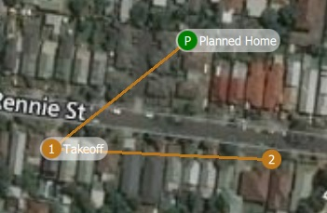

You should move/drag the planned home position to roughly the location where you plan to takeoff. The altitude for the planned home position is set in the [Mission Settings](https://word-edit.officeapps.live.com/we/wordeditorframe.aspx?ui=ko-KR&rs=ko-KR&hid=2mWOPQhL50mMEjYL5cj+yw.0&WOPISrc=https%3A%2F%2Fwopi.onedrive.com%2Fwopi%2Ffiles%2FD12DB2555512DF7%213518&wdnd=1&wdPreviousSession=0e43a0ac-2186-4d7b-a50e-5c8de0ff7e7d&wdNewAndOpenCt=1555562078658&wdo=4&wdOrigin=wacFileNew&wdPreviousCorrelation=09861a00-356b-4040-8a89-e153d9da8134&wde=docx&sc=host%3D%26qt%3DFolders&mscc=1&wdp=0#mission_settings) panel.

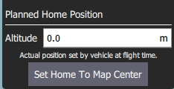

The Fly View displays the *actual* home position set by the vehicle firmware when it arms (this where the vehicle will return in Return/RTL mode).

**Plan Tools**

The plan tools are used for adding individual waypoints, easing mission creation for complicated geometries, uploading/downloading/saving/restoring missions, and for navigating the map. The main tools are described below.

**Center map**, **Zoom In**, **Zoom Out** tools help users better view and navigate the *Plan view* map (they don't affect the mission commands sent to the vehicle).

**Add Waypoints**

Click on the **Add Waypoint** tool to activate it. While active, clicking on the map will add new mission waypoint at the clicked location. The tool will stay active until you select it again. Once you have added a waypoint, you can select it and drag it around to change its position.

**File (Sync)**

The *File tools* are used to move missions between the ground station and vehicle, and to save/restore them from files. The tool displays an ! to indicate that there are mission changes that you have not sent to the vehicle.

Before you fly a mission you must upload it to the vehicle.

The *File tools* provide the following functionality:

* Upload (Send to vehicle)
* Download (Load from vehicle)
* Save/Save as to File, including as KML file.
* Load from File
* Remove All (removes all mission waypoints from *Plan view* and from vehicle)

**Pattern**

The [Pattern](https://word-edit.officeapps.live.com/we/Pattern.html) tool simplifies the creation of missions for flying complex geometries, including [surveys](https://word-edit.officeapps.live.com/we/pattern_survey.html) and [structure scans](https://word-edit.officeapps.live.com/we/pattern_structure_scan.html).

+

**Mission Command List**

Mission commands for the current mission are listed on the right side of the view. At the top are a set of options to switch between editing the mission, GeoFence and rally points. Within the list you can select individual mission items to edit their values.

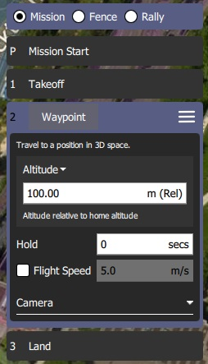

**Mission Command Editors**

Click on a mission command in the list to display its editor (in which you can set/change the command attributes).

You can change the **type** of the command by clicking on the command name (for example: *Waypoint*). This will display the *Select Mission Command* dialog shown below. By default this just displays the "Basic Commands", but you can use the **Category** drop down menu to display more (e.g. choose **All commands** to see all the options).

To the right of each command name is a menu that you can click to access to additional options such as *Insert* and *Delete*.

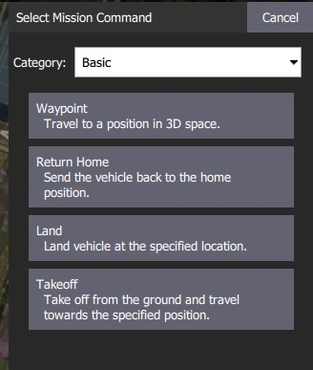

The list of available commands will depend on firmware and vehicle type. Examples may include: Waypoint, Start image capture, Jump to item (to repeat mission) and other commands.

**Mission Settings**

The *Mission Start* panel is the first item that appears in the [mission command list](https://word-edit.officeapps.live.com/we/wordeditorframe.aspx?ui=ko-KR&rs=ko-KR&hid=2mWOPQhL50mMEjYL5cj+yw.0&WOPISrc=https%3A%2F%2Fwopi.onedrive.com%2Fwopi%2Ffiles%2FD12DB2555512DF7%213518&wdnd=1&wdPreviousSession=0e43a0ac-2186-4d7b-a50e-5c8de0ff7e7d&wdNewAndOpenCt=1555562078658&wdo=4&wdOrigin=wacFileNew&wdPreviousCorrelation=09861a00-356b-4040-8a89-e153d9da8134&wde=docx&sc=host%3D%26qt%3DFolders&mscc=1&wdp=0#mission_command_list). It may be used to specify a number default settings that may affect the start or end of the mission.

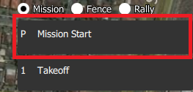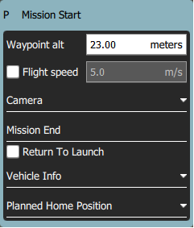

**Mission Defaults**

**Waypoint alt**

Set the default altitude for the first mission item added to a plan (subsequent items take an initial altitude from the previous item). This can also be used to change the altitude of all items in a plan to the same value; you will be prompted if you change the value when there are items in a plan.

**Flight speed**

Set a flight speed for the mission that is different than the default mission speed.

**Mission End**

##### Return to Launch after mission end

Check this if you want your vehicle to Return/RTL after the final mission item.

#### planned Home Position

The [Planned Home Position](https://word-edit.officeapps.live.com/we/wordeditorframe.aspx?ui=ko-KR&rs=ko-KR&hid=2mWOPQhL50mMEjYL5cj+yw.0&WOPISrc=https%3A%2F%2Fwopi.onedrive.com%2Fwopi%2Ffiles%2FD12DB2555512DF7%213518&wdnd=1&wdPreviousSession=0e43a0ac-2186-4d7b-a50e-5c8de0ff7e7d&wdNewAndOpenCt=1555562078658&wdo=4&wdOrigin=wacFileNew&wdPreviousCorrelation=09861a00-356b-4040-8a89-e153d9da8134&wde=docx&sc=host%3D%26qt%3DFolders&mscc=1&wdp=0#planned_home) section allows you to simulate the vehicle's home position while planning a mission. This allows you to view the waypoint trajectory for your vehicle from takeoff to mission completion.



This is only the *planned* home position and you should place it where you plan to start the vehicle from. It has no actual impact on flying the mission. The actual home position of a vehicle is set by the vehicle itself when arming.

The section allows you to set the **Altitude** and **Set Home to Map Centre** (you can move it to another position by dragging it on the map).

**Camera**

The camera section allows you to specify a camera action to take, control the gimbal and set your camera into photo or video mode.

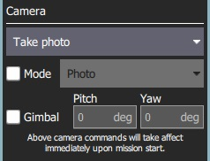

The available camera actions are:

* No change (continue current action)
* Take photos (time)
* Take photos (distance)
* Stop taking photos
* Start recording video
* Stop recording video

**Vehicle Info**

The appropriate mission commands for the vehicle depend on the firmware and vehicle type.

If you are planning a mission while you are *connected to a vehicle* the firmware and vehicle type will be determined from the vehicle. This section allows you to specify the vehicle firmware/type when not connected to a vehicle.

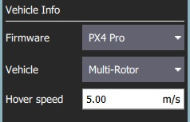

The additional value that can be specified when planning a mission is the vehicle flight speed. By specifying this value, total mission or survey times can be approximated even when not connected to a vehicle.

+

**Troubleshooting**

**Mission (Plan) Upload/Download Failures**

Plan uploading and downloading can fail over a noisy communication link (affecting missions, GeoFence, and rally points). If a failure occurs you should see a status message in the QGC UI similar to:

Mission transfer failed. Retry transfer. Error: Mission write mission count failed, maximum retries exceeded.

The loss rate for your link can be viewed in [Settings View > MAVLink](https://word-edit.officeapps.live.com/SettingsView/MAVLink.html). The loss rate should be in the low single digits (i.e. maximum of 2 or 3):

* A loss rate in the high single digits can lead to intermittent failures.
* Higher loss rates often lead to 100% failure.

There is a much smaller possibility that issues are caused by bugs in either flight stack or QGC. To analyse this possibility you can turn on [Console Logging](https://word-edit.officeapps.live.com/SettingsView/console_logging.html) for Plan upload/download and review the protocol message traffic.

**Further Info**

* New Plan View features for [QGC release v3.2](https://word-edit.officeapps.live.com/releases/stable_v3.2_long.html#plan_view)
* New Plan View features for [QGC release v3.3](https://word-edit.officeapps.live.com/releases/stable_v3.3_long.html#plan_view)

# **Plan View - GeoFence**

GeoFences allow you to create virtual regions within which the vehicle can fly, or in which it is *not allowed* to fly. You can also configure the action taken if you fly outside permitted areas.

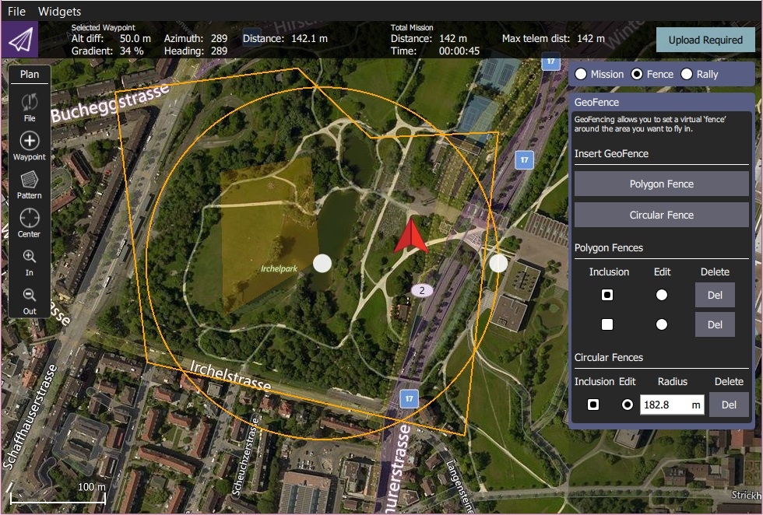

Not all vehicle firmware and types support GeoFence/all geofence capabilities. *QGroundControl* will not display the GeoFence options if they are not supported by the connected vehicle.

## **Create a Geofence**

To create a GeoFence:

1. Navigate to the Plan View
2. Select the *Geofence* radio button above the Mission Command List

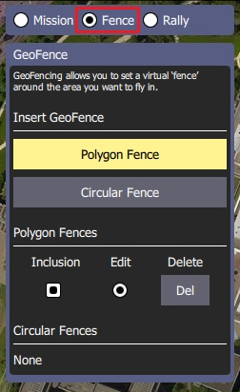

1. Insert a circular or polygon region by pressing the **Circular Fence** or **Polygon Fence** buttons, respectively. A new region will be added to the map and to the associated list of fences below the buttons.

You can create multiple regions by pressing the buttons multiple times, allowing complex geofence definitions to be created.

* + Circular region:
  + 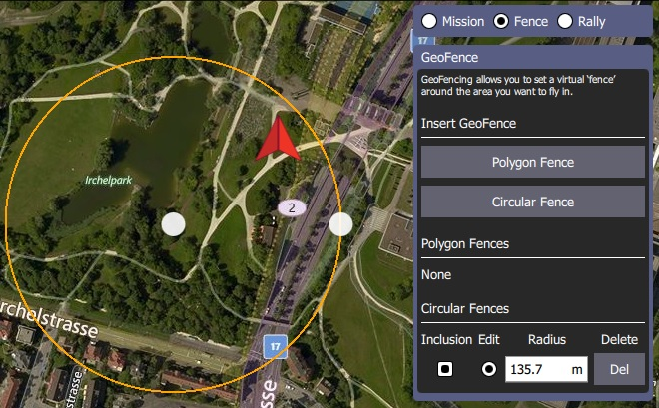
    - Move the region by dragging the central dot on the map
    - Resize the circle by dragging the map dot on the edge of the circle (or you can change the radius value in the fence panel).
  + Polygon region:
  + 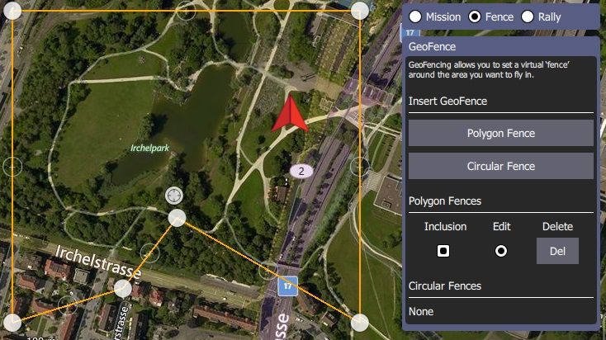
    - Move the vertices by dragging the filled dots
    - Create new vertices by clicking the "unfilled" dots on the lines between the filled vertices.

1. By default new regions are created as *inclusion* zones (vehicles must stay within the region). Change them to exclusion zones (where the vehicle can't travel) by unchecking the associated *Inclusion* checkbox in the fence panel.

## **Edit/Delete a GeoFence**

You can select a geofence region to edit by selecting its *Edit* radio button in the GeoFence panel. You can then edit the region on the map as described in the previous section.

Regions can be deleted by pressing the associated **Del** button

## **Upload a GeoFence**

The GeoFence is uploaded in the same way as a mission, using **File** in the [Plan tools](https://docs.qgroundcontrol.com/en/PlanView/PlanView.html).

## **Remaining tools**

# **Plan View - Rally Points**

Rally Points are alternative landing or loiter locations.

They are typically used to provide a safer or more convenient destination than the home position in Return/RTL mode.

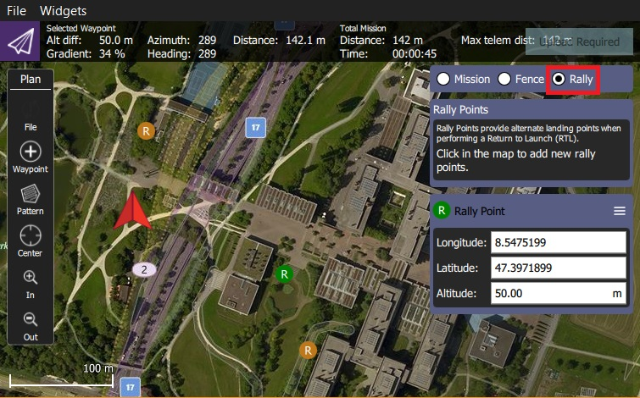

Not all vehicle firmware and airframe types support Rally Points. *QGroundControl* will not display the Rally Point options if they are not supported by the connected vehicle.

## **Rally Point Usage**

To create Rally Points:

1. Navigate to the Plan View
2. Select the *Rally* radio button above the Mission Command List
3. Click the map wherever you want rally points.
   * An **R** marker is added for each
   * the currently active marker has a different colour (green) and can be edited using the *Rally Point* panel.

4 Make any rally point active by selecting it on the map:

* + Move the active rally point by either dragging it on the map or editing the position in the panel.
  + Delete the active rally point by selecting the menu option on the *Rally Point* panel

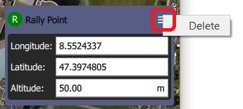

## **Upload Rally Points**

Rally points are uploaded in the same way as a mission, using **File** in the [Plan tools](https://docs.qgroundcontrol.com/en/PlanView/PlanView.html).

## **Remaining tools**

The rest of the tools work exactly as they do while editing a Mission.

# **Pattern**

The *Pattern tools* (in the [PlanView](https://docs.qgroundcontrol.com/en/PlanView/PlanView.html) *Plan Tools*) allow you to specify complex flight patterns using a simple graphical UI. The available pattern tools depend on the vehicle (and support for the vehicle-type in the flight stack).

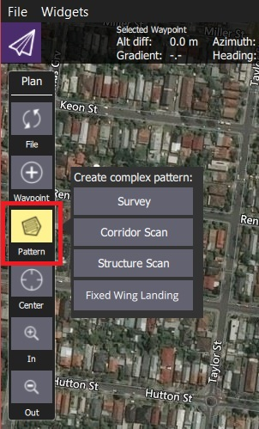

|  |  |  |
| --- | --- | --- |
| **Pattern** | **Description** | **Vehicles** |
| [Survey](https://docs.qgroundcontrol.com/en/PlanView/pattern_survey.html) | Create a grid flight pattern over a polygonal area.  You can specify the polygon as well as the specifications for the grid and camera settings appropriate for creating geotagged images. | All |
| [Structure Scan](https://docs.qgroundcontrol.com/en/PlanView/pattern_structure_scan.html) | Create a grid flight pattern that captures images over vertical surfaces (polygonal or circular).  These are typically used for the visual inspection or creation of 3d models of structures. | MultiCopter, VTOL |
| [Corridor Scan](https://docs.qgroundcontrol.com/en/PlanView/pattern_corridor_scan.html) | Create a flight pattern which follows a poly-line (for example, to survey a road). | All |
| [Fixed Wing Landing](https://docs.qgroundcontrol.com/en/PlanView/pattern_fixed_wing_landing.html) | Add a landing pattern for fixed wing vehicles to a mission. | Fixed Wing |

# **Survey (Plan Pattern)**

A survey allows you to create a grid flight pattern over a polygonal area. You can specify an arbitrary polygon, the angle and other properties of the grid, and camera settings appropriate for creating geotagged images.

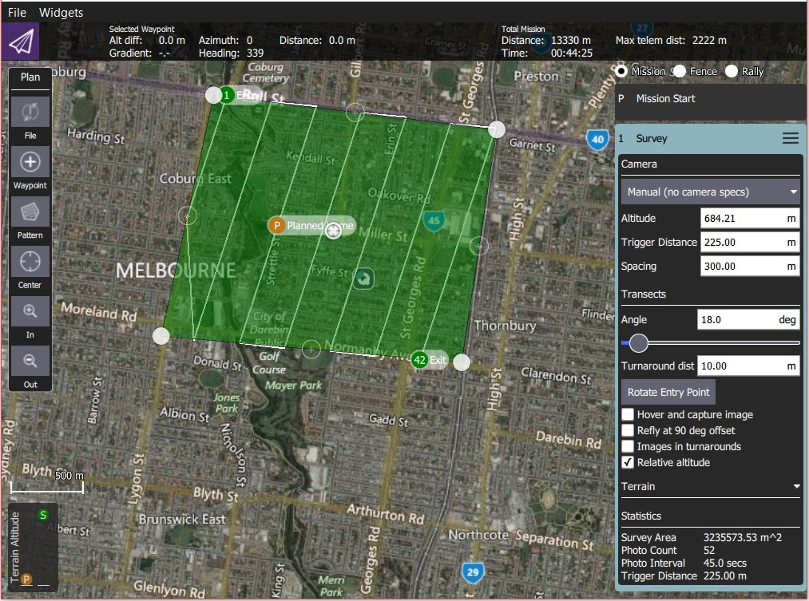

## **Creating a Survey**

To create a survey:

1. Open [PlanView](https://docs.qgroundcontrol.com/en/PlanView/PlanView.html) *Plan Tools*.
2. Choose the *Pattern Tool* from the *Plan Tools* and then select *Survey*.

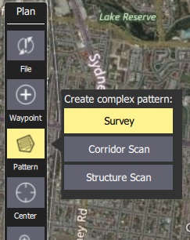

This will add a survey grid to the map, and a *Survey* item to the mission list (on the right).

1. On the map drag the vertices to the change the shape of the polygon.
2. Click the (+) symbol between existing vertices to create a new vertix. The new vertix can then be dragged into a new position.

The survey settings are covered in the next section.

## **Settings**

The survey can be further configured in the associated mission item (in the mission item list on the right hand side of the *Plan View*).

### **Camera**

Camera triggering behaviour depends on the camera/camera settings. You can select an existing camera, custom camera, or manually enter the settings. The list of available cameras (QGC 3.4) is given below.

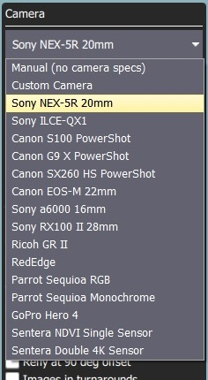

#### Known Camera

Selecting a known camera from the option dropdown generates a grid pattern based on the camera capabilities.

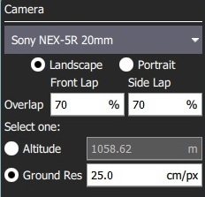

The default settings can be tuned for your survey using the configuration options:

* **Landscape/Portrait** - Camera orientation relative to the "normal" orientation of the vehicle.
* **Overlap** - Overlap between each image capture. This can be configured separately for when flying along grid lines or across them.
* Select one of:
  + **Altitude** - Survey altitude (ground resolution will be calculated/displayed for this altitude).
  + **Ground resolution** - Ground resolution for each image (altitude required to achieve this resolution calculated and shown).

#### Custom Camera

Selecting the custom camera option allows you to specify the settings for a new camera in a similar way to a known camera.

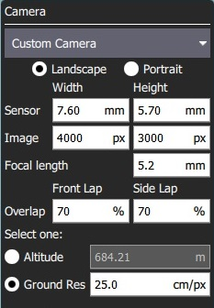

The camera-specific settings are:

* **Sensor width/height** - The size of the image sensor of the camera.
* **Image width/height** - The resolution of the image captured by the camera.
* **Focal Length** - The focal length of the camera lens.

The remaining settings are the same as for a [known camera](https://docs.qgroundcontrol.com/en/PlanView/pattern_survey.html#known_camera).

#### Manual Camera

The manual camera option allows you to specify desired survey height, trigger interval and appropriate grid spacing for your camera.

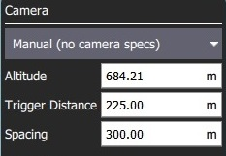

The configurable options are:

* **Altitude** - Survey altitude to fly the whole grid.
* **Trigger Distance** - The distance over ground between each camera shot.
* **Spacing** - Distance between adjacent grid (flight path) lines across the corridor.

### **Transects**

The *Transects* section is used for grid settings that are independent of the camera used.

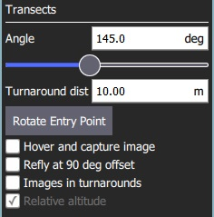

The configurable options are:

* **Angle** - The angle of the grid lines, relative to North. 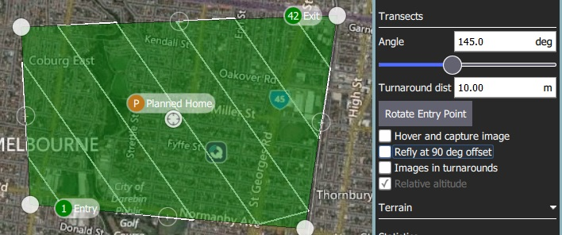
* **Turnaround dist** - Amount of additional distance to add outside the survey area for vehicle turn around.
* **Rotate Entry Point** - Press button to swap the start and end point of the survey.
* **Hover and capture image** - Hover to capture images (multicopter only).
* **Refly at 90 degree offset** - Check to refly the whole mission at a 90% offset.

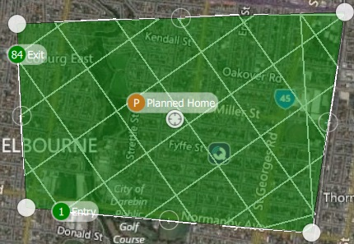

* **Images in turnarounds** - Check to take images when turning
* **Relative altitude** - Check to ... TBD.

### **Terrain**

By default, a flying vehicle will follow the survey path at a fixed altitude. Enabling *Terrain Following* makes the vehicle maintain a constant height relative to ground.

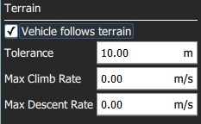

Terrain following uses terrain heights queried from *AirMap* servers.

The configurable options are:

* **Vehicle follows terrain** - Check to enable terrain following (and display the following options).
  + **Tolerance** - The accepted deviation in altitude from the target altitude.
  + **Max Climb Rate** - Maximum climb rate when following terrain.
  + **Max Descent Rate** - Maximum descent rate when following terrain.

### **Statistics**

The *Statistics* section shows the calculated survey area, photo interval, photo spacing and planned photo count.

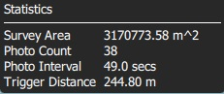

# **Structure Scan (Plan Pattern)**

A *Structure Scan* allows you to create a grid flight pattern that captures images over vertical surfaces. These are typically used for the visual inspection or creation of 3d models of structures.

Structure Scans may be inserted into a mission using the Plan view **Pattern > Structure Scan** tool

The new version of Structure Scan can't read older Structure Scan plans. They will need to be recreated

This feature is not yet supported by ArduPilot firmware. It is supported in PX4.

Overview

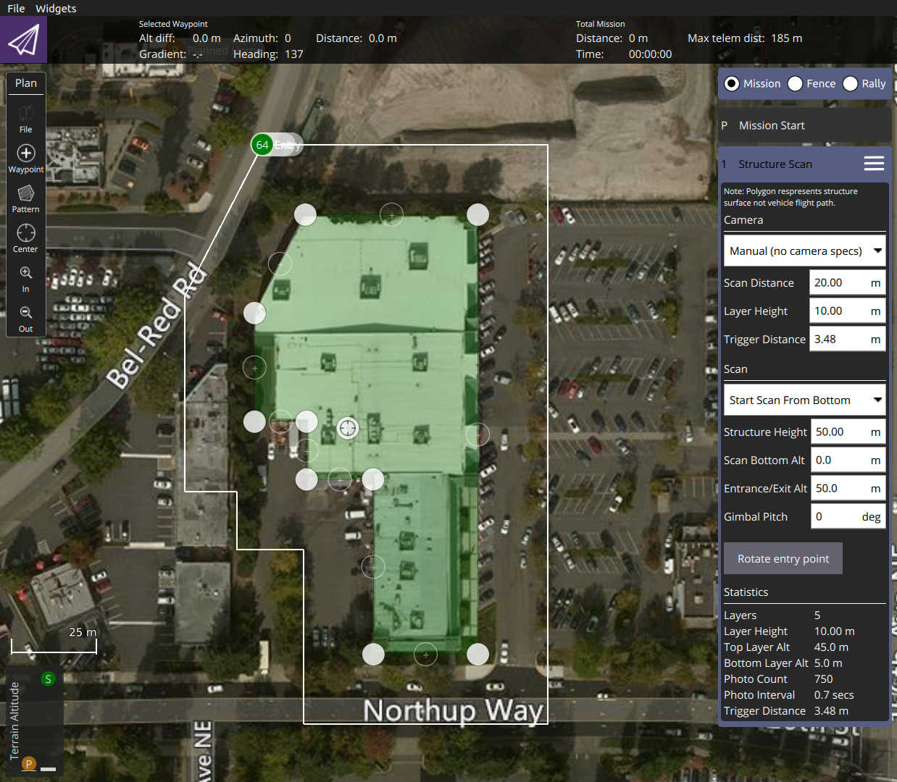

The scan divides the structure evenly into layers; the vehicle flies all the way around the structure at a particular altitude and scan distance from the structure, then repeats the process at each layer until the whole surface has been scanned.

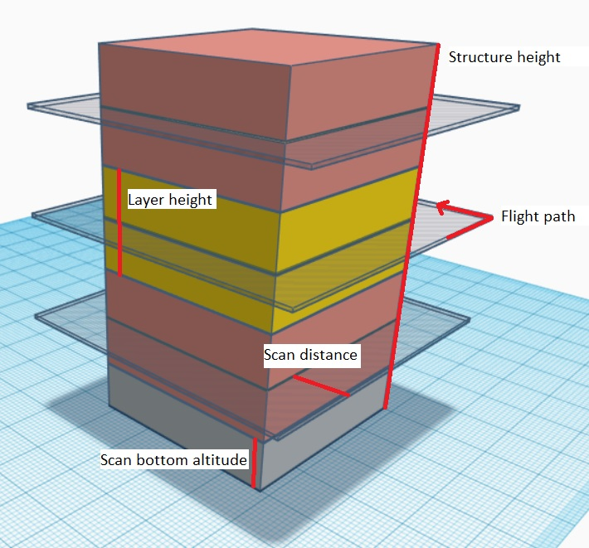

Users can set the scan bottom altitude to avoid obstacles at the bottom of the structure, and the extrance/exit altitude to avoid obstacles as the vehicle travels to/from the scan.

## Creating a Scan

To create a scan:

1. In the **Plan View** select **Pattern tool > Structure Scan**.

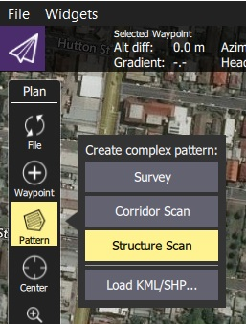

1. This will create a simple square structure scan on the map.

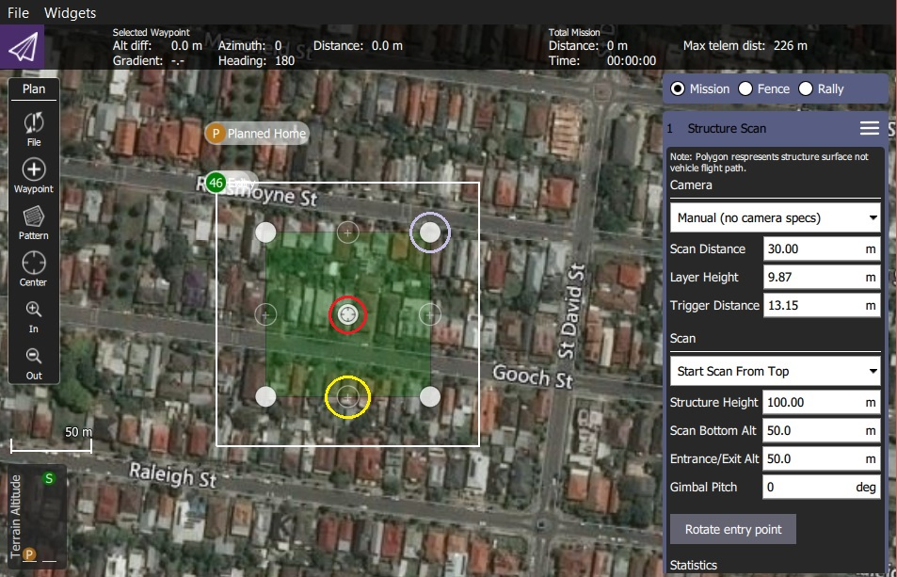

The region shown in green must be modified so that it surrounds the structure.

* Drag the opaque vertices on the map to the edge of the structure (example circled in mauve above).
* If the structure footprint is more than a simple square you can click the semi-transparent circles between the vertices to create a new vertix.

3 You can also change to a circular footprint by clicking on the central "vertix" (marked in red) and selecting Circle in the popup menu.

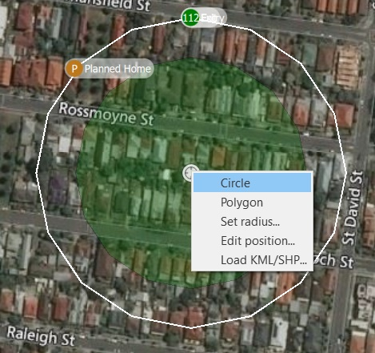.

* From the popup menu you can switch back to a polygon footprint and change the radius and/or position of the scan.
* Drag the central vertix to position the centre of the circle.

4/The rest of the configuration is handled using the Structure Scan editor on the right hand side of the view. First select whether you want to perform a manual scan, a scan using a particular camera, or a scan using a custom camera definition.

The main difference between the modes is that predefined cameras are already set up to correctly calculate an effective layer height and trigger distance.

Options for the different modes are shown below.

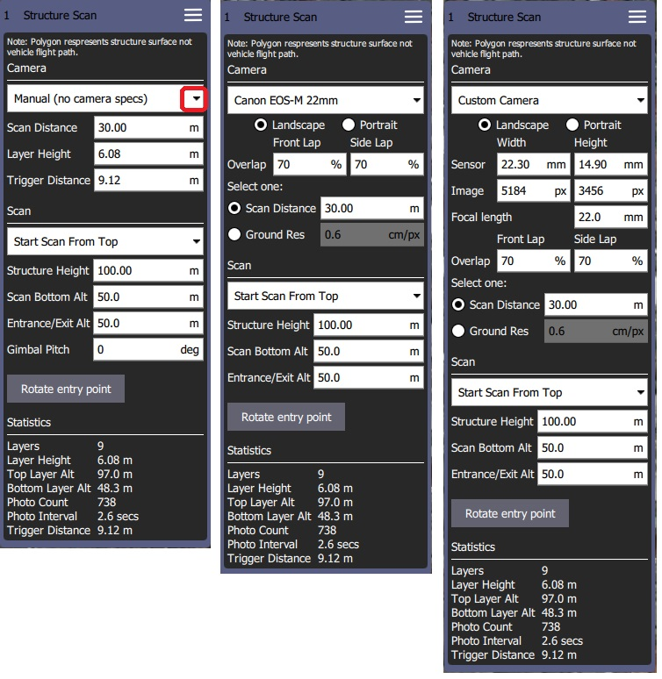

The user can always configure the following settings:

* **Start scan from top/bottom:** The direction in which layers are scanned.
* **Structure height:** The height of the object being scanned.
* **Scan distance:** Distance from the structure of the flight path.
* **Entrance/Exit Alt:** Use this setting to avoid obstacles between the last/next waypoint and the structure to be scanned.
  + The vehicle will fly to the Entrance/Exit point at this altitude and then descend to the initial layer to start the scan.
  + The vehicle will ascend to this altitude after completing the scan and then move to the next waypoint.
* **Scan Bottom Alt:** Use this setting to avoid obstacles around the base of the structure. This adjust the bottom of the structure to be above the ground, and hence the altitude of the first scan (the height of the lowest layer flight path is shown in the scan statistics as Bottom Layer Alt.
* **Rotate Entry Point:** Move the start/finish point to the next vertix/position on the flight path.

The remaining settings depend on the camera mode:

* Manual Mode allows you to specify:
  + **Layer height:** The height of each layer.
  + **Trigger Distance:** The distance between each camera trigger. The camera is only triggered while flying the layer path. It does not trigger images while transitioning from one layer to the next.
  + **Gimbal Pitch** - Gimbal pitch you want to use for the scan.
* Selecting a pre-defined camera automatically selects an appropriate layer height and camera triggering distance. It also ensures that the camera is always pointed directly at the right angles to the surface which it is capturing images.
* Selecting a custom camera allows you to enter your own camera characteristics, and otherwise behaves the same as a predefined camera.

# Corridor Scan (Plan Pattern)

A corridor scan allows you to create a flight pattern that follows a poly-line. This can be used to, for example, survey a road. It is supported on all autopilots and vehicle types.

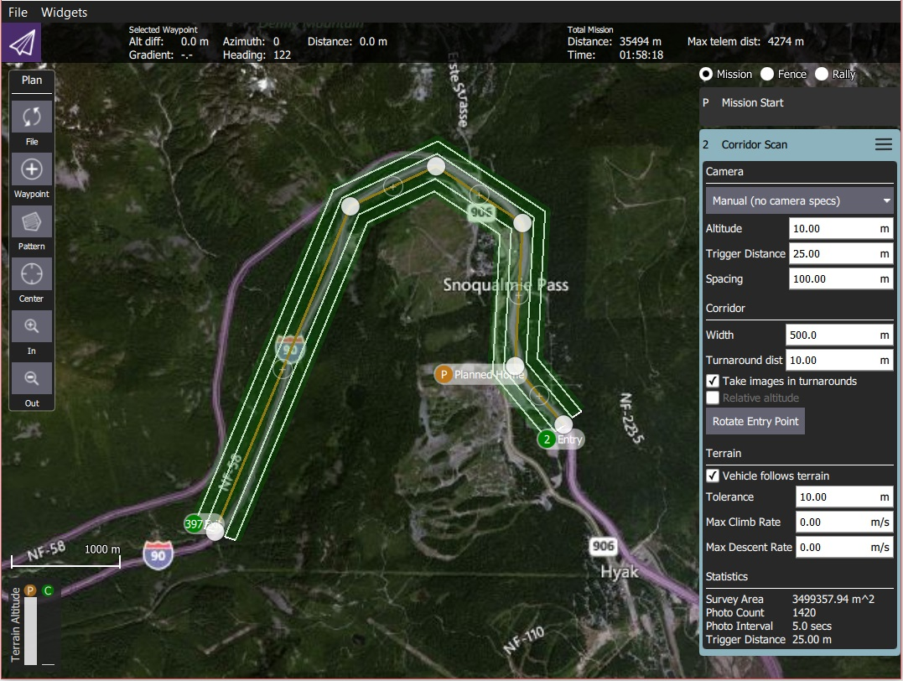

You can specify the path, the width of the corridor, and camera settings appropriate for creating geotagged images.

## Creating a Scan

To create a corridor scan:

1. Open [PlanView](https://docs.qgroundcontrol.com/en/PlanView/PlanView.html) Plan Tools.
2. Choose the Pattern Tool from the Plan Tools and then select Corridor Scan.

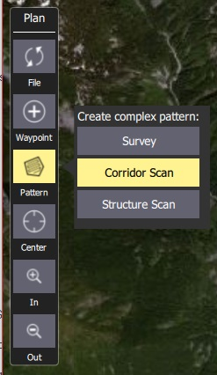

This will add a corridor to the map, and a Corridor Scan item to the mission list (on the right).

1. On the map drag the ends of the corridor to the start and end positions of the scan, respectively.
2. Click the (+) symbol at the centre of a line to create a new vertix. The new vertix can then be dragged into position to follow the path of the desired corridor.

The corridor scan settings are covered in the next section.

## Settings

The corridor scan can be further configured in the associated mission item (in the mission item list on the right hand side of the Plan View).

### Camera

Camera triggering behaviour depends on the camera/camera settings. You can select an existing camera or manually enter the settings. The list of available cameras (QGC 3.4) is given below.

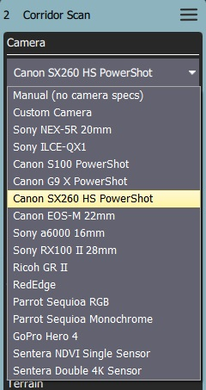

#### Known Camera

Selecting a known camera from the option dropdown allows you to generate a grid pattern based on the camera's specifications.

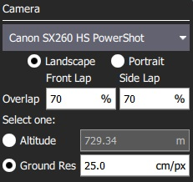

The configurable options are:

* **Landscape/Portrait** - Camera orientation relative to the "normal" orientation of the vehicle.
* **Image Overlap** - Overlap between each image.
* Select one of:
  + **Altitude** - Survey altitude (ground resolution will be calculated/displayed for this altitude).
  + **Ground resolution** - Ground resolution for each image (altitude required to achieve this resolution calculated and shown).

#### Manual Camera

The manual camera option allows you to specify desired survey height, trigger interval and appropriate grid spacing for your camera.

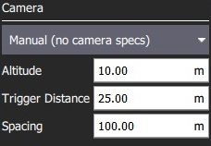

The configurable options are:

* **Altitude** - Survey altitude.
* **Trigger Distance** - The distance over ground between each camera shot.
* **Spacing** - Distance between adjacent grid (flight path) lines across the corridor.

### Corridor

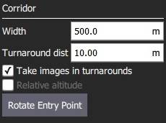

The configurable options are:

* **Width** - Set the width of the scan around the polyline that defines the path.
* **Turnaround dist** - Amount of additional distance to add outside the survey area for vehicle turn around.
* **Take images in turnarounds** - Check to enable image capture a turnaround points.
* **Relative altitude** - Check to specify a relative altitude. This is only supported for manual grids that are not using [terrain following](https://docs.qgroundcontrol.com/en/PlanView/pattern_corridor_scan.html#terrain_following).
* **Rotate entry point** - Press button to swap the start and end point of the corridor scan.

### Terrain Following

By default a flying vehicle will follow the corridor path at a fixed altitude. Enabling Terrain Following makes the vehicle maintain a constant height relative to ground.

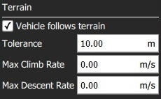

Terrain following uses terrain heights queried from AirMap servers.

The configurable options are:

* **Vehicle follows terrain** - Check to enable terrain following (and display the following options).
  + **Tolerance** - The accepted deviation in altitude from the target altitude.
  + **Max Climb Rate** - Maximum climb rate when following terrain.
  + **Max Descent Rate** - Maximum descent rate when following terrain.

### Statistics

The Statistics section shows the calculated survey area, photo interval, photo spacing and planned photo count.

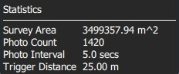

In the diagram green is used to show the polygon that represents the structure. In white you can see the flight path for the vehicle. You can also fly circular structure scans by change the polygon to a circle using the *center tool*.

## **Camera based scan**

The settings for the scan can be based on the specifications of the camera on the vehicle. By using the option you can also specify the resolution of the images for the structure surface. You do this by selecting a camera from the list or selecting **Custom Camera** to provide you own camera specs.

For camera based scans the camera is always pointed directly at the right angles to the surface which it is capturing images for.

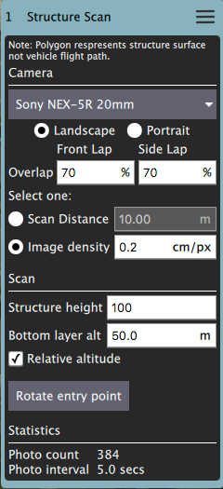

### **Structure information**

The vehicle will fly a pattern such that images fully cover the structure starting from "Base layer alt" up to "Structure height":

* Base layer alt - The bottom of the lowest layer of the scan.
* Structure height - The height of the structure.

## **Manual scan**

A manual scan allows you to specify the various distances and heights associated with a structure scan yourself. You select **Manual** from the list for a manual scan.

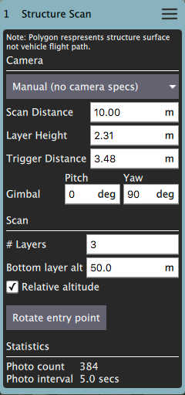

* Scan Distance - The amount of distance to fly away from the structure.
* Bottom Layer Alt - The bottom altitude of the first layer.
* Layer Height - The height of each subsequent layer.
* Layers - The number of layers to generate.
* Trigger Distance - The distance between each camera trigger.
* Gimbal - Gimbal angles you want to use for the scan.

# **Structure Scan (Plan Pattern) - Daily Builds**

A *Structure Scan* allows you to create a grid flight pattern that captures images over *vertical surfaces* (e.g. walls) around a structure with an arbitrary polygonal (or circular) ground footprint. Structure Scans are typically used for the visual inspection or creating 3d models of structures.

*Structure Scans* may be inserted into a mission using the Plan view **Pattern > Structure Scan** tool.

The new version of *Structure Scan* can't read older *Structure Scan* plans. They will need to be recreated.

This feature is not yet supported by ArduPilot firmware. It is supported in PX4.

## **Overview**

The image below shows a screenshot of structure scan. The green polygon is used to mark out the ground footprint of the structure, while the white line around it indicates the vehicle flight path. The green numbered circle on the flight path is the scan entry/exit point (where the scan starts).



The scan divides the structure evenly into layers; the vehicle flies all the way around the structure at a particular altitude and *scan distance* from the structure, then repeats the process at each layer until the whole surface has been scanned.



Users can set the *scan bottom altitude* to avoid obstacles at the bottom of the structure, and the *extrance/exit altitude* to avoid obstacles as the vehicle travels to/from the scan.

## **Creating a Scan**

To create a scan:

1. In the **Plan View** select **Pattern tool > Structure Scan**.
2. 
3. This will create a simple square structure scan on the map.
4. 
5. The region shown in green must be modified so that it surrounds the structure.
   * Drag the opaque vertices on the map to the edge of the structure (example circled in mauve above).
   * If the structure footprint is more than a simple square you can click the semi-transparent circles between the vertices to create a new vertix.
6. You can also change to a circular footprint by clicking on the central "vertix" (marked in red) and selecting *Circle* in the popup menu.
7. .
   * From the popup menu you can switch back to a polygon footprint and change the radius and/or position of the scan.
   * Drag the central vertix to position the centre of the circle.
8. The rest of the configuration is handled using the *Structure Scan* editor on the right hand side of the view. First select whether you want to perform a manual scan, a scan using a particular camera, or a scan using a custom camera definition.
9. The main difference between the modes is that predefined cameras are already set up to correctly calculate an effective layer height and trigger distance.
10. Options for the different modes are shown below.
11. 

The user can always configure the following settings:

* **Start scan from top/bottom:** The direction in which layers are scanned.
* **Structure height:** The height of the object being scanned.
* **Scan distance:** Distance from the structure of the flight path.
* **Entrance/Exit Alt:** Use this setting to avoid obstacles between the last/next waypoint and the structure to be scanned.
  + The vehicle will fly to the *Entrance/Exit* point at this altitude and then descend to the initial layer to start the scan.
  + The vehicle will ascend to this altitude after completing the scan and then move to the next waypoint.
* **Scan Bottom Alt:** Use this setting to avoid obstacles around the base of the structure. This adjust the bottom of the structure to be above the ground, and hence the altitude of the first scan (the height of the lowest layer flight path is shown in the scan statistics as *Bottom Layer Alt*.
* **Rotate Entry Point:** Move the start/finish point to the next vertix/position on the flight path.

The remaining settings depend on the *camera mode*:

* *Manual Mode* allows you to specify:
  + **Layer height:** The height of each layer.
  + **Trigger Distance:** The distance between each camera trigger. The camera is only triggered while flying the layer path. It does not trigger images while transitioning from one layer to the next.
  + **Gimbal Pitch** - Gimbal pitch you want to use for the scan.
* Selecting a pre-defined camera automatically selects an appropriate layer height and camera triggering distance. It also ensures that the camera is always pointed directly at the right angles to the surface which it is capturing images.
* Selecting a custom camera allows you to enter your own camera characteristics, and otherwise behaves the same as a predefined camera.

# **Corridor Scan (Plan Pattern)**

A corridor scan allows you to create a flight pattern that follows a poly-line. This can be used to, for example, survey a road. It is supported on all autopilots and vehicle types.



You can specify the path, the width of the corridor, and camera settings appropriate for creating geotagged images.

## **Creating a Scan**

To create a corridor scan:

1. Open [PlanView](https://docs.qgroundcontrol.com/en/PlanView/PlanView.html) *Plan Tools*.
2. Choose the *Pattern Tool* from the *Plan Tools* and then select *Corridor Scan*.
3. 
4. This will add a corridor to the map, and a *Corridor Scan* item to the mission list (on the right).
5. On the map drag the ends of the corridor to the start and end positions of the scan, respectively.
6. Click the (+) symbol at the centre of a line to create a new vertix. The new vertix can then be dragged into position to follow the path of the desired corridor.

The corridor scan settings are covered in the next section.

## **Settings**

The corridor scan can be further configured in the associated mission item (in the mission item list on the right hand side of the Plan View).

### **Camera**

Camera triggering behaviour depends on the camera/camera settings. You can select an existing camera or manually enter the settings. The list of available cameras (QGC 3.4) is given below.



#### Known Camera

Selecting a known camera from the option dropdown allows you to generate a grid pattern based on the camera's specifications.



The configurable options are:

* **Landscape/Portrait** - Camera orientation relative to the "normal" orientation of the vehicle.
* **Image Overlap** - Overlap between each image.
* Select one of:
  + **Altitude** - Survey altitude (ground resolution will be calculated/displayed for this altitude).
  + **Ground resolution** - Ground resolution for each image (altitude required to achieve this resolution calculated and shown).

#### Manual Camera

The manual camera option allows you to specify desired survey height, trigger interval and appropriate grid spacing for your camera.



The configurable options are:

* **Altitude** - Survey altitude.
* **Trigger Distance** - The distance over ground between each camera shot.
* **Spacing** - Distance between adjacent grid (flight path) lines across the corridor.

### **Corridor**



The configurable options are:

* **Width** - Set the width of the scan around the polyline that defines the path.
* **Turnaround dist** - Amount of additional distance to add outside the survey area for vehicle turn around.
* **Take images in turnarounds** - Check to enable image capture a turnaround points.
* **Relative altitude** - Check to specify a relative altitude. This is only supported for manual grids that are not using [terrain following](https://docs.qgroundcontrol.com/en/PlanView/pattern_corridor_scan.html#terrain_following).
* **Rotate entry point** - Press button to swap the start and end point of the corridor scan.

### **Terrain Following**

By default a flying vehicle will follow the corridor path at a fixed altitude. Enabling *Terrain Following* makes the vehicle maintain a constant height relative to ground.



Terrain following uses terrain heights queried from *AirMap* servers.

The configurable options are:

* **Vehicle follows terrain** - Check to enable terrain following (and display the following options).
  + **Tolerance** - The accepted deviation in altitude from the target altitude.
  + **Max Climb Rate** - Maximum climb rate when following terrain.
  + **Max Descent Rate** - Maximum descent rate when following terrain.

### **Statistics**

The *Statistics* section shows the calculated survey area, photo interval, photo spacing and planned photo count.



# **Fixed Wing Landing Pattern (Plan Pattern)**

The *Fixed Wing Landing Pattern* tool allows you to add a fixed wing landing pattern to a mission. It is supported on both ArduPilot and PX4.

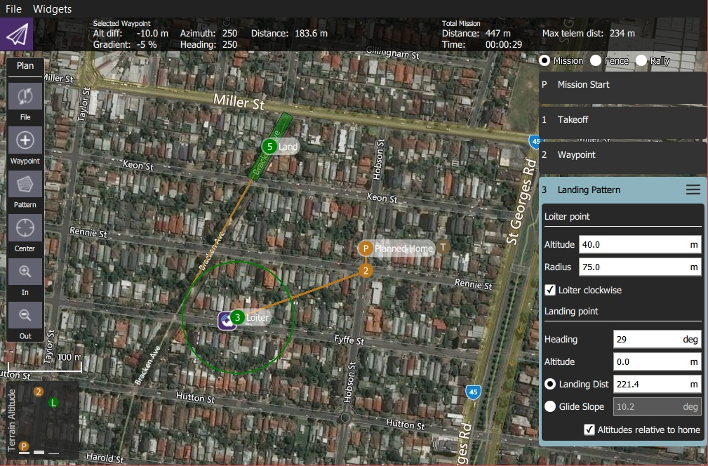

The first point of the pattern is a loiter point with a specific altitude and the second is a landing point. The vehicle will loiter at the first point until it reaches the target altitude, and then begin the landing sequence to fly down to the specified landing spot.

Both the loiter and land points can be dragged to new positions, and a number of other settings can be configured in the associated mission item.

## **Creating a Landing Pattern**

To create a landing pattern:

* + 1. Open [PlanView](https://docs.qgroundcontrol.com/en/PlanView/PlanView.html) *Plan Tools*).
    2. Choose the *Pattern Tool* from the *Plan Tools* and then select *Fixed Wing Landing Pattern*.

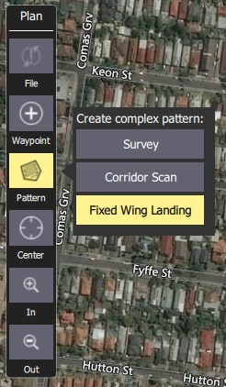

This will add a *Landing Pattern* item to the mission list (on the right).

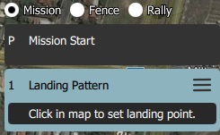

* + 1. Click on the map to create both the loiter and landing points. These can be moved on the map.

Additional settings are covered in the next section.

## **Settings**

The landing pattern can be further configured in the associated mission item (in the mission item list on the right hand side of the Plan View).

### **Loiter Point**

The *Loiter Point* settings are used to configure the loiter altitude, radius and direction.

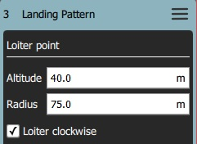

The configurable options are:

* **Altitude** - Loiter altitude.
* **Radius** - Loiter radius.
* **Loiter clockwise** - Check to loiter in a clockwise direction (anti-clockwise is the default).

### **Landing Point**

The *Landing Point* settings are used to configure the landing position and path.

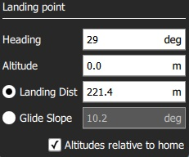

The configurable options are:

* **Heading** - Heading from loiter point to land point.
* **Altitude** - Altitude for landing point (nominally zero).
* *Radio Buttons*
  + **Landing Dist** - Distance between loiter and landing points.
  + **Glide Slope** - Glide slope between loiter and landing points.
* **Altitudes relative to home** - Check to set all altitudes in mission item to be relative to home (default is AMSL).

## **Implementation**

This pattern creates three mission items:

* DO_LAND_START - If you abort a landing it sends DO_GO_AROUND to the vehicle, which then causes the mission to return to this point and try to land again.
* NAV_LOITER_TO_ALT - Start point for landing
* NAV_LAND - End point for landing

The vehicle flares to landing using a flight path generated by the firmware between the NAV_LOITER_TO_ALT point and the NAV_LAND point.

If those two locations violate the vehicle's flare constraints (e.g. descent angle is too steep) an error will be raised after you upload the invalid mission to the vehicle.

On PX4, violating the flare constraints sends an error message to the ground station at upload time, and the autopilot will refuse to start the mission (since it fails integrity checks).

# **Setup View**

The Setup View is used to configure a new vehicle prior to first flight and/or tune a configured vehicle.

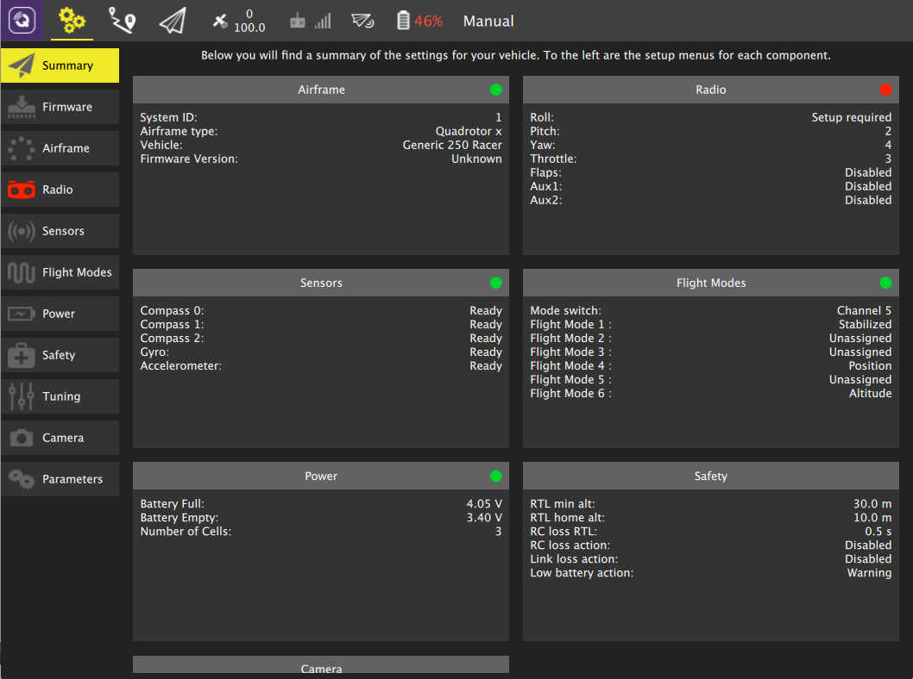

## **Setup Options**

To the left of the screen are the set of available setup options. A setup button is marked with a red icon if there are still settings needed to be adjusted/specified. You should not fly if any of these are red. In the above image the Radio setup is not yet complete.

The set of options shown and the contents of each option may differ based on whether the vehicle is running PX4 Pro or ArduPilot firmware. The image above is from a vehicle which is running PX4 Pro firmware.

**Summary**   
An overview of all the important setup options for your vehicle. Similar to the individual setup buttons, the summary blocks show a red indicator when those settings are not fully configured.

[**Firmware**](https://docs.qgroundcontrol.com/en/SetupView/Firmware.html)   
Flash new firmware onto your vehicle.

[**Airframe**](https://docs.qgroundcontrol.com/en/SetupView/Airframe.html)   
Specify the airframe type for the vehicle.

[**Radio**](https://docs.qgroundcontrol.com/en/SetupView/Radio.html)   
Calibrate your Radio Control Transmitter.

[**Sensors**](https://docs.qgroundcontrol.com/en/SetupView/Sensors.html)   
Calibrate the sensors on the vehicle.

[**Flight Modes**](https://docs.qgroundcontrol.com/en/SetupView/FlightModes.html)   
Used to assign flight modes to your RC Transmitter switches.

[**Power**](https://docs.qgroundcontrol.com/en/SetupView/Power.html)   
Battery settings and additional power options such as ESC calibration.

[**Motors**](https://docs.qgroundcontrol.com/en/SetupView/Motors.html)   
Motors testing and setup.

[**Safety**](https://docs.qgroundcontrol.com/en/SetupView/Safety.html)   
Specify settings for options related to Safety such as Return to Home or Failsafes.

[**Tuning**](https://docs.qgroundcontrol.com/en/SetupView/Tuning.html)   
Tune flight characteristics of the vehicle.

[**Camera**](https://docs.qgroundcontrol.com/en/SetupView/Camera.html)   
Configure settings for camera and gimbal.

[**Parameters**](https://docs.qgroundcontrol.com/en/SetupView/Parameters.html)   
Allows you to modify all parameters associated with your vehicle.

# **Loading Firmware**

*QGroundControl* **desktop** versions can install [PX4 Pro](http://px4.io/) or [ArduPilot](http://ardupilot.com/) firmware onto Pixhawk-family flight-controller boards. By default QGC will install the current stable version of the selected autopilot, but you can also choose to install beta builds, daily builds, or custom firmware files.

*QGroundControl* can also install the firmware for SiK Radios and PX4 Flow devices.

Loading Firmware is currently not available on tablet or phone versions of *QGroundControl*.

## **Connect Device for Firmware Update**

**Before you start installing Firmware** all USB connections to you vehicle must be *disconnected* (both direct or through a telemetry radio). The vehicle must *not be* powered by a battery.

* First select the **Gear** icon (*Vehicle Setup*) in the top toolbar and then **Firmware** in the sidebar.

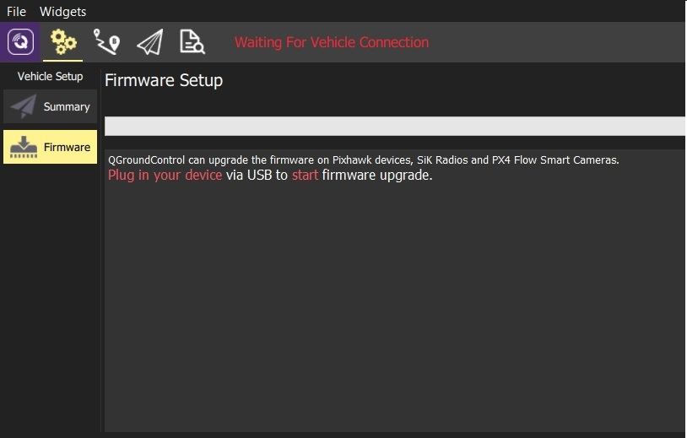

* Connect your device (Pixhawk, SiK Radio, PX4 Flow) directly to your computer via USB.
* Connect directly to a powered USB port on your machine (do not connect through a USB hub).

## **Select Firmware to Load**

Once the device is connected you can choose which firmware to load (*QGroundControl* presents sensible options based on the connected hardware).

1. For a Pixhawk-compatible board choose either **PX4 Flight Stack vX.X.X Stable Release** or **ArduPilot Flight Stack** radio buttons to download the *current stable release*.

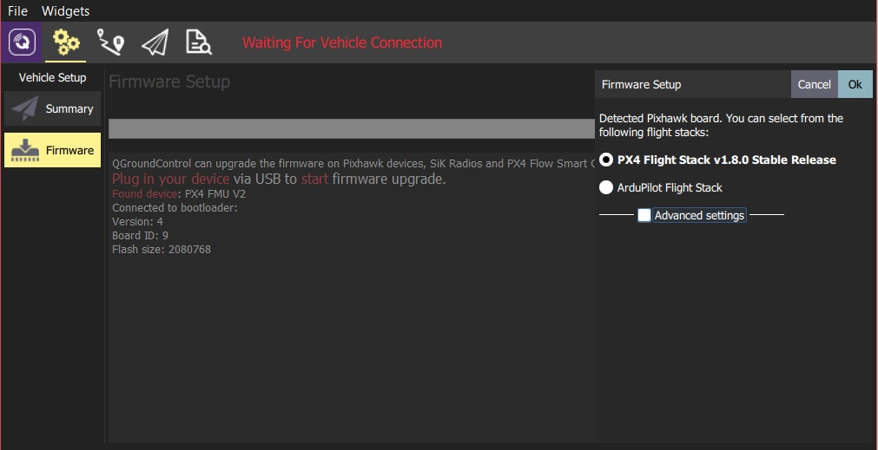

If you select *ArduPilot* you will also have to choose the specific firmware the type of vehicle (as shown below).

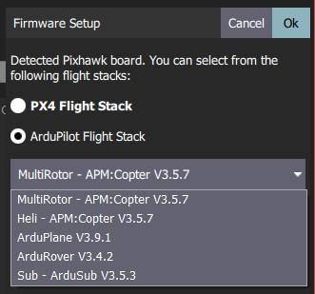

1. Check **Advanced settings** to select specific developer releases or install firmware from your local file system.

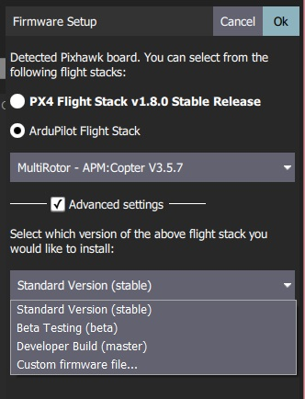

## **Update the firmware**

1Click the **OK** button to start the update.

* The firmware will then proceed through a number of upgrade steps (downloading new firmware, erasing old firmware etc.). Each step is printed to the screen and overall progress is displayed on a progress bar.

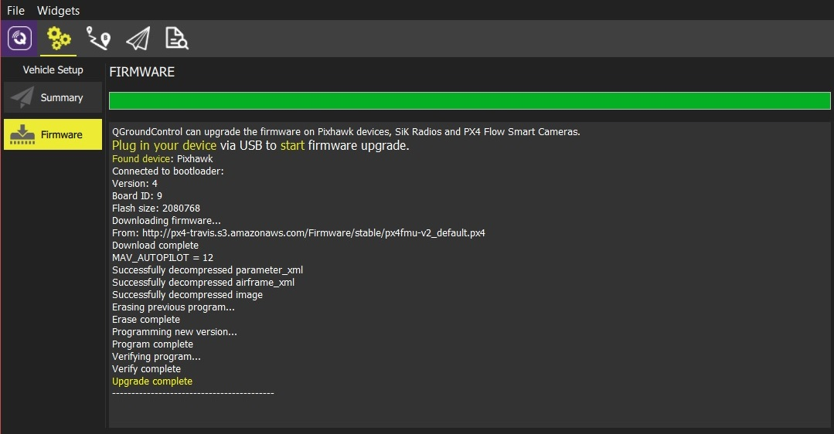

Once the firmware has completed loading the device/vehicle will reboot and reconnect. Next you will need to configure the [airframe](https://docs.qgroundcontrol.com/en/SetupView/Airframe.html) (and then sensors, radio, etc.)

# **Airframe Setup**

This page allows you to configure the main airframe selection associated with your vehicle. The view/process differs slightly based on the flight controller firmware used.

* [Airframe (ArduPilot)](https://docs.qgroundcontrol.com/en/SetupView/airframe_ardupilot.html)
* [Airframe (PX4)](https://docs.qgroundcontrol.com/en/SetupView/airframe_px4.html)

**Airframe Setup (ArduPilot)**

Airframe Setup is used to select the frame class and type that matches your vehicle

Airframe Setup is only available on *ArduCopter* and *ArduSub* vehicles (it is not shown for *ArduPilot* Rover or Plane vehicles).

## **ArduCopter Airframe Setup**

To select the airframe in Copter:

* + 1. First select the **Gear** icon (Vehicle Setup) in the top toolbar and then **Airframe** in the sidebar.

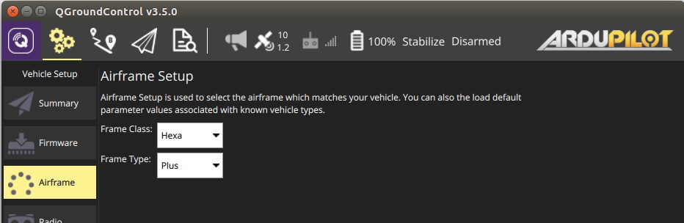

* + - 1. Select the broad *Frame Class* for your vehicle:

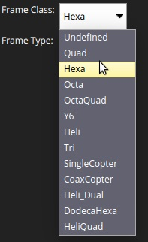

You will need to reboot the vehicle for class changes to take effect.

* + - 1. Select the specific *Frame Type* for your vehicle:

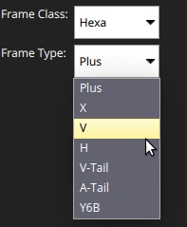

## **ArduSub Frame Setup**

To select the frame type for Sub:

* First select the **Gear** icon (Vehicle Setup) in the top toolbar and then **Frame** in the sidebar.
* Select the frame type that matches your vehicle (selecting a frame applies the selection).
* Make sure that all **green** thrusters have **clockwise** propellers and all **blue** thrusters have **counter-clockwise** propellers (or vice-versa).
* 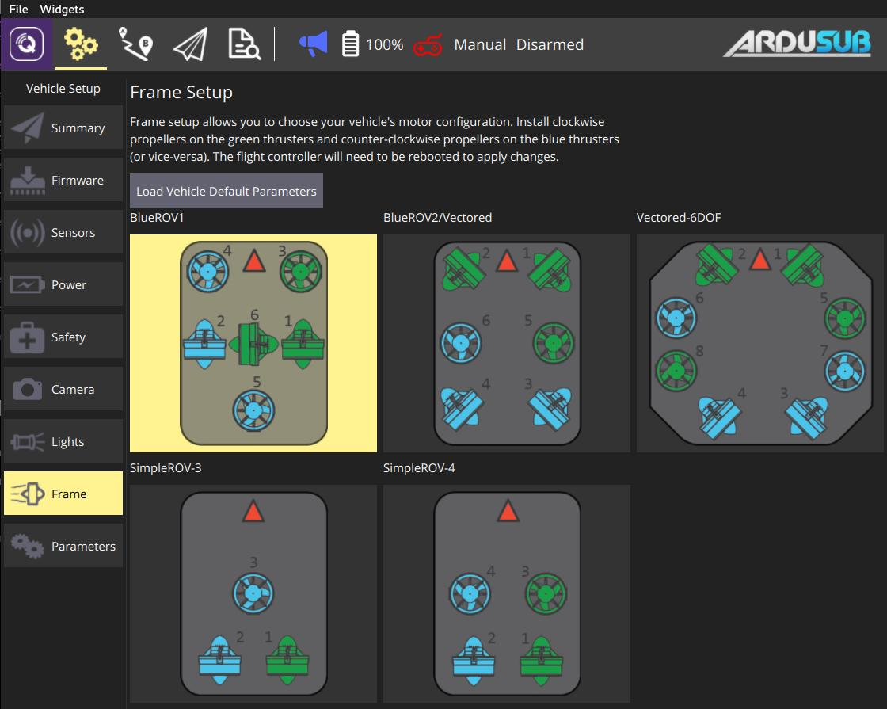
  + You can also click **Load Vehicle Default Parameters** to load default parameter set for ArduSub.
  + 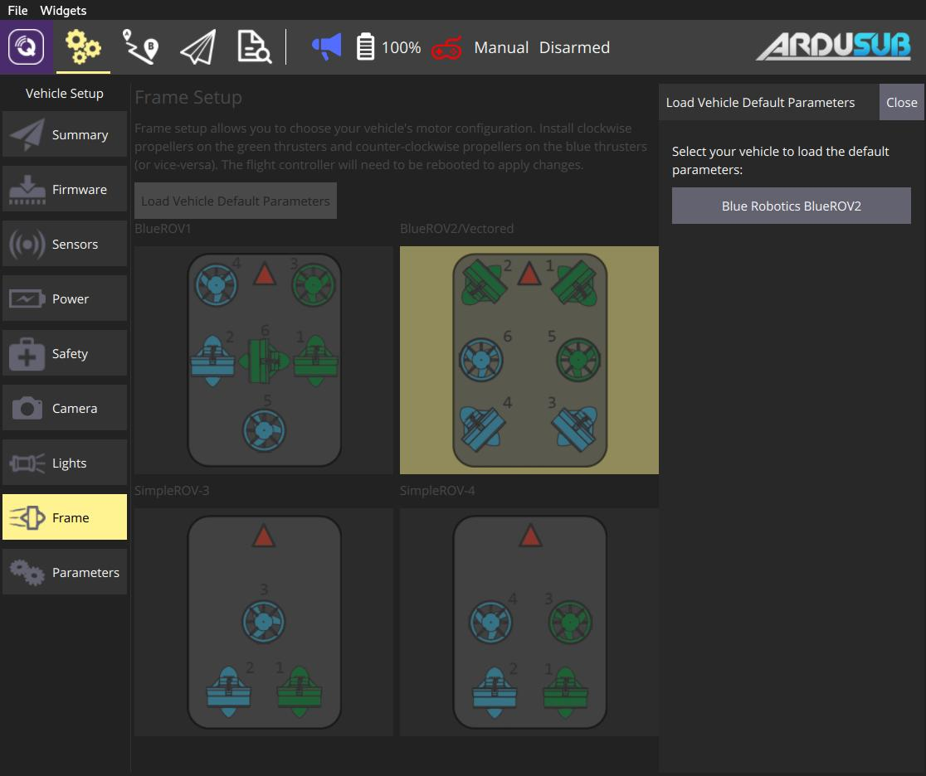

**Airframe Setup (PX4)**

To select the airframe in PX4:

* First select the **Gear** icon (Vehicle Setup) in the top toolbar and then **Airframe** in the sidebar.
* Select the broad vehicle group/type that matches your airframe and then use the dropdown within the group to choose the airframe that best matches your vehicle.
* 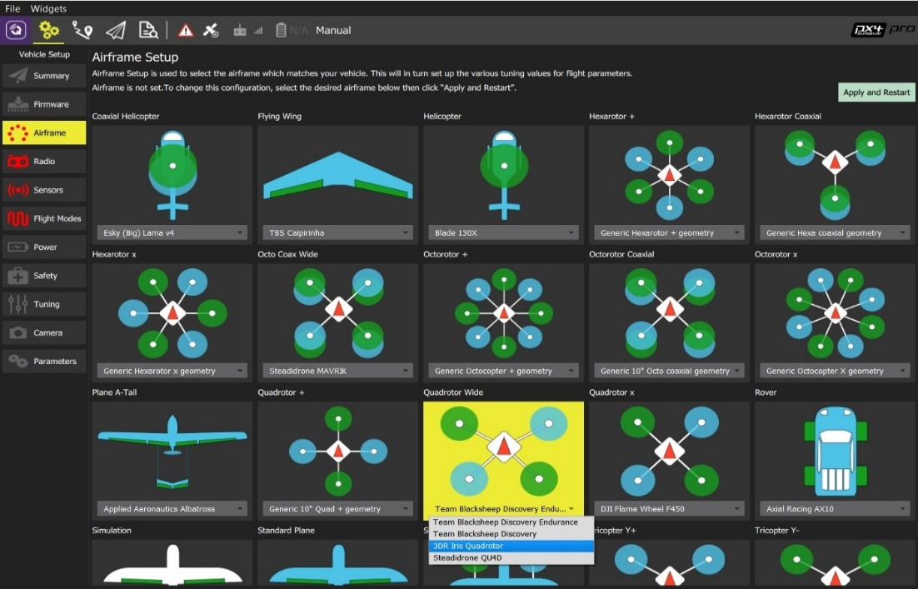
* The example above shows *3DR Iris Quadrotor* selected from the *Quadrotor Wide* group.
* Click the **Apply and Restart** button to the top right of the screen.
* Click **Apply** in the following prompt to save the settings and restart the vehicle.

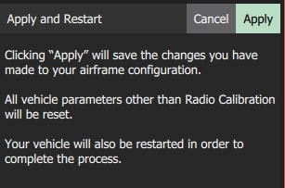

**Radio Setup**

Radio Setup is used to configure the mapping of your main transmitter attitude control sticks (roll, pitch, yaw, throttle) to channels, and to calibrate the minimum, maximum, trim and reverse settings for all other transmitter controls/RC channels.

The main calibration process is identical for PX4 and ArduPilot (a number of additional flight-controller specific settings/tools are [detailed below](https://docs.qgroundcontrol.com/en/SetupView/Radio.html#additional-radio-setup)).

Before you can calibrate the radio system the receiver and transmitter must be connected/bound. The process for binding a transmitter and receiver pair is hardware specific (see your manual for instructions).

## **Performing the Calibration**

The calibration process is straightforward - you will be asked to move the sticks in a specific pattern that is shown on the transmitter diagram on the top right of the screen. Simply follow the instructions to complete calibration.

To calibrate the radio:

* Select the **Gear** icon (Vehicle Setup) in the top toolbar and then **Radio** in the sidebar.
* Turn on your RC transmitter.
* Press **OK** to start the calibration.
* 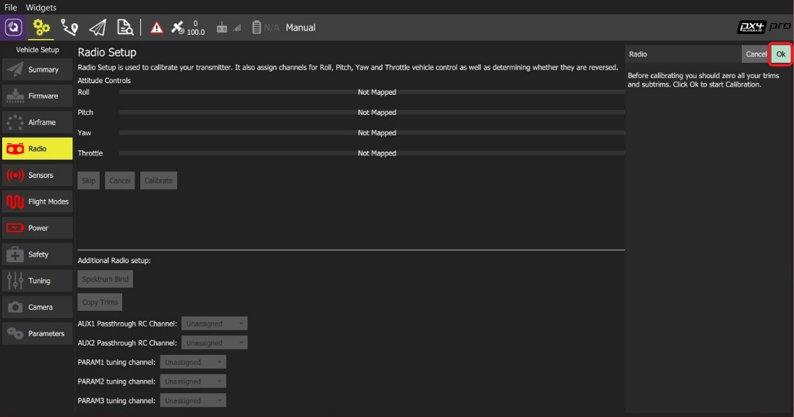
* The image above is for PX4 Pro. Calibration/top section is the same for both firmware, but the *Additional Radio setup* section will differ.
* Set the *transmitter mode* radio button that matches your transmitter configuration (this ensures that *QGroundControl* displays the correct stick positions for you to follow during calibration).
* 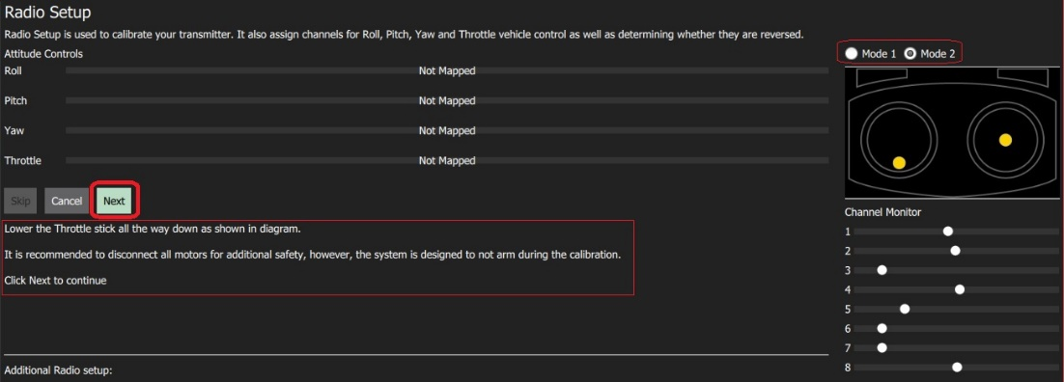
* Move the sticks to the positions indicated in the text (and on the transmitter image). Press **Next** when the sticks are in position. Repeat for all positions.
* When prompted, move all other switches and dials through their full range (you will be able to observe them moving on the *Channel Monitor*).
* Press **Next** to save the settings.

Radio calibration is demonstrated in the [PX4 setup video here](https://youtu.be/91VGmdSlbo4?t=4m30s) (youtube).

## **Additional Radio Setup**

At the lower part of the *Radio Setup* screen is firmware-specific *Additional Radio setup* section. The options for each autopilot are shown below.

|  |  |
| --- | --- |
| **PX4** | **ArduPilot** |
|  |  |

### **Spectrum Bind (ArduPilot/PX4)**

Before you can calibrate the radio system the receiver and transmitter must be connected/bound. If you have a *Spektrum* receiver you can put it in *bind mode* using *QGroundControl* as shown below (this can be particularly useful if you don't have easy physical access to the receiver on your vehicle).

To bind a Spektrum transmitter/receiver:

* Select the **Spektrum Bind** button
* Select the radio button for your receiver
* Press **OK**
* 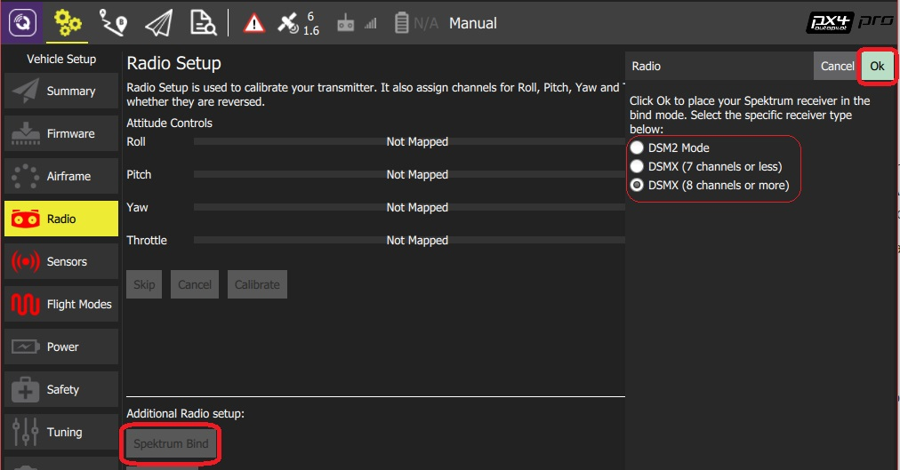
* Power on your Spektrum transmitter while holding down the bind button.

### **Copy Trims (PX4)**

This setting is used to copy the manual trim settings from your radio transmitter so that they can be applied automatically within the autopilot. After this is done you will need to remove the manually set trims.

To copy the trims:

* Select **Copy Trims**.
* Center your sticks and move throttle all the way down.
* Press **Ok**.
* 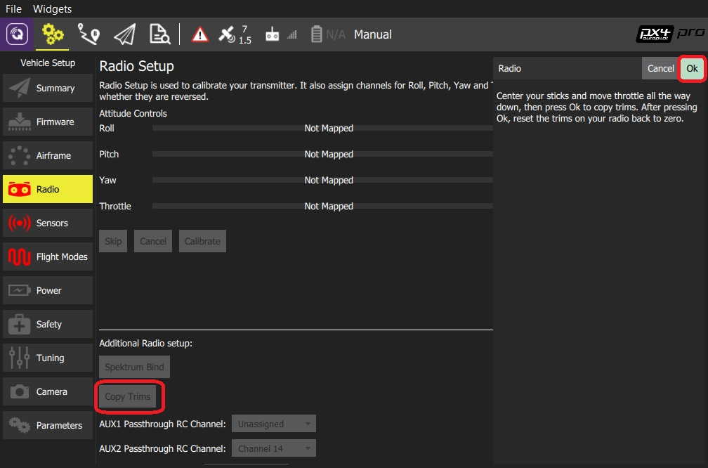
* Reset the trims on your transmitter back to zero.

### **AUX Passthrough Channels (PX4)**

AUX passthrough channels allow you to control arbitrary optional hardware from your transmitter (for example, a gripper).

To use the AUX passthrough channels:

* Map up to 2 transmitter controls to separate channels.
* Specify these channels to map to the AUX1 and AUX2 ports respectively, as shown below. Values are saved to the vehicle as soon as they are set.
* 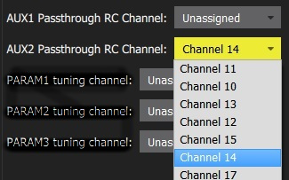

The flight controller will pass through the unmodified values from the specified channels out of AUX1/AUX2 to the connected servos/relays that drive your hardware.

### **Param Tuning Channels (PX4)**

Tuning channels allow you to map a transmitter tuning knob to a parameter (so that you can dynamically modify a parameter from your transmitter).

This feature is provided to enable manual in-flight tuning.

The channels used for parameter tuning are assigned in the *Radio* setup (here!), while the mapping from each tuning channel to its associated parameter is defined in the *Parameter editor*.

To set up tuning channels:

* Map up to 3 transmitter controls (dials or sliders) to separate channels.
* Select the mapping of *PARAM Tuning Id* to radio channels, using the selection lists. Values are saved to the vehicle as soon as they are set.
* 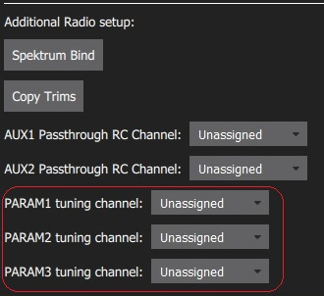

To map a PARAM tuning channel to a parameter:

1. Open the **Parameters** sidebar.
2. Select the parameter to map to your transmitter (this will open the *Parameter Editor*).
3. Check the **Advanced Settings** checkbox.
4. Click the **Set RC to Param...** button (this will pop-up the foreground dialog displayed below)

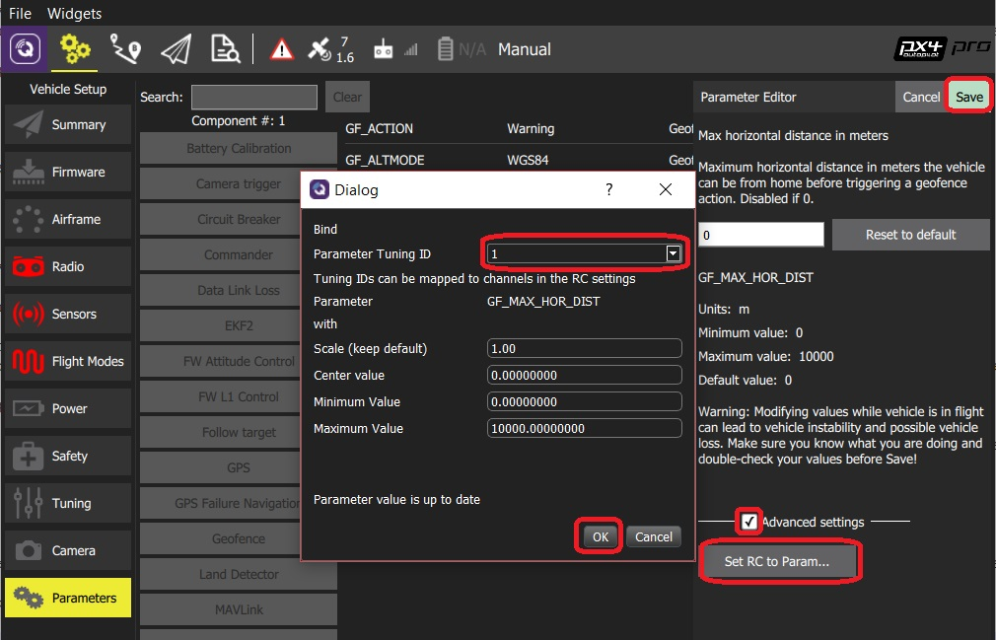

1. Select the tuning channel to map (1, 2 or 3) from the *Parameter Tuning ID* selection list.
2. Press **OK** to close the dialog.
3. Press **Save** to save all changes and close the *Parameter Editor*.

You can clear all parameter/tuning channel mappings by selecting menu **Tools > Clear RC to Param** at the top right of the *Parameters* screen.

# **Sensors**

The *Sensor Setup* section allows you to configure and calibrate the vehicle's compass, gyroscope, accelerometer and any other sensors (the available sensors will depend on the autopilot firmware and vehicle type).

Available sensors are displayed as a list of buttons beside the sidebar. Sensors marked with green are already calibrated, while sensors marked with red require calibration prior to flight. Sensors with no light are simple settings with default values that you may choose not to calibrate.

Click on the button for each sensor to start its calibration sequence.

Flight stack specific instructions are provided in the following topics:

* [Sensors (ArduPilot)](https://docs.qgroundcontrol.com/en/SetupView/sensors_ardupilot.html)
* [Sensors (PX4)](https://docs.qgroundcontrol.com/en/SetupView/sensors_px4.html)

# **Sensor Setup (ArduPilot)**

The *Sensor Setup* section allows you to configure and calibrate the vehicle's compass, gyroscope, accelerometer and any other sensors (the available sensors will depend on the vehicle type).

Available sensors are displayed as a list of buttons beside the sidebar. Sensors marked with green are already calibrated, while sensors marked with red require calibration prior to flight. Sensors with no light are simple settings with default values that you may choose not to calibrate.

Click on the button for each sensor to start its calibration sequence.

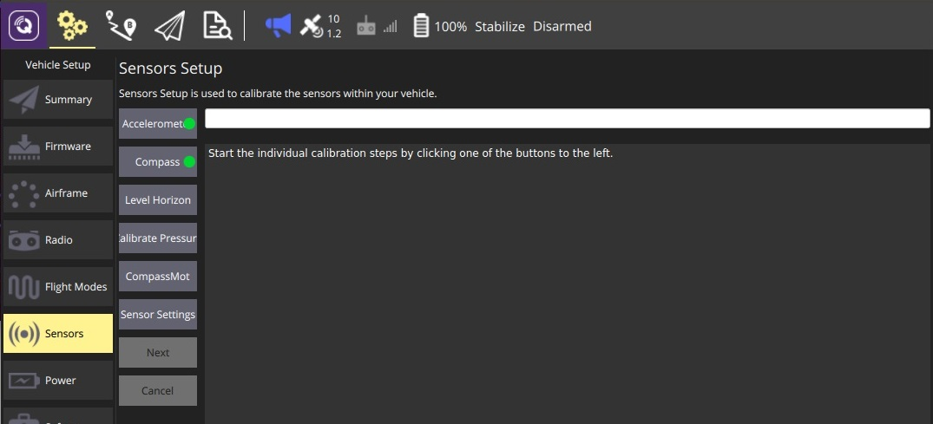

## **Accelerometer**

To calibrate the flight controller accelerometers you will be asked to place and hold your vehicle a number of orientations (you will be prompted when to move between positions).

The calibration steps are:

1. Click the **Accelerometer** sensor button. 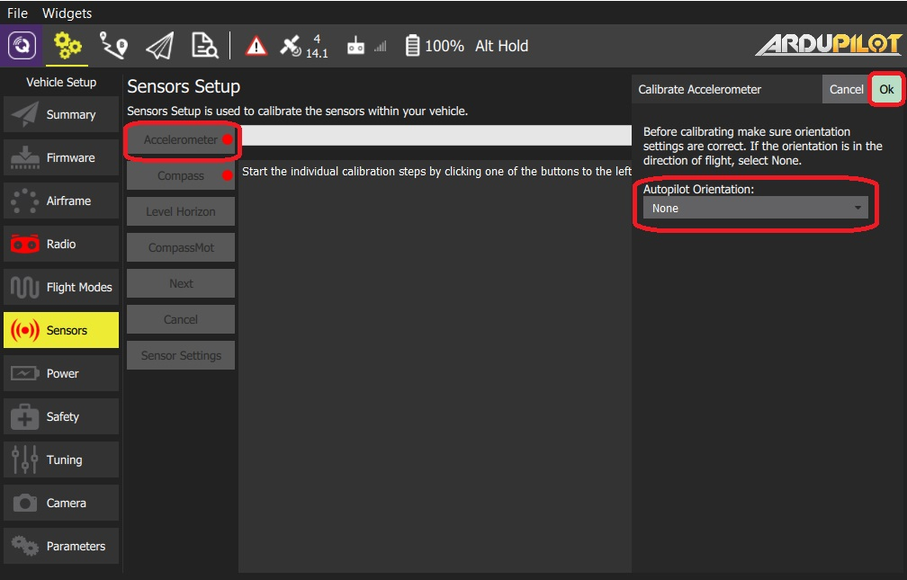
2. You should already have set the [Flight Controller Orientation](https://docs.qgroundcontrol.com/en/SetupView/sensors_ardupilot.html#flight_controller_orientation) above. If not, you can also set it here.
3. Click **OK** to start the calibration.
4. Position the vehicle based on text instructions in the center display. Click the **Next** button to capture each position. 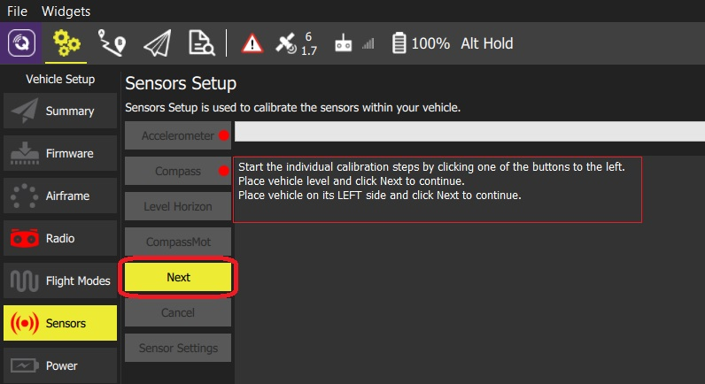

## **Compass**

ArduPilot uses onboard calibration support that allows for more accurate calibration.

Older ArduPilot firmware can be calibrated using the [same process as PX4](https://docs.qgroundcontrol.com/en/SetupView/sensors_px4.html#compass).

You need to rotate the vehicle randomly around all axes until the progress bar fills all the way to the right and the calibration completes. When the calibration completes you will get the following results:

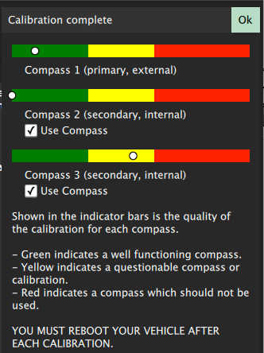

This shows you the quality of the calibration for each compass. Using these values you can determine whether you may want to turn off usage of poorly performing compasses.

## **Level Horizon**

If the horizon (as shown in the HUD) is not level after completing accelerometer calibration you can calibrate the level horizon for your vehicle. You will be asked to place the vehicle in a level orientation while it captures the information.

1. Click the **Level Horizon** sensor button. 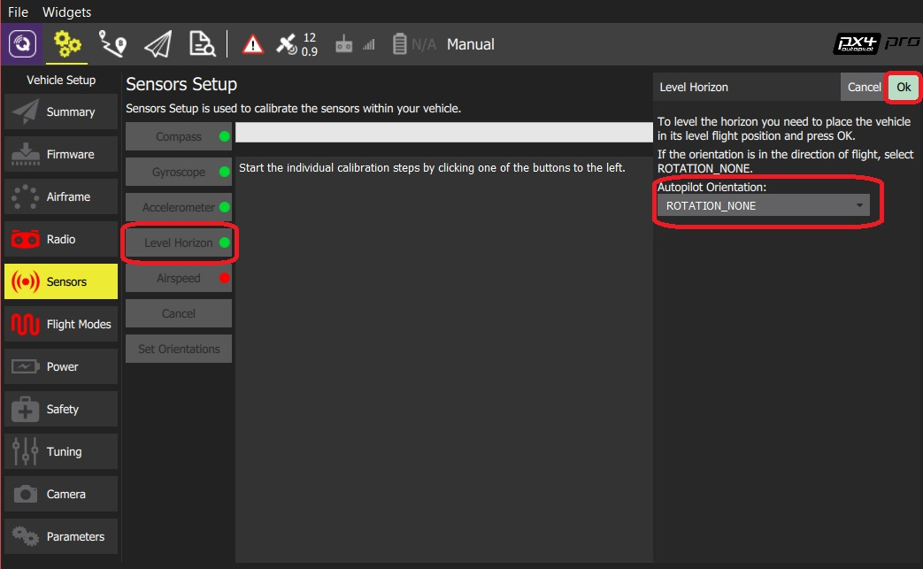

You should already have set the [Flight Controller Orientation](https://docs.qgroundcontrol.com/en/SetupView/sensors_ardupilot.html#flight_controller_orientation) above. If not, you can also set it here.

1. Place the vehicle in its level flight orientation on a level surface:
   * For planes this is the position during level flight (planes tend to have their wings slightly pitched up!)
   * For copters this is the hover position.
2. Click **OK** to start the calibration.

## **Pressure/Barometer**

This calibration set's the altitude to zero at the current pressure.

To perform **Pressure** calibration:

1. Click the **Calibrate Pressure** button and then **Ok**.

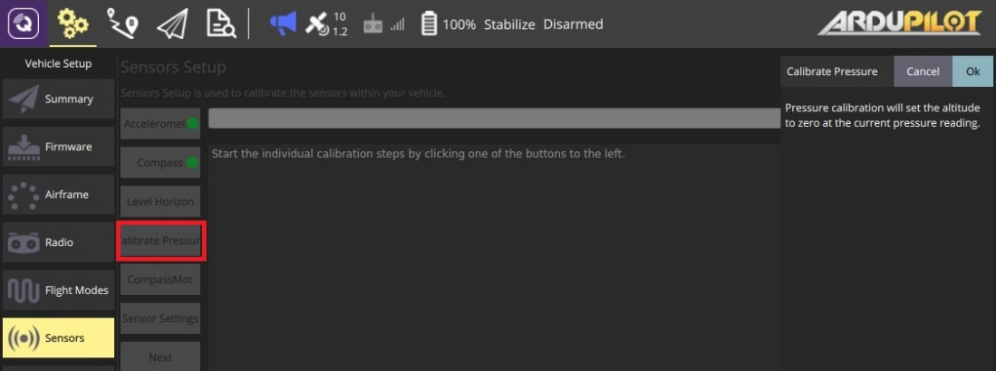

The calibration result is immediately displayed:

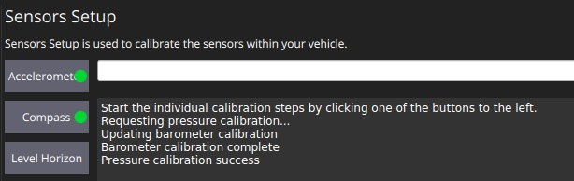

## **CompassMot (Optional)**

CompassMot calibration is optional! It is recommended for vehicles that only have an internal compass and where there is significant interference on the compass from the motors, power wires, etc. CompassMot only works well if you have a battery current monitor because the magnetic interference is linear with current drawn.

To perform **CompassMot** calibration:

* + 1. Click the **CompassMot** sensor button.

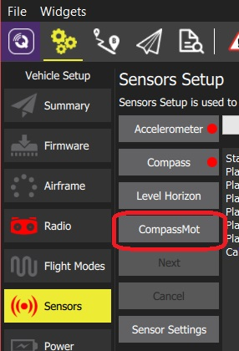

* + - 1. Follow the onscreen prompts.

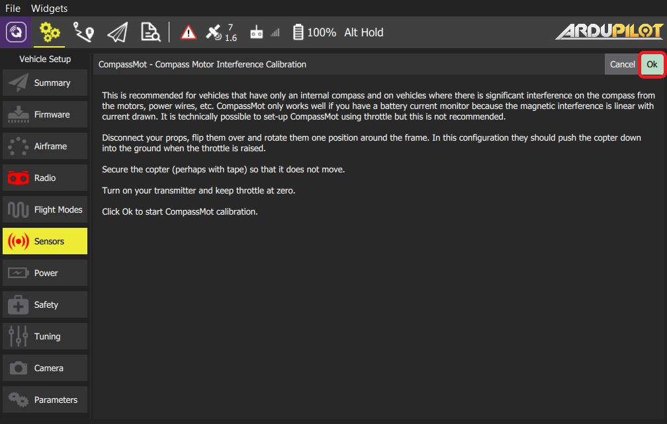

## **Sensor Settings**

The *Sensor Settings* section allows you to specify the compass orientation and which compasses are enabled.

You can skip this section if the flight controller and compass are mounted upright on the vehicle and facing the front (this is the default orientation - ROTATION_NONE).

If the autopilot/compass are mounted in any other way you will need to specify their orientations as YAW, PITCH and/or ROLL offsets relative to the forward-facing-upright orientation (clock-wise rotation around the Z, Y and X axis, respectively).

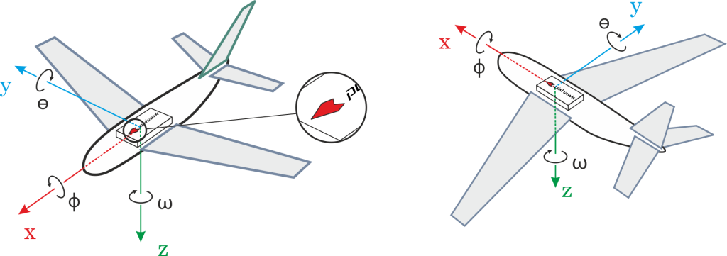

For example, the image below are at orientations: ROTATION_NONE, ROTATION_YAW_90,ROTATION_YAW_180,ROTATION_YAW_270.

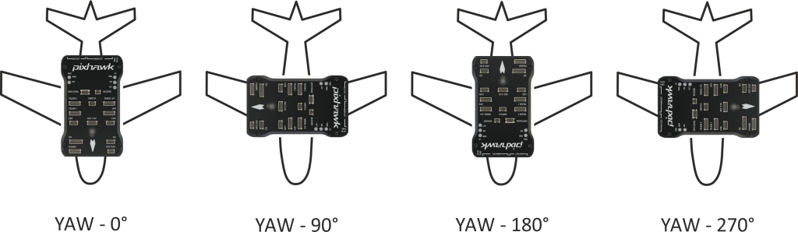

To set the orientation(s) and compasses used:

1. Select the **Sensor Settings** button.

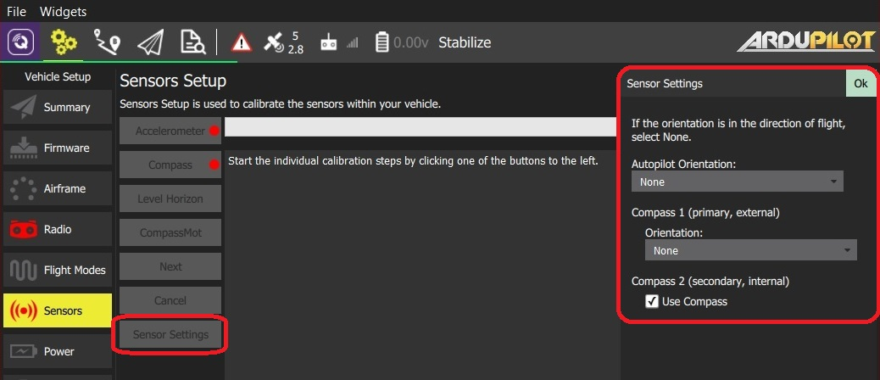

1. Select the **AutoPilot Orientation**.
2. Select the *orientation* from **Compass 1 (primary/external) > Orientation** (or check **Compass2 (secondary, external) > Use Compass** to instead use the internal compass).
3. Press **OK**.

# **Sensor Setup (PX4)**

The *Sensor Setup* section allows you to configure and calibrate the vehicle's compass, gyroscope, accelerometer and any other sensors (the available sensors will depend on the vehicle type).

Available sensors are displayed as a list of buttons beside the sidebar. Sensors marked with green are already calibrated, while sensors marked with red require calibration prior to flight. Sensors with no light are simple settings with default values that you may choose not to calibrate.

Click on the button for each sensor to start its calibration sequence.

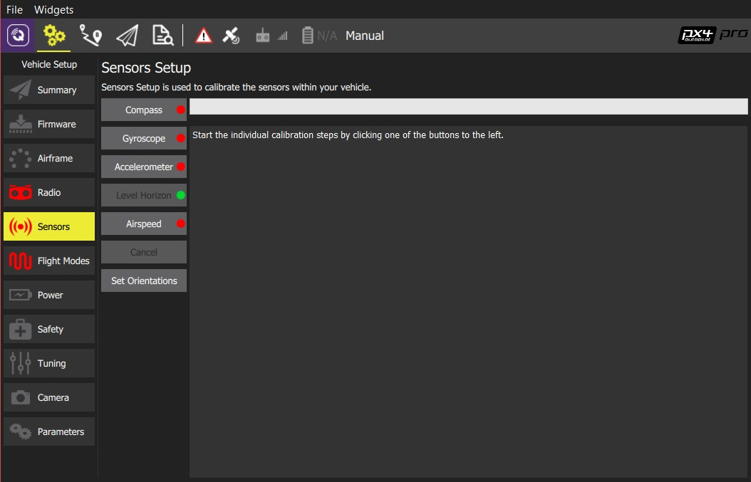

The image shown is from a VTOL vehicle running PX4 firmware. Other autopilot firmware and vehicles will offer slightly different options.

## **Compass**

The process guides you to position the vehicle in a number of set orientations and rotate the vehicle about the specified axis.

The calibration steps are:

1. Click the **Compass** sensor button 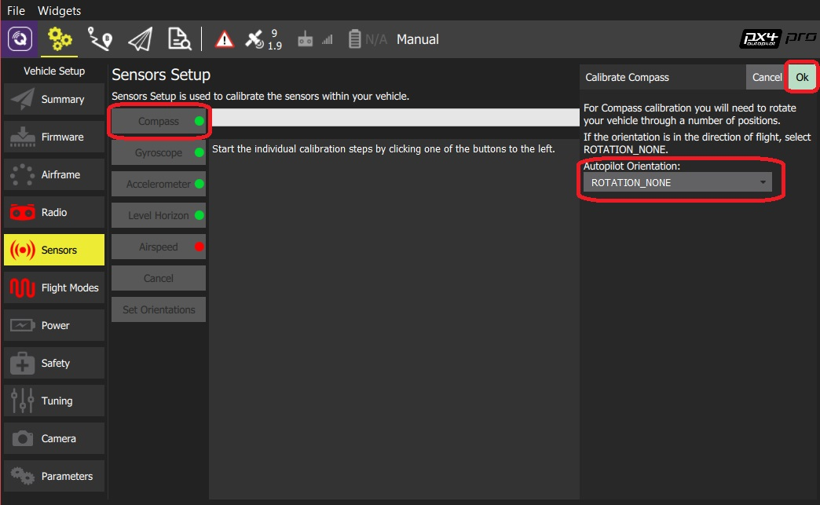

The default flight controller orientation is ROTATION_NONE (flight controller and compass mounted upright on the vehicle and facing the front). You can set a different value here or in [Set Orientations](https://docs.qgroundcontrol.com/en/SetupView/sensors_px4.html#flight_controller_orientation).

1. Click **OK** to start the calibration.
2. Place the vehicle in any of the orientations shown in red (incomplete) and hold it still. Once prompted (the orientation-image turns yellow) rotate the vehicle around the specified axis in either/both directions. Once the calibration is complete in that orientation the associated image on the screen will turn green. 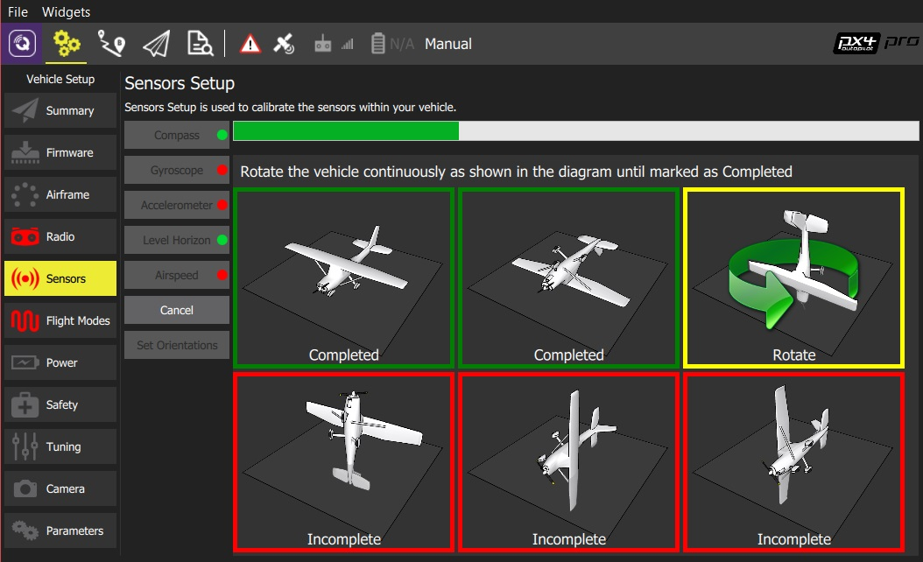
3. Repeat the calibration process for all vehicle orientations.

Once you've rotated the vehicle in all the positions *QGroundControl* will display *Calibration complete* (all orientation images will be displayed in green and the progress bar will fill completely) You can then proceed to the next sensor.

## **Gyroscope**

You will be guided to place the vehicle on a flat surface and keep it still.

The calibration steps are:

1. Click the **Gyroscope** sensor button 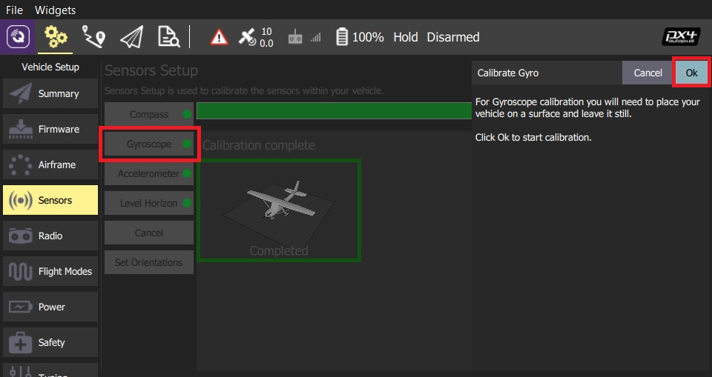
2. Place the vehicle on a surface and leave it still.
3. Click **Ok** to start the calibration.

The bar at the top shows the progress:

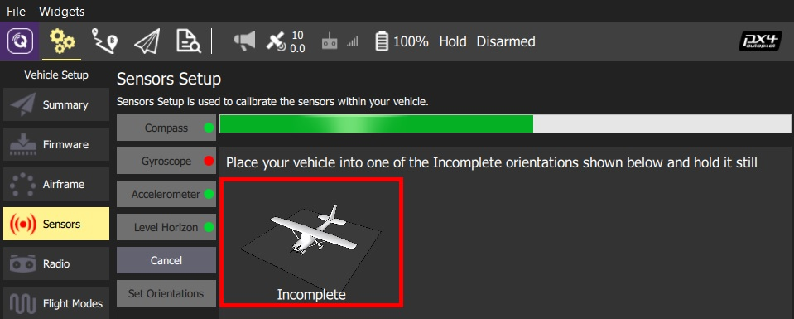

1. When finished, *QGroundControl* will display a progress bar *Calibration complete* 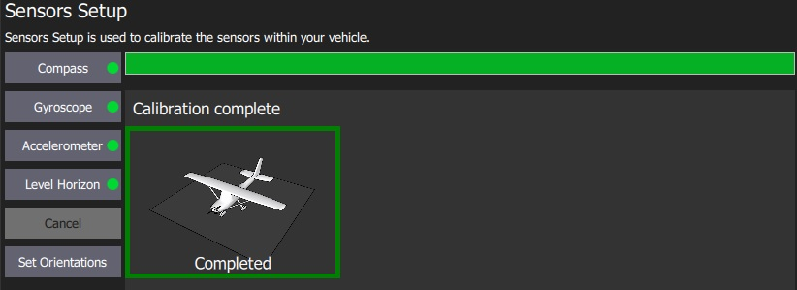

If you move the vehicle *QGroundControl* will automatically restart the calibration.

You can then proceed to the next sensor.

## **Accelerometer**

To calibrate the flight controller accelerometers you will be asked to place and hold your vehicle a number of orientations (you will be prompted when to move between positions).

The calibration steps are:

1. Click the **Accelerometer** sensor button. 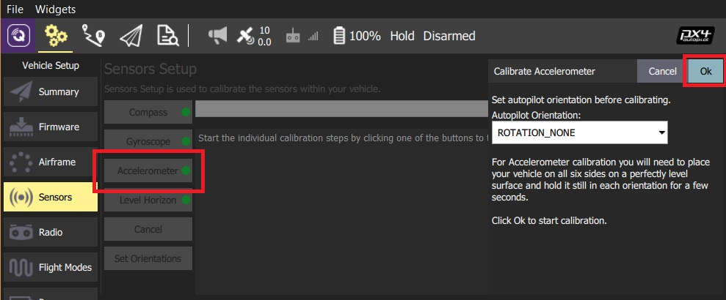

You should already have set the [Flight Controller Orientation](https://docs.qgroundcontrol.com/en/SetupView/sensors_px4.html#flight_controller_orientation) above. If not, you can also set it here.

1. Click **OK** to start the calibration.
2. Position the vehicle as guided by the *images* on the screen. This is very similar to compass calibration. 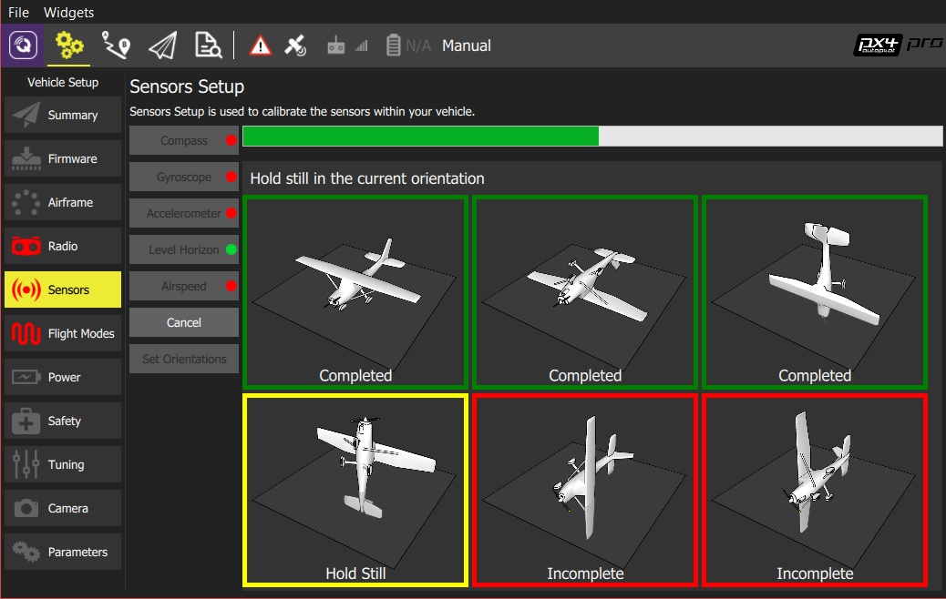
3. Repeat the calibration process for all vehicle orientations.

Once you've rotated the vehicle in all the positions *QGroundControl* will display *Calibration complete*.

You can then proceed to the next sensor.

## **Level Horizon**

If the horizon (as shown in the HUD) is not level after completing accelerometer calibration you can calibrate the level horizon for your vehicle. You will be asked to place the vehicle in a level orientation while it captures the information.

1. Click the **Level Horizon** sensor button. 

You should already have set the [Flight Controller Orientation](https://docs.qgroundcontrol.com/en/SetupView/sensors_px4.html#flight_controller_orientation) above. If not, you can also set it here.

1. Place the vehicle in its level flight orientation on a level surface:
   * For planes this is the position during level flight (planes tend to have their wings slightly pitched up!)
   * For copters this is the hover position.
2. Click **OK** to start the calibration.

## **Airspeed**

The airspeed calibration needs to read a stable baseline with 0 airspeed in order to determine an offset. Cup your hands over the pitot to block any wind (if calibrating the sensor indoors this is not needed) and then blow into the tube using your mouth (to signal completion of the calibration).

To calibrate the airspeed sensor:

1. Click the **Airspeed** sensor button

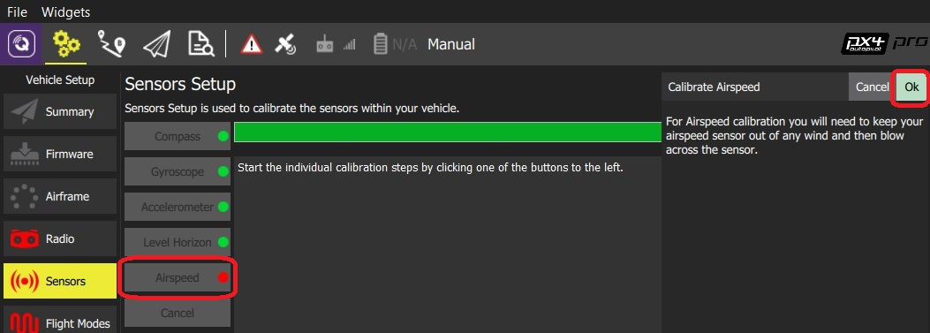

1. Cover the sensor (i.e. with your hand)

Do not touch the sensor (obstruct any holes) during calibration.

1. Click **OK** to start the calibration.
2. Blow into the sensor.
3. Wait for 2-3 seconds before removing the covering (calibration completes silently after several seconds)

## **Set Orientations**

You can skip this section if the flight controller and compass are mounted upright on the vehicle and facing the front (this is the default orientation - ROTATION_NONE).

If the autopilot/compass are mounted in any other way you will need to specify their orientations as YAW, PITCH and/or ROLL offsets relative to the forward-facing-upright orientation (clock-wise rotation around the Z, Y and X axis, respectively).



For example, the image below are at orientations: ROTATION_NONE, ROTATION_YAW_90,ROTATION_YAW_180,ROTATION_YAW_270.



To set the orientation(s) on PX4:

1. Select the **Set Orientations** button.

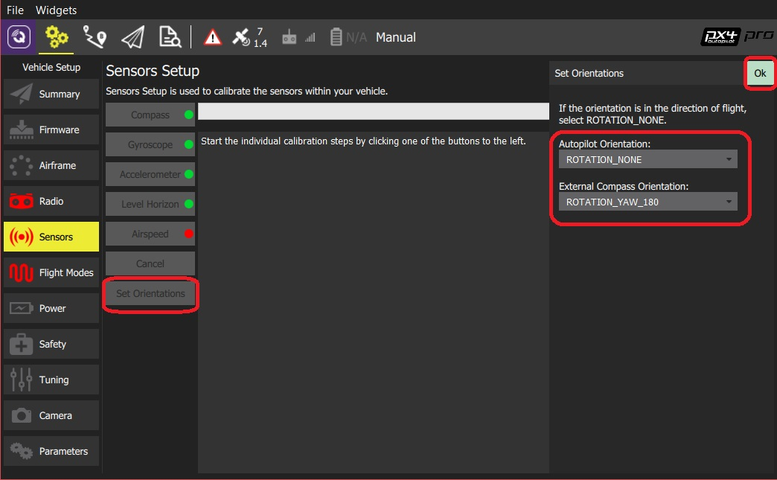

1. Select the **AutoPilot Orientation**.
2. Select the **External Compass Orientation** (this option will only be displayed if there is an external compass).
3. Press **OK**.

# Flight Modes Setup

The *Flight Modes* section allows you to map flight modes to radio channel(s), and hence to the switches on your radio control transmitter. Both flight mode setup and the available flight modes are different in PX4 and ArduPilot (and there are some differences between ArduCopter and ArduPlane).

To access this section, select the **Gear** icon (Vehicle Setup) in the top toolbar and then **Flight Modes** in the sidebar.

You must already have [configured your radio](https://word-edit.officeapps.live.com/we/Radio.html) in order to set flight modes.

Flight modes provide different levels of *autopilot-assisted flight*, and *fully autonomous flight* via missions or offboard (API-based) control. Different flight modes allow new users to learn flying with a more forgiving platform than provided by basic RC control alone. They also enable automation of common tasks like taking off, landing and returning to the original launch position.

For more information about the flight modes on each platform see:

* [PX4 Flight Modes](https://docs.px4.io/en/flight_modes/)
* [ArduCopter Flight Modes](http://ardupilot.org/copter/docs/flight-modes.html)
* [ArduPlane Flight Modes](http://ardupilot.org/plane/docs/flight-modes.html)

## ArduPilot Flight Mode Setup

On ArduPilot you can assign up to 6 different flight modes to a single channel of your transmitter (the channel is selectable on Plane, but fixed to channel 5 on Copter).

ArduCopter (only) also allows you to specify additional *Channel Options* for channels 7-12. These allow you to assign functions to these switches (for example, to turn on a camera, or return to launch). There is additional information about channel configuration in the ArduCopter docs: [Auxiliary Function Switches](

To set the flight modes:

1. Turn on your RC transmitter.
2. Select the **Gear** icon (Vehicle Setup) in the top toolbar and then **Flight Modes** in the sidebar.

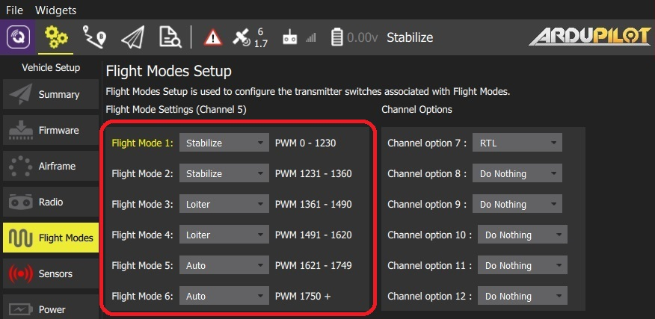The above image is a screenshot of the flight mode setup for ArduCopter.

1. Select up to 6 flight modes in the drop downs.
2. **ArduCopter only:** Select additional *Channel Options* for channels 7-12.
3. **ArduPlane only:** Select the mode channel from the dropdown.

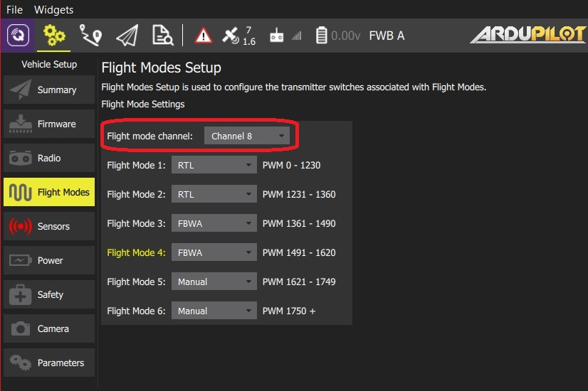

1. Test that the modes are mapped to the right transmitter switches by selecting each mode switch on your transmitter in turn, and check that the desired flight mode is activated (the text turns yellow on *QGroundControl* for the active mode).

All values are automatically saved as they are changed.

The ArduCopter screenshot above shows a typical setup for a three position flight mode switch with an additional option of RTL being on a channel 7 switch. You can also setup 6 flight modes using two switches plus mixing on your transmitter. Scroll down to the center section of this [page](http://ardupilot.org/copter/docs/common-rc-transmitter-flight-mode-configuration.html#common-rc-transmitter-flight-mode-configuration) for tutorials on how to do that.

## PX4 Pro Flight Mode Setup

*PX4* (*QGroundControl*) supports two modes for mapping flight modes to transmitter switches/dials:

* **Single Channel Mode Selection:** Assign up to 6 flight modes to switch positions encoded in a single channel.
* **Multi Channel Mode Selection:** Assign modes to switch positions encoded in one or more channels. Some modes are hard coded to share channels, or are defined/set automatically based on other mode selections (the behaviour of multi-channel mode selection can sometimes be confusing).

The recommended approach is use *Single Channel Mode Selection* because it easy to understand and configure. It is similar to the approach used by ArduPilot.

### Single-Channel Mode

The single-channel selection mode allows you to specify a "mode" channel and select up to 6 flight modes that will be activated based on the PWM value of the channel. You can also separately specify channels for mapping a kill switch, return to launch mode, and offboard mode.

In order to use approach you will first need to configure your *transmitter* to encode the physical positions of your mode switch(es) into a single channel. There is a video guide of how this is done for the popular *Taranis* transmitter [below](https://word-edit.officeapps.live.com/we/wordeditorframe.aspx?ui=ko-KR&rs=ko-KR&hid=2mWOPQhL50mMEjYL5cj+yw.0&WOPISrc=https%3A%2F%2Fwopi.onedrive.com%2Fwopi%2Ffiles%2FD12DB2555512DF7%213518&wdnd=1&wdPreviousSession=0e43a0ac-2186-4d7b-a50e-5c8de0ff7e7d&wdNewAndOpenCt=1555562078658&wdo=4&wdOrigin=wacFileNew&wdPreviousCorrelation=09861a00-356b-4040-8a89-e153d9da8134&wde=docx&sc=host%3D%26qt%3DFolders&mscc=1&wdp=0#taranis_setup) (check your documentation if you use a different transmitter).

To configure single-channel flight mode selection:

1. Turn on your RC transmitter.
2. Select the **Gear** icon (Vehicle Setup) in the top toolbar and then **Flight Modes** in the sidebar.

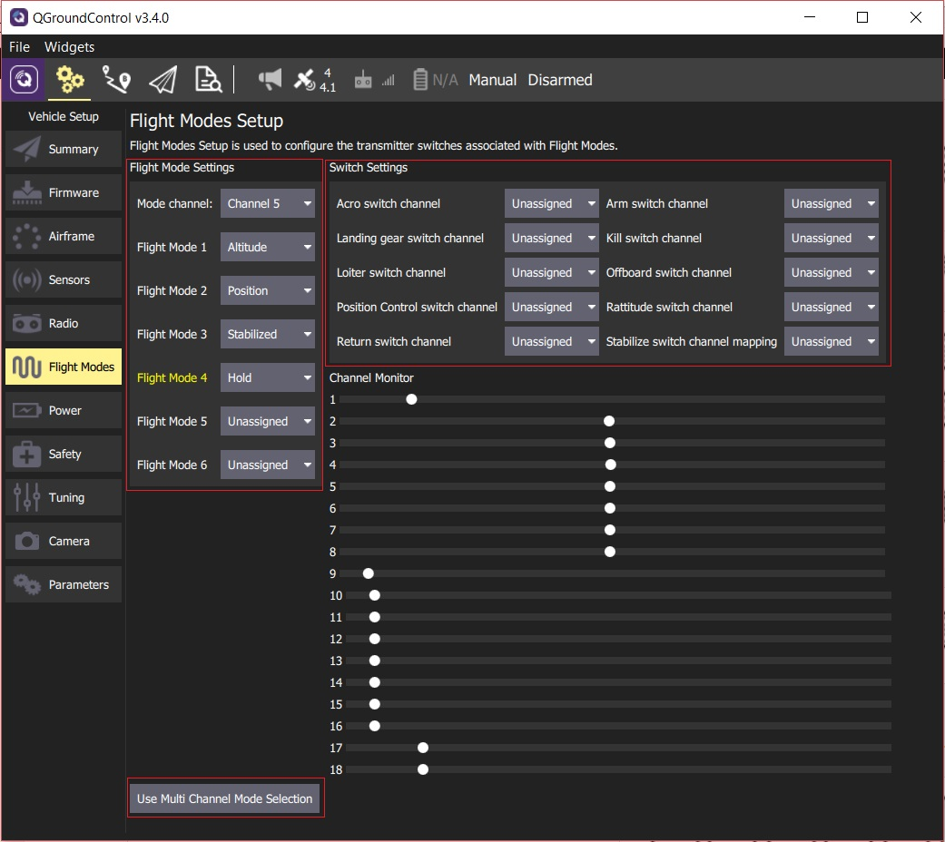

If the screen opens in *Multi Channel Mode* click the **Use Single Channel Mode Selection** button to change screen.

1. Specify *Flight Mode Settings*:
   * Select the **Mode channel** (above this shown as Channel 5, but this will depend on your transmitter configuration).
   * Select up to six **Flight Modes**.
2. Specify *Switch Settings*:
   * Select the channels that you want to map to specific actions - e.g. *Return* mode, *Kill switch*, *offboard* mode, etc. (if you have spare switches and channels on your transmitter).
3. Test that the modes are mapped to the right transmitter switches:
   * Check the *Channel Monitor* to confirm that the expected channel is changed by each switch.
   * Select each mode switch on your transmitter in turn, and check that the desired flight mode is activated (the text turns yellow on *QGroundControl* for the active mode).

All values are automatically saved as they are changed.

#### Video Example (including Transmitter Setup)

It is common to use the positions of a 2- and a 3-position switch on the transmitter to represent the 6 flight modes, and encode each combination of switches as a particular PWM value for the mode that will be sent on a single channel.

The video below shows how this is done with the *FrSky Taranis* transmitter (a very popular and highly recommended RC transmitter). The process involves assigning a "logical switch" to each combination of positions of the two real switches. Each logical switch is then assigned to a different PWM value on the same channel.

The video then shows how to use *QGroundControl* to specify the mode channel and map modes to each of the 6 "slots".

<https://youtu.be/scqO7vbH2jo>

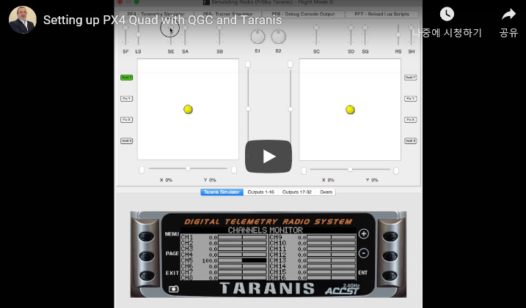

### Multi-Channel Mode

We recommend you use [Single Channel Flight Mode](https://word-edit.officeapps.live.com/we/wordeditorframe.aspx?ui=ko-KR&rs=ko-KR&hid=2mWOPQhL50mMEjYL5cj+yw.0&WOPISrc=https%3A%2F%2Fwopi.onedrive.com%2Fwopi%2Ffiles%2FD12DB2555512DF7%213518&wdnd=1&wdPreviousSession=0e43a0ac-2186-4d7b-a50e-5c8de0ff7e7d&wdNewAndOpenCt=1555562078658&wdo=4&wdOrigin=wacFileNew&wdPreviousCorrelation=09861a00-356b-4040-8a89-e153d9da8134&wde=docx&sc=host%3D%26qt%3DFolders&mscc=1&wdp=0#single_channel) selection because the Multi Channel selection user interface can be confusing. If you do choose to use this method, then the best approach is to start assigning channels and take note of information displayed by *QGroundControl* following your selection.

The multi-channel selection UI allows you to map one or more modes to one or more channels. There are some modes (and hence switches) that must always be defined, and the channel to which they must be allocated

To configure flight modes using the multi-channel UI:

1. Turn on your RC transmitter.
2. Select the **Gear** icon (Vehicle Setup) in the top toolbar and then **Flight Modes** in the sidebar.

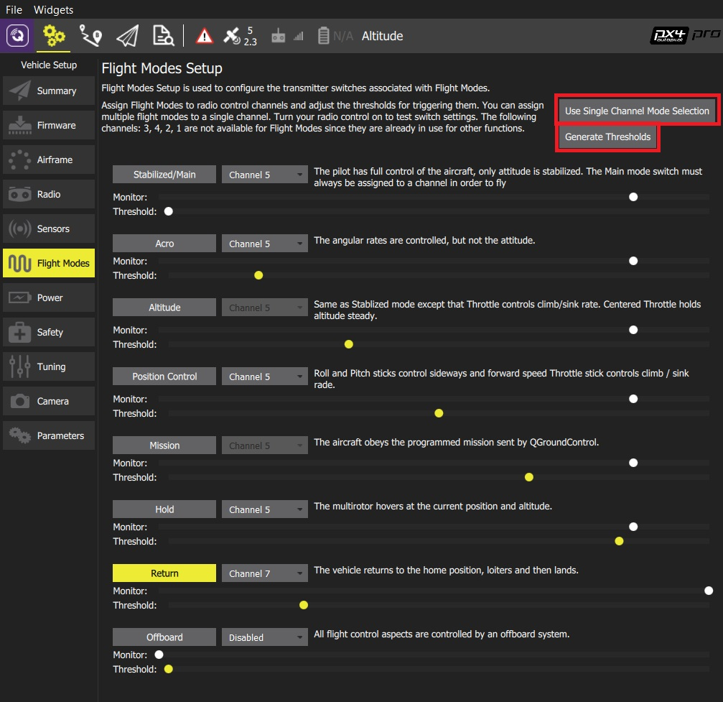

If the screen opens in *Single Channel Mode* click the **Use Multi Channel Mode Selection** button to change screen.

1. Select the modes you want to assign to your switches and select the associated channel (selected modes will *move* in the UI to be grouped by channel). There are a number of complications on the mode to channel assignments:
   * Some modes will have a grayed out channel selector because they cannot be disabled and you cannot directly set the value. For example:
     + *Mission* mode - Has the same channel number as *Hold* (if it is defined), or otherwise the same channel as *Stabilized/Main* mode.
     + *Altitude* mode - Has the same channel number as *Position Control* (if it is defined), or otherwise the same channel as *Stabilized/Main* mode.
   * *Assist* mode - This mode is added to the same channel as *Stabilized/Main* mode if (and only if) *Position Control* is enabled and defined on a different channel than *Stabilized/Main*.
2. Click the **Generate Thresholds** button.
   * This will automatically create threshold values for all modes, spread evenly across each channel for its assigned modes. For example, in the mode assignment shown above, most modes are assigned to mode 5, and you can see that the channel thresholds for each mode are spread evenly across the channel.

This mode is demonstrated in the [PX4 setup video @6m53s](https://youtu.be/91VGmdSlbo4?t=6m53s) (youtube).

This flight mode selection mechanism is relatively complicated due to the way that PX4 works out which mode should be selected. You may be able to gain some insight from this [flow chart](https://dev.px4.io/en/concept/flight_modes.html#flight-mode-evaluation-diagram) (PX4 Developer Guide).

# **Power Setup**

The *Power Setup* screen is used to configure battery parameters and also provide advanced settings for propellers.

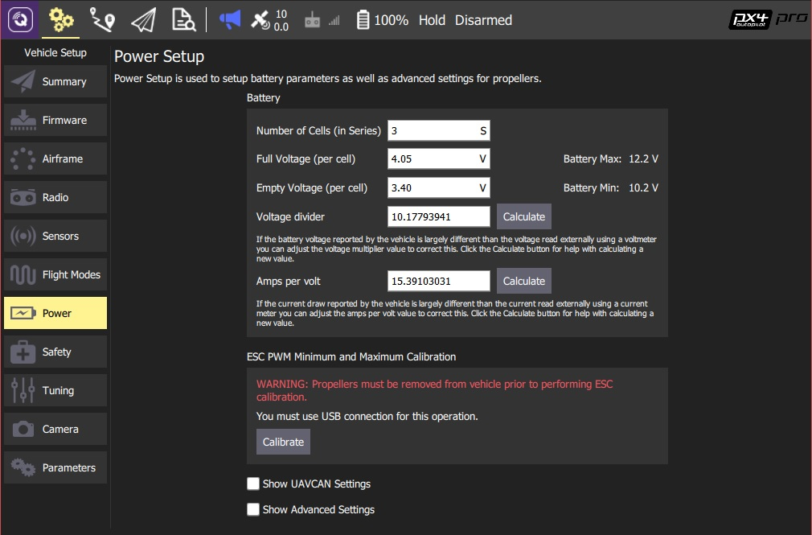

## **Battery Voltage/Current Calibration**

Enter data for your battery/power module from its data sheet: number of cells, full voltage per cell, empty voltage per cell. If provided, also enter voltage divider and amps-per-volt information.

*QGroundControl* can be used to calculate appropriate voltage divider and amps-per-volt values from measurements:

1. Measure the voltage from the battery using a multimeter.
2. Click **Calculate** next to the *Voltage divider* field. On the prompt that appears:
   1. Enter the measured voltage.
   2. Click **Calculate** to generate a new voltage-divider value.
   3. Click **Close** to save the value into the main form.
3. Measure the current from the battery.
4. Click **Calculate** next to the *Amps per volt* field. On the prompt that appears:
   1. Enter the measured current.
   2. Click **Calculate** to generate a new *amps per volt* value.
   3. Click **Close** to save the value into the main form.

## **Advanced Power Settings**

Click the **Show Advanced Settings** checkbox to specify advanced power settings.

### **Voltage Drop on Full Load**

Batteries show less voltage at high throttle. Enter the difference in Volts between idle throttle and full throttle, divided by the number of battery cells. The default value should be used if unsure!

If the value is too high the battery may be deep-discharged and damaged.

## **ESC PWM Minimum and Maximum Calibration**

To calibrate the ESC max/min PWM values:

1. Remove the propellers.
2. Connect the vehicle to QGC via USB (only).
3. Click the **Calibrate** button.

Never attempt ESC calibration with props on.

Motors should not spin during ESC calibration. However if an ESC doesn't properly support/detect the calibration sequence then it will respond to the PWM input by running the motor at maximum speed.

## **Other Settings**

Select the **Show UAVCAN Settings** checkbox to access additional settings for UAVCAN Bus Configuration and motor index and direction assignment.

# **Motors Setup**

This section is used to setup and test individual motors.

Currently only supported for [**ArduSub**](https://www.ardusub.com/).

## **ArduSub**

The ArduSub motor setup allows you to test individual motors. The sliders allow spinning each motor in forward or reverse mode, and the checkboxes under the sliders allow reversing the operation of individual thrusters.

The image at the right shows the frame currently in use, along with the location and orientation of each thruster. If the frame selection does not match your vehicle, first select the correct frame in the [Frame](https://docs.qgroundcontrol.com/en/SetupView/airframe_ardupilot.html#ardusub) tab.

To set up and test the motors, read and follow the instructions on the page.

Make sure the motors and propellers are clear from obstructions before sliding the switch to arm the vehicle and enable the test!

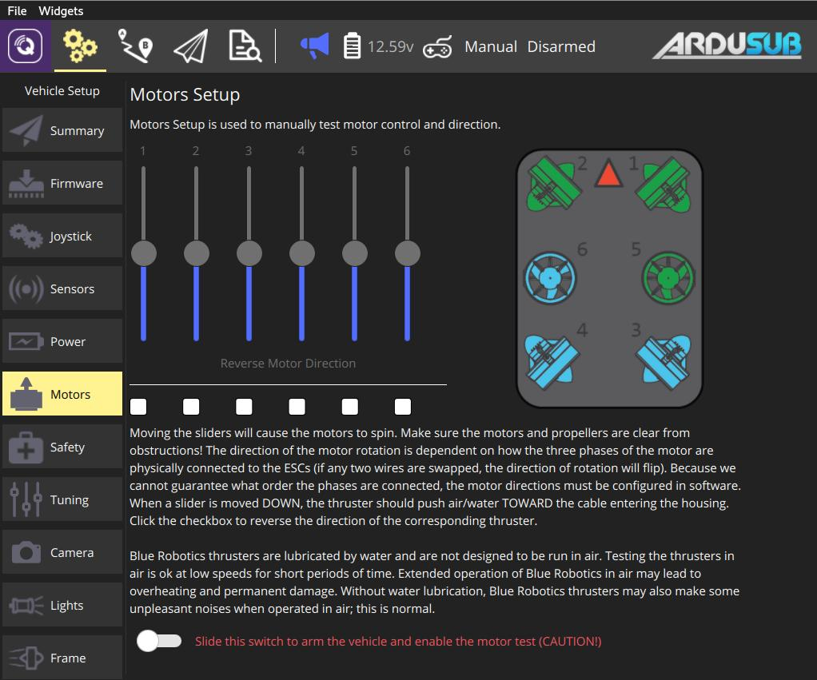

**Safety Setup**

The *Safety Setup* page allows you to configure the most important failsafe settings (other failsafe settings can be set via the [parameters](https://docs.qgroundcontrol.com/en/SetupView/Parameters.html) described in the failsafe documentation for each vehicle type).

For ArduPilot safety page information see: [Safety (ArduPilot)](https://docs.qgroundcontrol.com/en/SetupView/safety_ardupilot.html)

The PX4 page is shown below.

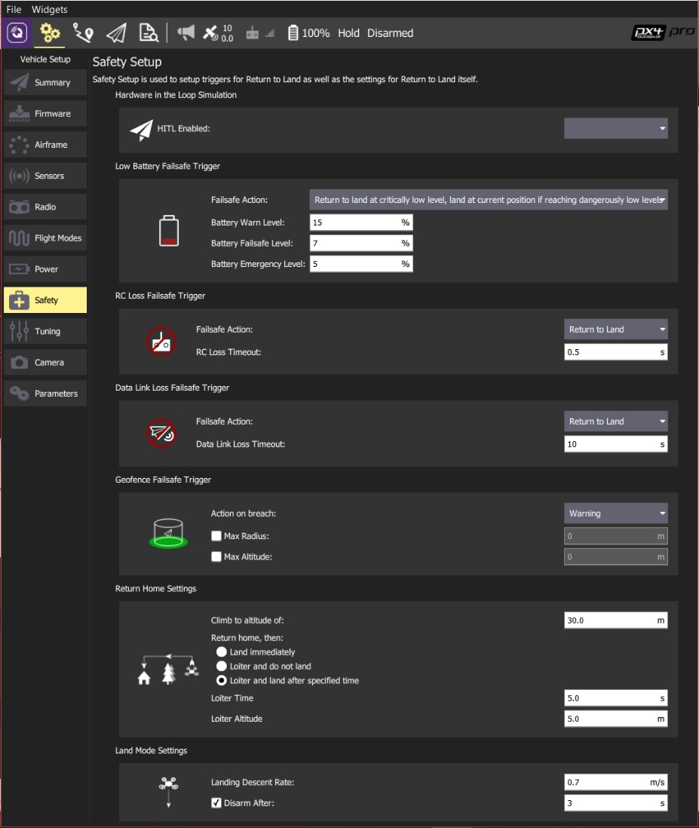

For additional PX4 safety settings and information see: [Safety Configuration](https://docs.px4.io/en/config/safety.html).

# Safety Setup (ArduPilot)

The *Safety Setup* page allows you to configure (vehicle specific) failsafe settings.

The setup page covers the most important safety options; other failsafe settings can be set via the [parameters](https://word-edit.officeapps.live.com/we/Parameters.html) described in the failsafe documentation for each vehicle type.

*QGroundControl* does not support polygon fences or rally points on ArduPilot.

## Copter

The Copter safety page is shown below.

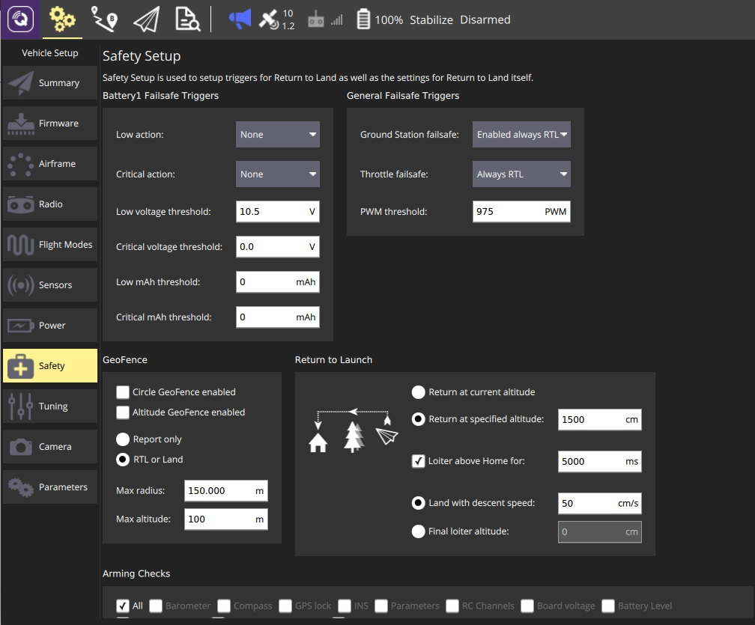

For additional safety settings and information see: [Failsafe](http://ardupilot.org/copter/docs/failsafe-landing-page.html)

### Battery Failsafe

This panel sets the [Battery Failsafe](http://ardupilot.org/copter/docs/failsafe-battery.html) parameters. You can set low and critical thresholds for voltage and/or remaining capacity and define the action if the failsafe value is breached. The thresholds can be disabled by setting them to zero.

If there is a second battery (enabled in the [Power Setup](https://word-edit.officeapps.live.com/we/Power.html)) a second panel will be displayed with the same settings.

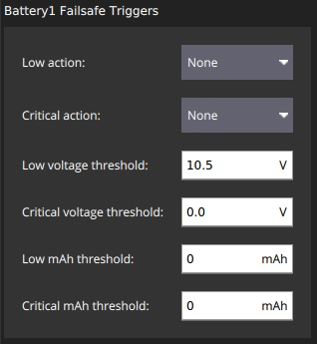

The configuration options are:

* **Low action** ([BATT_FS_LOW_ACT](http://ardupilot.org/copter/docs/parameters.html#batt-fs-low-act-low-battery-failsafe-action)) - Select one of: None, Land, RTL, SmartRTL, SmartRTL or Land, Terminate.
* **Critical action** ([BATT_FS_CRT_ACT](http://ardupilot.org/copter/docs/parameters.html#batt-fs-crt-act-critical-battery-failsafe-action)) - Select one of: None, Land, RTL, SmartRTL, SmartRTL or Land, Terminate.
* **Low voltage threshold** ([BATT_LOW_VOLT](http://ardupilot.org/copter/docs/parameters.html#batt-low-volt-low-battery-voltage)) - Battery voltage that triggers the *low action*.
* **Critical voltage threshold** ([BATT_CRT_VOLT](http://ardupilot.org/copter/docs/parameters.html#batt-crt-volt-critical-battery-voltage))- Battery voltage that triggers the *critical action*.
* **Low mAh threshold** ([BATT_LOW_MAH](http://ardupilot.org/copter/docs/parameters.html#batt-low-mah-low-battery-capacity)) - Battery capacity that triggers the *low action*.
* **Critical mAh threshold** ([BATT_CRT_MAH](http://ardupilot.org/copter/docs/parameters.html#batt-crt-mah-battery-critical-capacity)) - Battery capacity that triggers the *critical action*.

### General Failsafe Triggers

This panel enables the [GCS Failsafe](http://ardupilot.org/copter/docs/gcs-failsafe.html) and enables/configures the throttle failsafe.

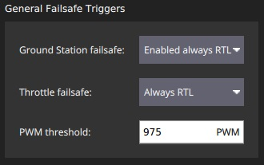

The configuration options are:

* **Ground Station failsafe** - Disabled, Enabled always RTL, Enabled Continue with Mission in Auto Mode, Enabled Always SmartRTL or RTL, Enabled Always SmartRTL or Land.
* **Throttle failsafe** - Disabled, Always RTL, Continue with Mission in Auto Mode, Always land.
* **PWM Threshold** ([FS_THR_VALUE](http://ardupilot.org/copter/docs/parameters.html#fs-thr-value-throttle-failsafe-value)) - PWM value below which throttle failsafe triggers.

### Geofence

This panel sets the parameters for the cylindrical [Simple Geofence](http://ardupilot.org/copter/docs/ac2_simple_geofence.html). You can set whether the fence radius or height are enabled, the maximum values for causing a breach, and the action in the event of a breach.

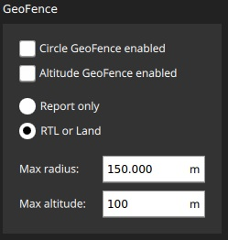

The configuration options are:

* **Circle GeoFence enabled** ([FENCE_TYPE](http://ardupilot.org/copter/docs/parameters.html#fence-type-fence-type), [FENCE_ENABLE](http://ardupilot.org/copter/docs/parameters.html#fence-enable-fence-enable-disable)) - Enable the circular geofence.
* **Altitude GeoFence enabled** ([FENCE_TYPE](http://ardupilot.org/copter/docs/parameters.html#fence-type-fence-type), [FENCE_ENABLE](http://ardupilot.org/copter/docs/parameters.html#fence-enable-fence-enable-disable)) - Enable altitude geofence.
* Fence action ([FENCE_ACTION](http://ardupilot.org/copter/docs/parameters.html#fence-action-fence-action)) One of:
  + **Report only** - Report fence breach.
  + **RTL or Land** - RTL or land on fence breach.
* **Max radius** ([FENCE_RADIUS](http://ardupilot.org/copter/docs/parameters.html#fence-radius-circular-fence-radius)) - Circular fence radius that when broken causes RTL.
* **Max altitude** ([FENCE_ALT_MAX](http://ardupilot.org/copter/docs/parameters.html#fence-alt-max-fence-maximum-altitude))- Fence maximum altitude to trigger altitude geofence.

### Return to Launch

This panel sets the [RTL Mode](http://ardupilot.org/copter/docs/rtl-mode.html) behaviour.

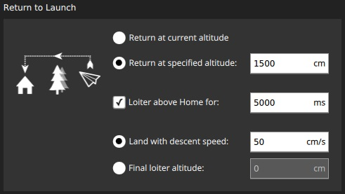

The configuration options are:

* Select RTL return altitude ([RTL_ALT](http://ardupilot.org/copter/docs/parameters.html#rtl-alt-rtl-altitude)):
  + **Return at current altitude** - Return at current altitude.
  + **Return at specified altitude** - Ascend to specified altitude to return if below current altitude.
* **Loiter above home for** ([RTL_LOIT_TIME](http://ardupilot.org/copter/docs/parameters.html#rtl-loit-time-rtl-loiter-time)) - Check to set a loiter time before landing.
* One of
  + **Land with descent speed** ([LAND_SPEED](http://ardupilot.org/copter/docs/parameters.html#land-speed-land-speed)) - Select final descent speed.
  + **Final loiter altitude** ([RTL_ALT_FINAL](http://ardupilot.org/copter/docs/parameters.html#rtl-alt-final-rtl-final-altitude)) - Select and set final altitude for landing after RTL or mission (set to 0 to land).

### Arming Checks

This panel sets which [Pre-ARM Safety Checks](http://ardupilot.org/copter/docs/prearm_safety_check.html) are enabled.

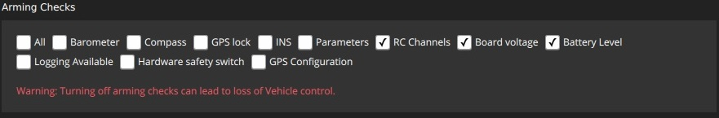

The configuration options are:

* **Arming Checks to perform** ([ARMING_CHECK](http://ardupilot.org/copter/docs/parameters.html#arming-check-arm-checks-to-peform-bitmask)) - Check all appropriate: Barometer, Compass, GPS lock, INS, Parameters, RC Channels, Board voltage, Battery Level, Airspeed, Logging Available, Hardware safety switch, GPS Configuration, System.

## Plane

The Plane safety page is shown below.

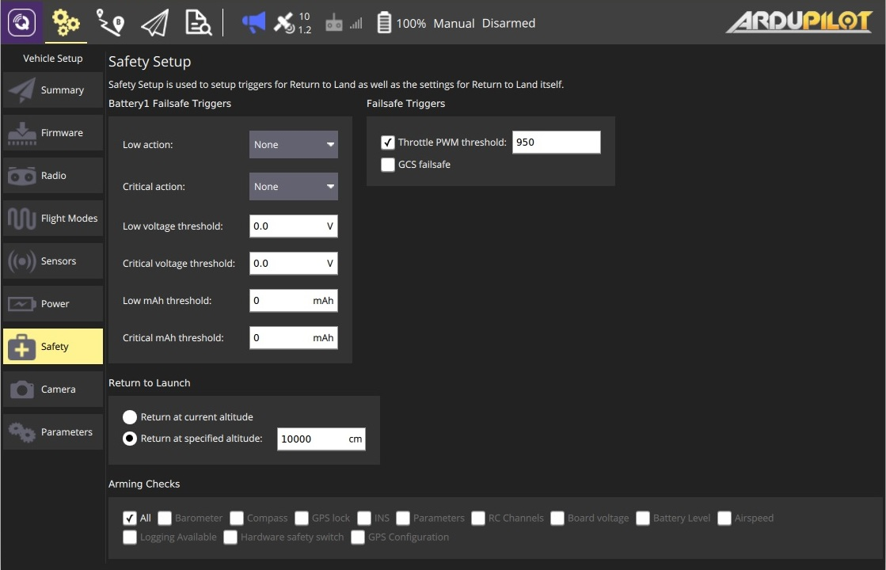

For additional safety settings and information see: [Plane Failsafe Function](http://ardupilot.org/plane/docs/apms-failsafe-function.html) and [Advanced Failsafe Configuration](http://ardupilot.org/plane/docs/advanced-failsafe-configuration.html).

### Battery Failsafe

The plane battery failsafe is the same as for copter except there are different options for the [Low](http://ardupilot.org/plane/docs/parameters.html#batt-fs-low-act-low-battery-failsafe-action) and [Critical](http://ardupilot.org/plane/docs/parameters.html#batt-fs-crt-act-critical-battery-failsafe-action) actions: None, RTL, Land, Terminate.

For more information see: [battery failsafe](https://word-edit.officeapps.live.com/we/wordeditorframe.aspx?ui=ko-KR&rs=ko-KR&hid=2mWOPQhL50mMEjYL5cj+yw.0&WOPISrc=https%3A%2F%2Fwopi.onedrive.com%2Fwopi%2Ffiles%2FD12DB2555512DF7%213518&wdnd=1&wdPreviousSession=0e43a0ac-2186-4d7b-a50e-5c8de0ff7e7d&wdNewAndOpenCt=1555562078658&wdo=4&wdOrigin=wacFileNew&wdPreviousCorrelation=09861a00-356b-4040-8a89-e153d9da8134&wde=docx&sc=host%3D%26qt%3DFolders&mscc=1&wdp=0#battery_failsafe_copter) (copter).

### Failsafe Triggers

This panel enables the [GCS Failsafe](http://ardupilot.org/plane/docs/advanced-failsafe-configuration.html#ground-station-communications-loss) and enables/configures the throttle failsafe.

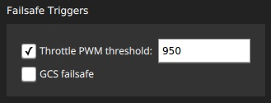

The configuration options are:

**Throttle PWM threshold** ([THR_FS_VALUE](http://ardupilot.org/plane/docs/parameters.html#thr-fs-value-throttle-failsafe-value)) - PWM value below which throttle failsafe triggers.

* **GCS failsafe** ([FS_GCS_ENABL](http://ardupilot.org/plane/docs/parameters.html#fs-gcs-enabl-gcs-failsafe-enable)) - Check to enable GCS failsafe.

### Return to Launch

This panel sets the [RTL Mode](http://ardupilot.org/copter/docs/rtl-mode.html) behaviour.

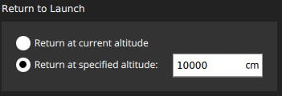

The configuration options are:

* Select RTL return altitude ([RTL_ALT](http://ardupilot.org/copter/docs/parameters.html#rtl-alt-rtl-altitude)):
  + **Return at current altitude** - Return at current altitude.
  + **Return at specified altitude** - Ascend to specified altitude to return if below current altitude.

### Arming Checks

[Arming Checks](https://word-edit.officeapps.live.com/we/wordeditorframe.aspx?ui=ko-KR&rs=ko-KR&hid=2mWOPQhL50mMEjYL5cj+yw.0&WOPISrc=https%3A%2F%2Fwopi.onedrive.com%2Fwopi%2Ffiles%2FD12DB2555512DF7%213518&wdnd=1&wdPreviousSession=0e43a0ac-2186-4d7b-a50e-5c8de0ff7e7d&wdNewAndOpenCt=1555562078658&wdo=4&wdOrigin=wacFileNew&wdPreviousCorrelation=09861a00-356b-4040-8a89-e153d9da8134&wde=docx&sc=host%3D%26qt%3DFolders&mscc=1&wdp=0#arming_checks_copter) are the same as for copter.

## Rover

The Rover safety page is shown below.

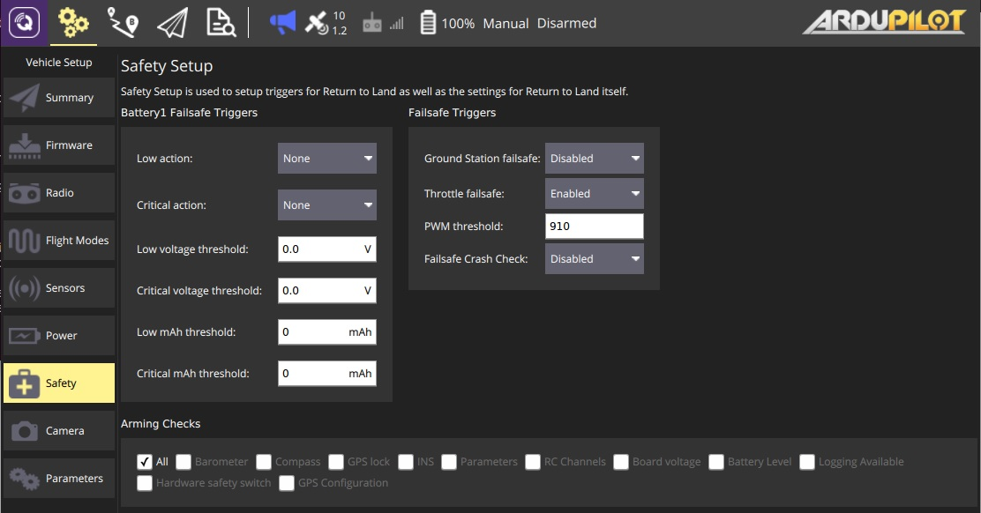

For additional safety settings and information see: [Failsafes](http://ardupilot.org/rover/docs/rover-failsafes.html).

### Battery Failsafe

The rover battery failsafe is the same as for [copter](https://word-edit.officeapps.live.com/we/wordeditorframe.aspx?ui=ko-KR&rs=ko-KR&hid=2mWOPQhL50mMEjYL5cj+yw.0&WOPISrc=https%3A%2F%2Fwopi.onedrive.com%2Fwopi%2Ffiles%2FD12DB2555512DF7%213518&wdnd=1&wdPreviousSession=0e43a0ac-2186-4d7b-a50e-5c8de0ff7e7d&wdNewAndOpenCt=1555562078658&wdo=4&wdOrigin=wacFileNew&wdPreviousCorrelation=09861a00-356b-4040-8a89-e153d9da8134&wde=docx&sc=host%3D%26qt%3DFolders&mscc=1&wdp=0#battery_failsafe_copter).

### Failsafe Triggers

This panel enables the rover [Failsafes](http://ardupilot.org/rover/docs/rover-failsafes.html).

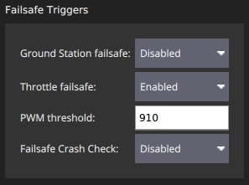

The configuration options are:

* **Ground Station failsafe** ([FS_GCS_ENABL](http://ardupilot.org/rover/docs/parameters.html#fs-gcs-enable-gcs-failsafe-enable)) - Check to enable GCS failsafe.
* **Throttle failsafe** ([FS_THR_ENABLE](http://ardupilot.org/rover/docs/parameters.html#fs-thr-enable-throttle-failsafe-enable)) - Enable/disable throttle failsafe (value is *PWM threshold* below).
* **PWM threshold** ([FS_THR_VALUE](http://ardupilot.org/rover/docs/parameters.html#fs-thr-value-throttle-failsafe-value)) - PWM value below which throttle failsafe triggers.
* **Failsafe Crash Check** ([FS_CRASH_CHECK](http://ardupilot.org/rover/docs/parameters.html#fs-crash-check-crash-check-action)) - What to do in the event of a crash: Disabled, Hold, HoldAndDisarm

### Arming Checks

[Arming Checks](https://word-edit.officeapps.live.com/we/wordeditorframe.aspx?ui=ko-KR&rs=ko-KR&hid=2mWOPQhL50mMEjYL5cj+yw.0&WOPISrc=https%3A%2F%2Fwopi.onedrive.com%2Fwopi%2Ffiles%2FD12DB2555512DF7%213518&wdnd=1&wdPreviousSession=0e43a0ac-2186-4d7b-a50e-5c8de0ff7e7d&wdNewAndOpenCt=1555562078658&wdo=4&wdOrigin=wacFileNew&wdPreviousCorrelation=09861a00-356b-4040-8a89-e153d9da8134&wde=docx&sc=host%3D%26qt%3DFolders&mscc=1&wdp=0#arming_checks_copter) are the same as for copter.

## Sub

The Sub safety page is shown below.

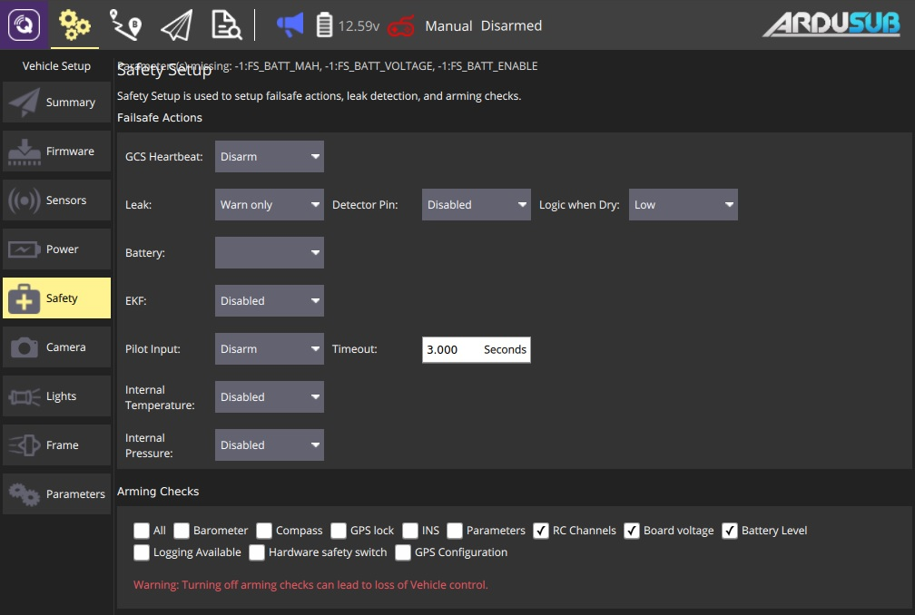

For additional safety settings and information see: [Failsafes](https://www.ardusub.com/operators-manual/failsafes.html).

### Failsafe Actions

The configuration options are:

* **GCS Heartbeat** - Select one of: Disabled, Warn only, Disarm, Enter depth hold mode, Enter surface mode.
* **Leak** - Select one of: Disabled, Warn only, Enter surface mode.
  + **Detector Pin** - Select one of: Disabled, Pixhawk Aux (1-6), Pixhawk 3.3ADC(1-2), Pixhawk 6.6ADC.
  + **Logic when Dry** - Select one of: Low, High.
* **Battery** - ?.
* **EKF** - Select one of: Disabled, Warn only, Disarm.
* **Pilot Input** - Select one of: Disabled, Warn only, Disarm.
* **Internal Temperature** - Select one of: Disabled, Warn only.
* **Internal Pressure** - Select one of: Disabled, Warn only.

### Arming Checks

[Arming Checks](https://word-edit.officeapps.live.com/we/wordeditorframe.aspx?ui=ko-KR&rs=ko-KR&hid=2mWOPQhL50mMEjYL5cj+yw.0&WOPISrc=https%3A%2F%2Fwopi.onedrive.com%2Fwopi%2Ffiles%2FD12DB2555512DF7%213518&wdnd=1&wdPreviousSession=0e43a0ac-2186-4d7b-a50e-5c8de0ff7e7d&wdNewAndOpenCt=1555562078658&wdo=4&wdOrigin=wacFileNew&wdPreviousCorrelation=09861a00-356b-4040-8a89-e153d9da8134&wde=docx&sc=host%3D%26qt%3DFolders&mscc=1&wdp=0#arming_checks_copter) are the same as for copter.

# **Tuning Setup**

The Tuning page allows you to configure settings on your vehicle which control basic flight characteristics. The details differ depending on flight stack:

* [Tuning (ArduPilot)](https://docs.qgroundcontrol.com/en/SetupView/tuning_ardupilot.html)
* [Tuning (PX4)](https://docs.qgroundcontrol.com/en/SetupView/tuning_px4.html)

# **Tuning (ArduPilot)**

* [Tuning (ArduCopter)](https://docs.qgroundcontrol.com/en/SetupView/tuning_arducopter.html)
* [Tuning (ArduSub)](https://docs.qgroundcontrol.com/en/SetupView/tuning_ardusub.html)

# **ArduCopter Tuning**

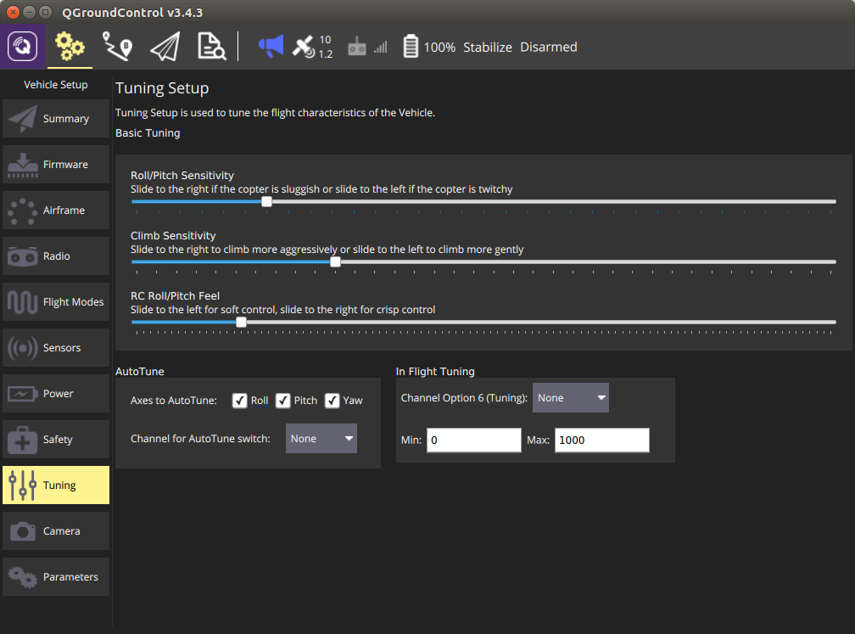

## **Basic Tuning**

Adjust the flight characteristics by moving the desired slider to the left or right.

## **AutoTune**

AutoTune is used to automatically tune the rate parameters in order to provide the highest response without significant overshoot.

Performing an AutoTune:

* Select which axes you would like to tune.
* Tuning all axes at once can take a significant amount of time, which may cause you to run out of battery. To prevent this choose to tune only one axis at a time.
* Assign AutoTune to one of your transmitter switches. Ensure that switch is in low position before taking off.
* Take off and put the copter into AltHold.
* Turn on AutoTune with your transmitter switch.
* The copter will twitch around the specified axes for a few minutes.
* When AutoTune completes the copter will change back to the original settings.
* Move the AutoTune switch back to low position and then back to high to test the new settings.
* Move the AutoTune switch to low to test previous settings.
* To save new settings, land and disarm while AutoTune switch is in high position.

Note:

* Since AutoTune is done in AltHold your copter must already have a tuning which is minimally flyable in AltHold. You can cancel AutoTune at any time by moving the AutoTune switch back to low position.
* You can reposition the copter using your transmitter at any time during AutoTune.

### **In-Flight Tuning**

This is an advanced option which allows you to tune a flight control parameter using one of your transmitter dial channels. Select the control option from the dropdown and specify the min/max for the values to assign to the dial.

# **ArduSub Tuning**

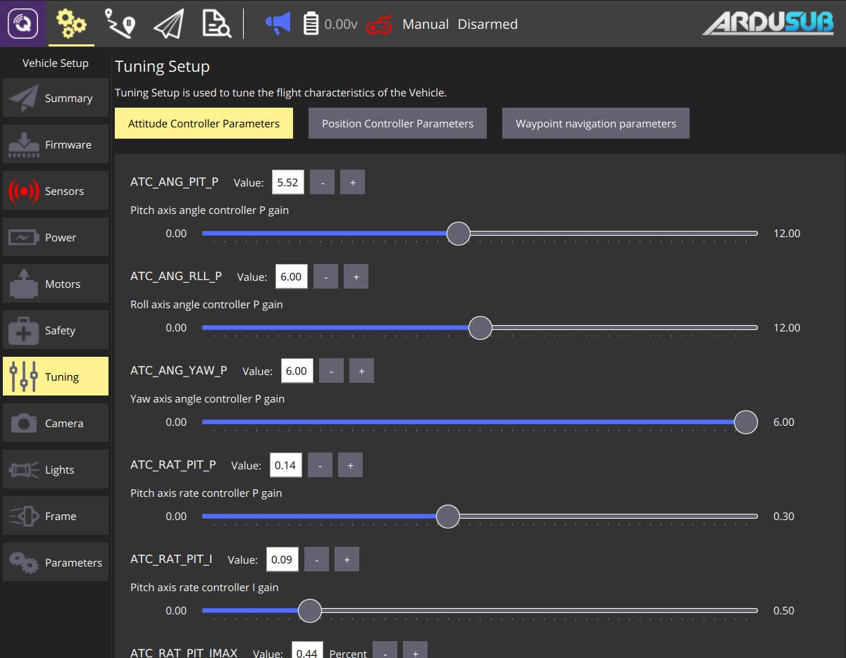

## **Basic Tuning**

This page allows changing the PID controller gains to better suit your vehicle and application. Changing these may help you get a snappier response for more precise movements, or a smoother response for recording cinematic footages. Adjust a parameter by moving the desired slider, or by clicking the increase/decrease buttons. There are three controllers that can be adjusted here:

* [**Attitude Controller Parameters**](https://www.ardusub.com/operators-manual/full-parameter-list.html#atc-parameters) are the parameters for the controller responsible for keeping the vehicle oriented as you want it, assuming your vehicle has ability (enough motors/DOF) to do so.
* **Position Controller Parameters** are the parameters for the controller responsible for positioning the vehicle at a point in 3D space. The **Z** parameters control how the depth control works (eg in [*Depth Hold*](https://www.ardusub.com/operators-manual/flight-modes.html#depth-hold) mode). The **XY** parameters affect how the vehicle controls the horizontal position in [*Position Enabled*](https://www.ardusub.com/operators-manual/flight-modes.html#position-enabled-modes) modes.
* **Waypoint Navigation Parameters** are the parameters for the controller responsible for following waypoints in **Auto** and **Guided** mode.
* **Guided** and **Auto** modes are currently unsupported and some features are disabled in QGC.

**Tuning (PX4)**

## **Basic Tuning (Multicoper, Fixed Wing, VTOL)**

Adjust the specified flight characteristic by moving the slider(s) to the left or right.

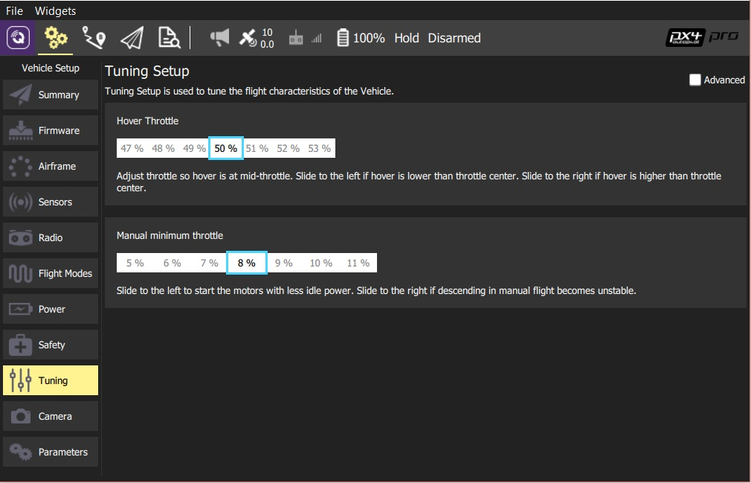

## **Advanced Tuning (MultiCopter)**

To access advanced tuning, select the **Advanced** checkbox.

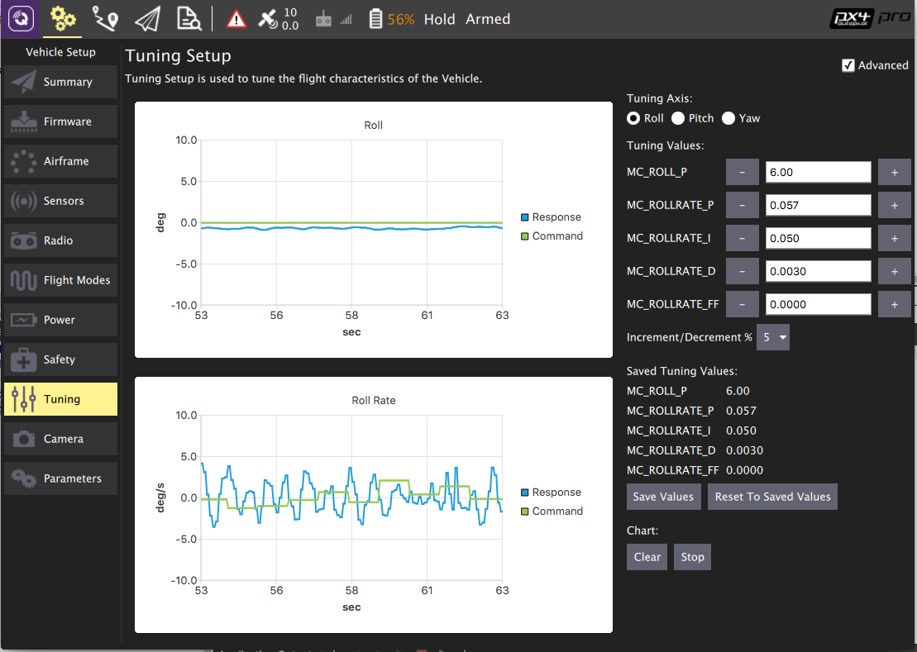

To use advanced tuning:

1. First select the *Tuning axis* to tune: **Rol**, **Pitch** or **Yaw** (each axis is tuned separately).
2. Fly the vehicle, observing the tracking on the chart.
   * Adjust the *Tuning Values* (parameters) to improve the tracking shown on the graph
   * Set the **Increment/Decrement %** to a larger/smaller value for course/fine tuning
   * Press the **Save Values** button if a change improves tracking.
   * At any point you can press **Reset To Saved Values** to restore the last saved good state.
   * You can also **Clear**/**Stop** the chart using the buttons provided.
3. Tune the other axes.

# **Camera Setup**

The details of the page differ if you are using PX4 Pro firmware or ArduPilot firmware.

## **ArduPilot Camera Setup**

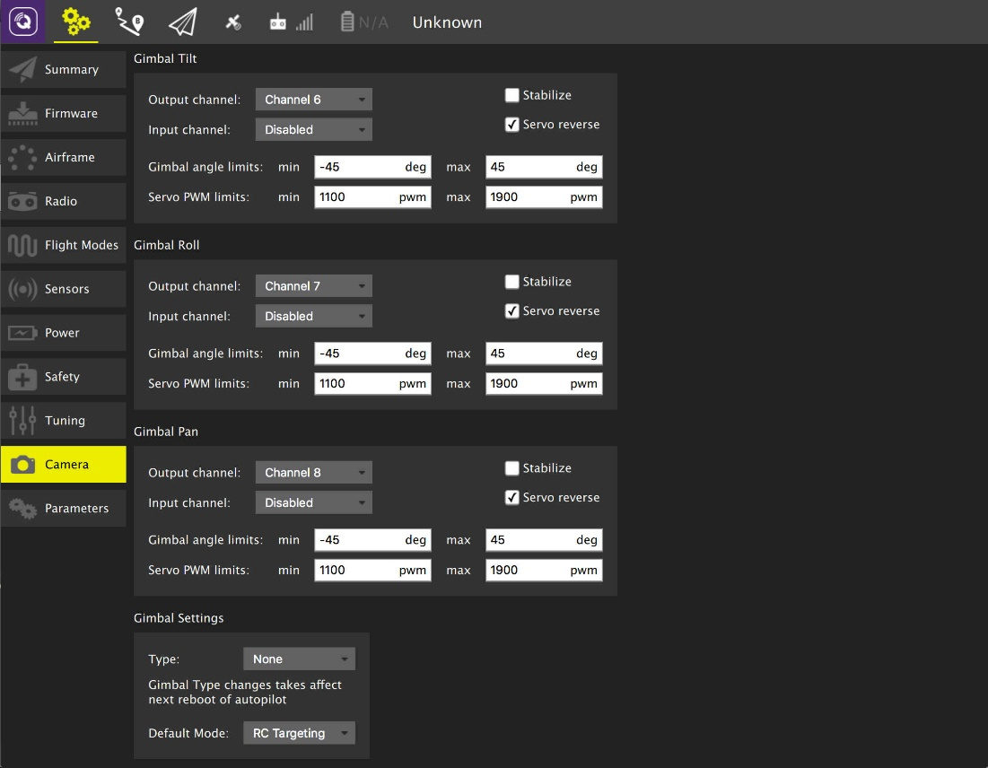

## **PX4 Pro Camera Setup**

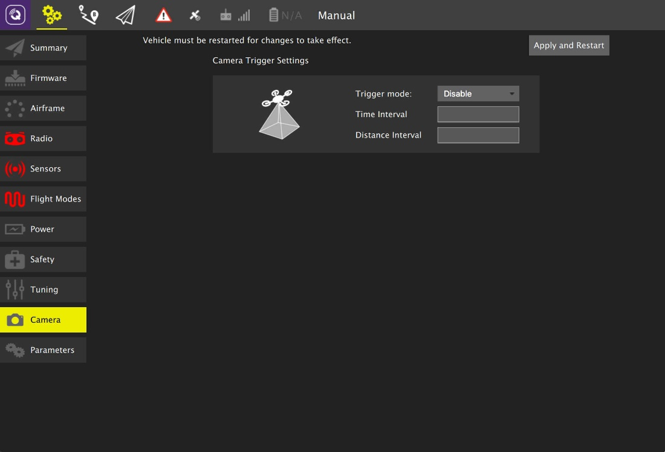

# Joystick Setup

*QGroundControl* allows you to control a vehicle using a joystick or gamepad instead of an RC Transmitter.

Flying with a Joystick (or [virtual thumb-sticks](https://word-edit.officeapps.live.com/SettingsView/VirtualJoystick.html)) is not as responsive as RC Control because joystick information is sent over MAVLink.

Joystick and Gamepad support is enabled using the cross-platform [SDL2](http://www.libsdl.org/index.php) library. Compatibility with a particular controller depends on SDL (all buttons that are exposed by that API are displayed through the *QGroundControl* UI). A [number of common joysticks and gamepads](https://word-edit.officeapps.live.com/we/wordeditorframe.aspx?ui=ko-KR&rs=ko-KR&hid=2mWOPQhL50mMEjYL5cj+yw.0&WOPISrc=https%3A%2F%2Fwopi.onedrive.com%2Fwopi%2Ffiles%2FD12DB2555512DF7%213518&wdnd=1&wdPreviousSession=0e43a0ac-2186-4d7b-a50e-5c8de0ff7e7d&wdNewAndOpenCt=1555562078658&wdo=4&wdOrigin=wacFileNew&wdPreviousCorrelation=09861a00-356b-4040-8a89-e153d9da8134&wde=docx&sc=host%3D%26qt%3DFolders&mscc=1&wdp=0#supported-joysticks) are known to work.

## Enabling PX4 Joystick Support

To enable Joystick support in PX4 you need to set the parameter COM_RC_IN_MODE to 1 - *Joystick/No RC Checks*. If this parameter is not set then *Joystick* will not be offered as a setup option.

This is enabled by default for PX4 SITL builds (see the [Parameters](https://word-edit.officeapps.live.com/we/Parameters.html) topic for information on how to find and set a particular parameter).

## Ardupilot Joystick Support

All ArduPilot vehicles are supported. No parameter configuration is necessary.

## Configuring the Joystick

To configure a joystick:

1. Start *QGroundControl* and connect to a vehicle.
2. Connect the Joystick or Gamepad to a USB port.
3. Select the **Gear** icon (Vehicle Setup) in the top toolbar and then **Joystick** in the sidebar. The screen below will appear.

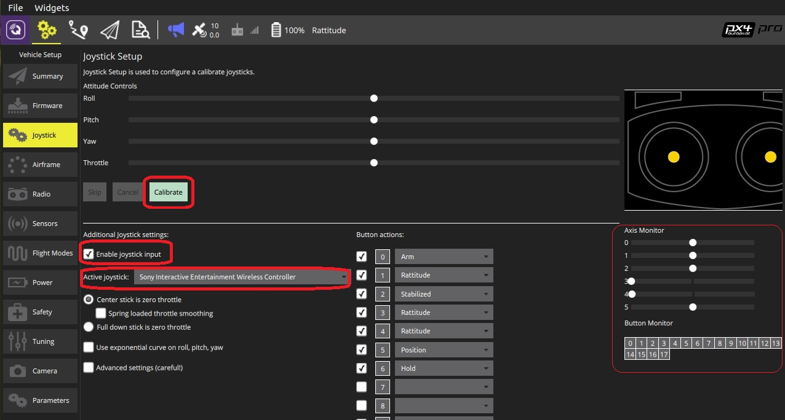Make sure your joystick is selected in the **Active joystick** dropdown.

1. Press the **Calibrate** button and then follow the on-screen instructions to calibrate/move the sticks.
2. Test the buttons and sticks work as intended by pressing them, and viewing the result in the Axis/Button monitor.
3. Select the flight modes/vehicle functions activated by each joystick button. A maximum of 16 joystick *button actions* can be set.
4. Check the **Enable joystick input** checkbox to begin sending joystick commands to the vehicle.

### Throttle Options

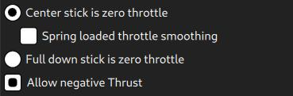

* **Center stick is zero throttle**: Centered or lowered stick sends 0 in [MANUAL_CONTROL **z**](https://mavlink.io/en/messages/common.html#MANUAL_CONTROL), raised stick sends 1000.
  + **Spring loaded throttle smoothing**: In this mode you control not the throttle itself, but the rate at which it increases/decreases. This is useful for setups where the throttle stick is spring loaded, as the user can hold the desired throttle while releasing the stick.
* **Full down stick is zero throttle**: In this mode, lowered stick sends 0 in [MANUAL_CONTROL **z**](https://mavlink.io/en/messages/common.html#MANUAL_CONTROL), centered stick 500, and raised 1000.
* **Allow negative thrust**: When in **Center stick is zero throttle** mode, this allows the user to send negative values by lowering the stick. So that lowered stick sends -1000 in [MANUAL_CONTROL **z**](https://mavlink.io/en/messages/common.html#MANUAL_CONTROL), centered sends zero, and raised stick sends 1000. This mode is only enabled for vehicles that support negative thrust, such as [Rover](http://ardupilot.org/rover/index.html).

### Expo

The expo slider allows you to make the sticks less sensitive in the center, allowing finer control in this zone.

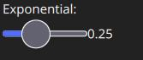

The slider adjusts the curvature of the exponential curve.

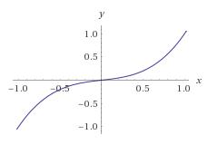

The higher the Expo value, the flatter the curve is at the center, and steeper it is at the edges.

### Advanced Settings

The advanced settings are not recommended for everyday users. They can cause unpredicted results if used incorrectly.

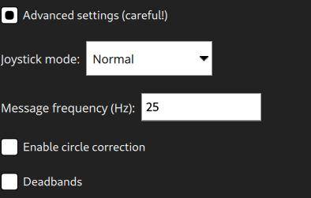

The following settings are available:

* **Joystick Mode**: Changes what the joystick actually controls, and the MAVLink messages sent to the vehicle.
  + **Normal**: User controls as if using a regular RC radio, MAVLink [MANUAL_CONTROL](https://mavlink.io/en/messages/common.html#MANUAL_CONTROL) messages are used.
  + **Attitude**: User controls the vehicle attitude, MAVLink [SET_ATTITUDE_TARGET](https://mavlink.io/en/messages/common.html#SET_ATTITUDE_TARGET) messages are used.
  + **Position**: User controls the vehicle position, MAVLink [SET_POSITION_TARGET_LOCAL_NED](https://mavlink.io/en/messages/common.html#SET_POSITION_TARGET_LOCAL_NED) messages with bitmask for **position** only are used.
  + **Force**: User controls the forces applied to the vehicle, MAVLink [SET_POSITION_TARGET_LOCAL_NED](https://mavlink.io/en/messages/common.html#SET_POSITION_TARGET_LOCAL_NED) messages with bitmask for **force** only are used.
  + **Velocity**: User controls the forces applied to the vehicle, MAVLink [SET_POSITION_TARGET_LOCAL_NED](https://mavlink.io/en/messages/common.html#SET_POSITION_TARGET_LOCAL_NED) messages with bitmask for **velocity** only are used.
* **Message Frequency**: When the joystick is idle (inputs are not changing), the joystick commands are sent to the vehicle at 5Hz. When the joystick is in use (input values are changing), the joystick commands are sent to the vehicle at the (higher) frequency configured by this setting. The default is 25Hz.
* **Enable Circle Correction**: RC controllers sticks describe a square, while joysticks usually describe a circle. When this option is enabled a square is inscribed inside the joystick movement area to make it more like an RC controller (so it is possible to reach all four corners). The cost is decreased resolution, as the effective stick travel is reduced.
  + **Disabled:** When this is **disabled** the joystick position is sent to the vehicle unchanged (the way that it is read from the joystick device). On some joysticks, the (roll, pitch) values are confined to the space of a circle inscribed inside of a square. In this figure, point B would command full pitch forward and full roll right, but the joystick is not able to reach point B because the retainer is circular. This means that you will not be able to achieve full roll and pitch deflection simultaneously.

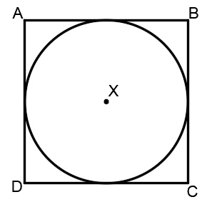

* + **Enabled:** The joystick values are adjusted in software to ensure full range of commands. The usable area of travel and resolution is decreased, however, because the area highlighted grey in the figure is no longer used.

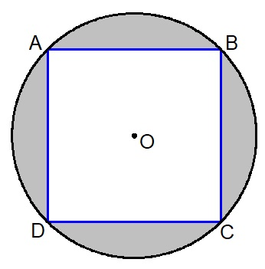

* **Deadbands:** Deadbands allow input changes to be ignored when the sticks are near their neutral positions. This helps to avoid noise or small oscillations on sensitive sticks which may be interpreted as commands, or small offsets when sticks do not re-center well. They can be adjusted during the first step of the [calibration](https://word-edit.officeapps.live.com/we/wordeditorframe.aspx?ui=ko-KR&rs=ko-KR&hid=2mWOPQhL50mMEjYL5cj+yw.0&WOPISrc=https%3A%2F%2Fwopi.onedrive.com%2Fwopi%2Ffiles%2FD12DB2555512DF7%213518&wdnd=1&wdPreviousSession=0e43a0ac-2186-4d7b-a50e-5c8de0ff7e7d&wdNewAndOpenCt=1555562078658&wdo=4&wdOrigin=wacFileNew&wdPreviousCorrelation=09861a00-356b-4040-8a89-e153d9da8134&wde=docx&sc=host%3D%26qt%3DFolders&mscc=1&wdp=0#configure), or by dragging vertically on the corresponding axis monitor.

## Supported Joysticks

The following joysticks/controllers have been shown to work with relatively recent *QGroundControl* builds.

### Sony Playstation 3/4 Controllers

These are both highly recommended. They work well "out of the box" and have many buttons that you can map to flight modes.

#### Sony PS4 - DualShock 4 Controller V2 (Wireless setup)

This controller supports both USB and Bluetooth wireless connection. Wired USB connection usually works out of the box. The wireless connection needs some setup.

##### **Linux Ubuntu setup**

To make the controller work wirelessly under Linux the [jstest-gtk](https://jstest-gtk.gitlab.io/) and [ds4drv](https://github.com/chrippa/ds4drv) utilities are needed.

The steps are:

1. Install *jstest-gtk*:

sudo apt install jstest-gtk

1. Install *ds4drv*:

sudo pip install ds4drv

1. Run ds4drv

sudo ds4drv

1. Hold **Share** button and then **PS** button until controller LED starts blinking rapidly. The *ds4drv* should then detect a new device.
2. Last of all, you should check the controller setup by running the *jstest-gtk* utility.

### **FrSky Taranis XD9 plus**

The *FrSky Taranis XD9 plus* remote control can also be connected as a joystick. You will need to connect it via the USB port on the back.

The Taranis does not allow you to use button options (to be precise, you can set the options, but toggling the buttons on your transmitter does not cause them to be pressed).

The Taranis is an open system that is openly being worked on. It is possible that at time of writing there is a firmware or configuration that allows it to work effectively as a joystick.

### Logitech Gamepad F310

The Logitech Gamepad F310 has been tested via USB on MacOSX "Sierra".

### Logitech Extreme 3D Pro

The [Logitech Extreme 3D Pro](http://gaming.logitech.com/en-ch/product/extreme-3d-pro-joystick) Joystick has been tested on all platforms (Linux, Windows, Mac OSX). This is a single stick controller that can also be twisted. The main stick axes are used for pitch and roll, while the twist action is used for yaw. The throttle is mapped onto a separate wheel.

### Logitech F710 Gamepad

This gamepad is great for flying a multirotor manually via QGroundControl. It works on Windows, Linux and Mac OS.

#### Mac OS Leopard / Lion Setup

The F710 is detected under Leopard / Lion but is not automatically configured as an input device. In order to get a working configuration, the F710 has to be recognised as *Rumblepad2*.

First check how it is recognised: **Apple > About this Mac > Additional Information > System Report > USB**. It is detected as "Logitech Cordless RumblePad 2" then nothing further needs to be done.

If it is detected as a "Logitech Wireless 710", perform these steps:

1. Unplug the USB receiver of the gamepad
2. Prepare to quickly plug it into a USB port
3. Hit the Logitech button (its silver with the Logitech Logo on it in the center of the pad)
4. Quickly connect the USB receiver to your Mac
5. The pad should now be detected in the system report as "Logitech Cordless RumblePad 2". If not, retry the above steps.

# **Parameters**

The *Parameters* screen allows you to find and modify any of the parameters associated with the vehicle.

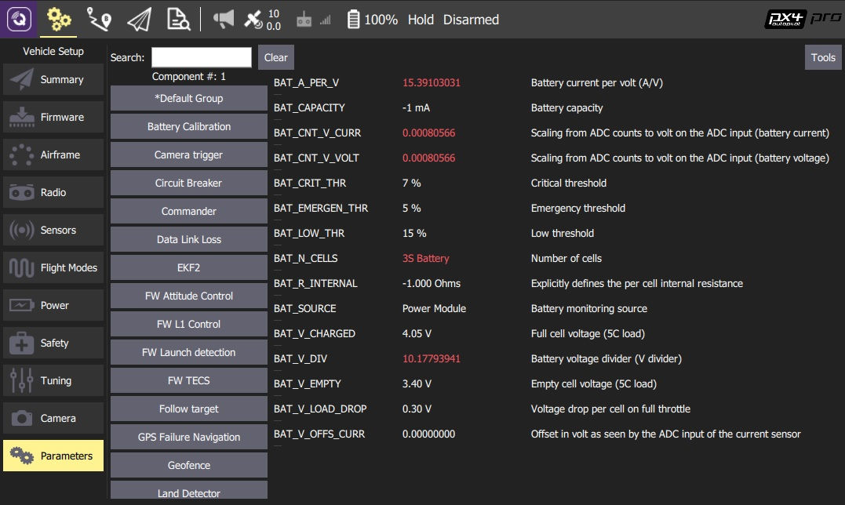

PX4 Pro and ArduPilot use different parameter sets, but they are both managed as described in this section.

## **Finding a Parameter**

The parameters are organized in groups. Select a group of parameters to view by clicking on the buttons to the left (in the image above the *Battery Calibration* group is selected).

You can also *search* for a parameter by entering a term in the *Search* field. This will show you a list of all parameter names and descriptions that contain the entered substring (press **Clear** to reset the search).

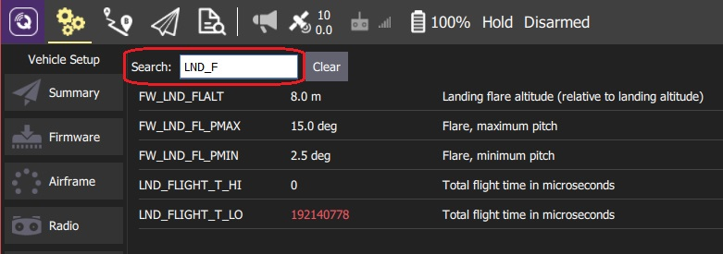

## **Changing a Parameter**

To change the value of a parameter click on the parameter row in a group or search list. This will open a side dialog in which you can update the value (this dialog also provides additional detailed information about the parameter - including whether a reboot is required for the change to take effect).

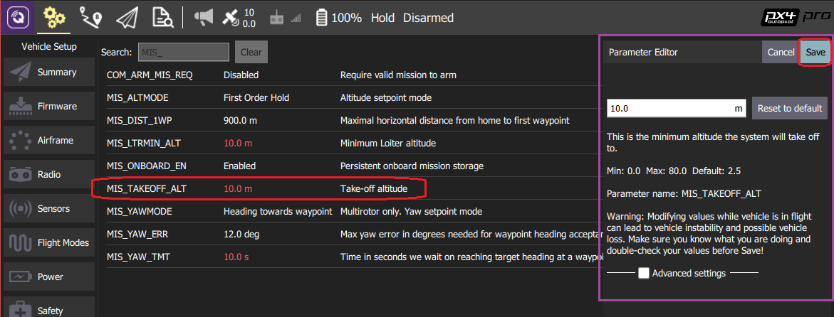

When you click **Save** the parameter is automatically and silently uploaded to the connected vehicle. Depending on the parameter, you may then need to reboot the flight controller for the change to take effect.

## **Tools**

You can select additional options from the **Tools** menu on the top right hand side of the screen.

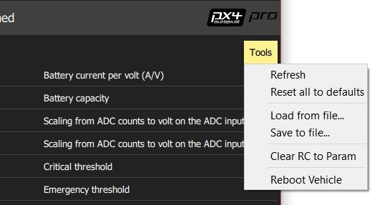

**Refresh**   
Refresh the parameter values by re-requesting all of them from the vehicle.

**Reset all to defaults**   
Reset all parameters to their original default values.

**Load from file / Save to file**   
Load parameters from an existing file or save your current parameter settings to a file.

**Clear RC to Param**   
This clears all associations between RC transmitter controls and parameters. For more information see: [Radio Setup > Param Tuning Channels](https://docs.qgroundcontrol.com/en/SetupView/Radio.html#param-tuning-channels-px4).

**Reboot Vehicle**   
Reboot the vehicle (required after changing some parameters).

# **Settings View**

The *Settings View* is used to configure the settings for the *QGroundControl* application (rather than a specific vehicle). You do not have to have a vehicle connected to change these values.

You can switch between the various settings options by clicking the buttons in the left-sidebar.

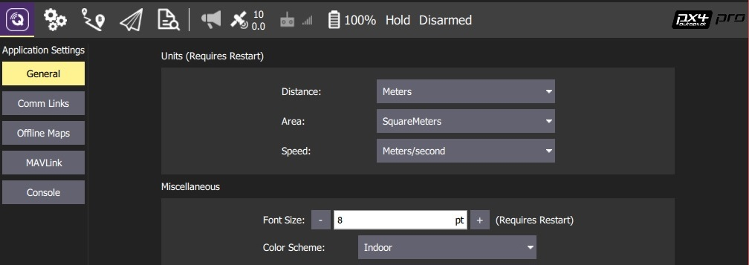

## **Settings Options**

[**General**](https://docs.qgroundcontrol.com/en/SettingsView/General.html)   
The main application configuration settings. These are used to specify: display units, autoconnection devices, video display and storage, RTK GPS, etc.

**Comm Links**   
Allows you to manually create communication links and connect to them. *Keep in mind that normally this is not needed since QGroundControl will automatically connect to the most common devices.*

[**Offline Maps**](https://docs.qgroundcontrol.com/en/SettingsView/OfflineMaps.html)   
Allows you to cache maps for use while you have no Internet connection.

[**MAVLink**](https://docs.qgroundcontrol.com/en/SettingsView/MAVLink.html)   
Settings associated with the MAVLink connection to a vehicle.

[**Console**](https://docs.qgroundcontrol.com/en/SettingsView/console_logging.html)   
Used to capture application logs for help with diagnosing application problems.

# General Settings (Settings View)

The general settings (**SettingsView > General Settings**) are the main place for application-level configuration. Settable values include: display units, autoconnection devices, video display and storage, RTK GPS, brand image, and other miscellaneous settings.

Values are settable even if no vehicle is connected. Settings that require a vehicle restart are indicated in the UI.

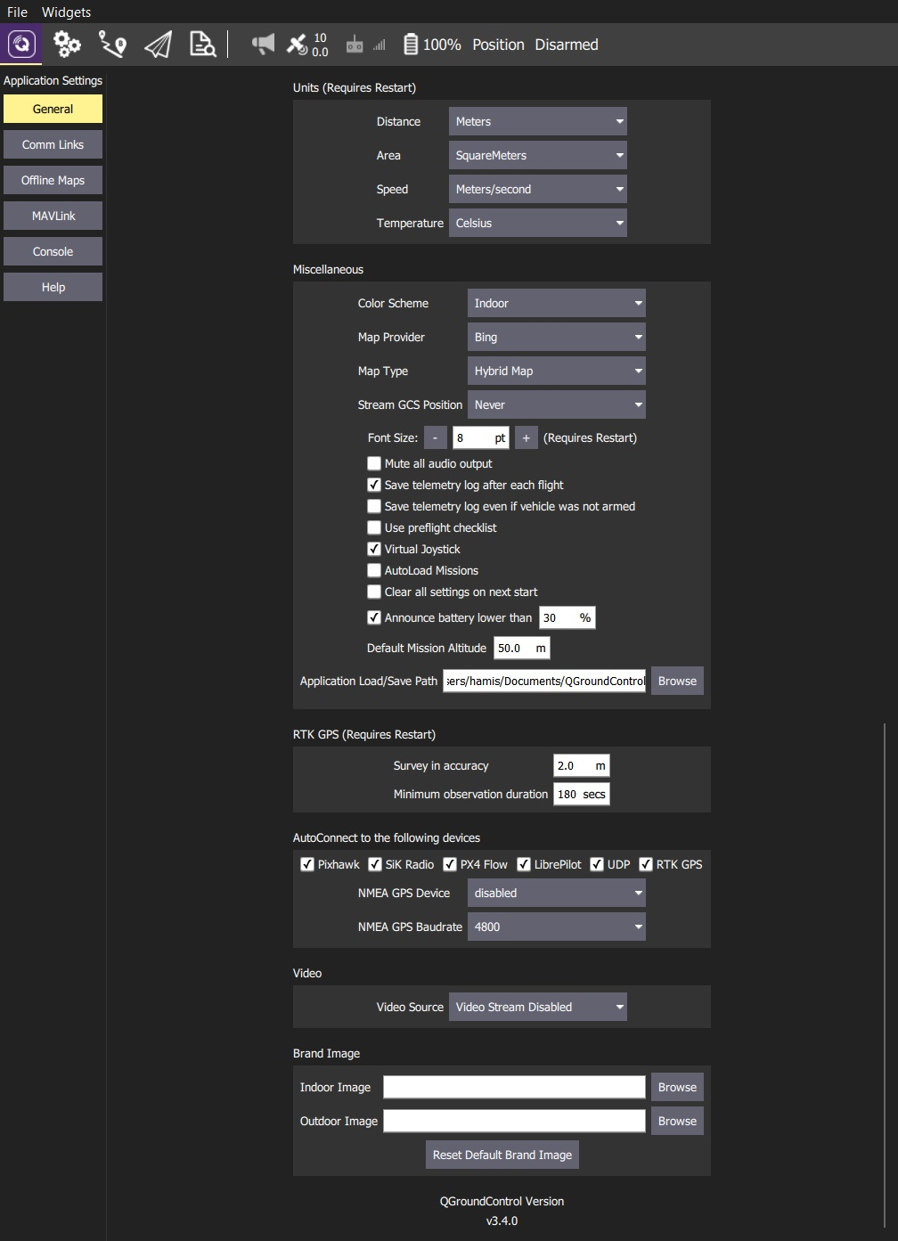

## Units

This section defines the display units used in the application.

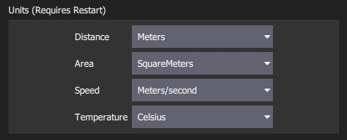

The settings are:

* **Distance**: Meters | Feet
* **Area**: SquareMetres | SquareFeet | SquareKilometers | Hectares | Acres |SquareMiles
* **Speed**: Metres/second | Feet/second | Miles/hour | Kilometres/hour | Knots
* **Temperature**: Celsius | Fahrenheit

## Miscellaneous

This section defines a number of miscellaneous settings, related to (non exhaustively): font sizes, colour schemes, map providers, map types, telemetry logging, audio output, low battery announcement levels, default mission altitude, [virtual joysticks](https://word-edit.officeapps.live.com/we/VirtualJoystick.html), mission autoloading, default application file load/save path etc.

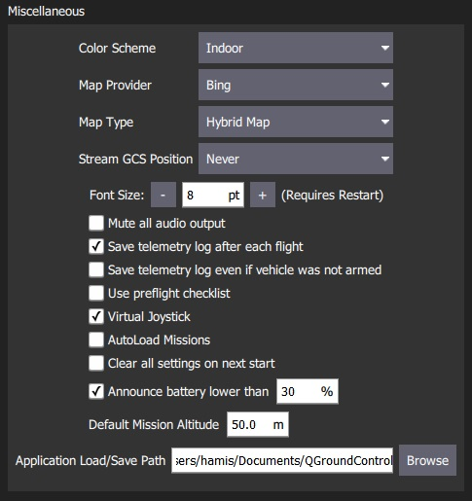

The settings are:

* **Color Scheme**: Indoor (Dark) | Outdoor (Light)
* **Map Provider**: Bing | Google | Statkart | Eniro
* **Map Type**: Hybrid | Street | Satellite
* **Stream GCS Position**: Never | Always | When in Follow Me flight mode.
* **Font Size**: Font size across app (Requires restart)
* **Mute all audio output**: Turns off all audio output.
* **Save telemetry log after each flight**: Logs automatically saved to the *Application Load/Save Path* ([below](https://word-edit.officeapps.live.com/we/wordeditorframe.aspx?ui=ko-KR&rs=ko-KR&hid=2mWOPQhL50mMEjYL5cj+yw.0&WOPISrc=https%3A%2F%2Fwopi.onedrive.com%2Fwopi%2Ffiles%2FD12DB2555512DF7%213518&wdnd=1&wdPreviousSession=0e43a0ac-2186-4d7b-a50e-5c8de0ff7e7d&wdNewAndOpenCt=1555562078658&wdo=4&wdOrigin=wacFileNew&wdPreviousCorrelation=09861a00-356b-4040-8a89-e153d9da8134&wde=docx&sc=host%3D%26qt%3DFolders&mscc=1&wdp=0#load_save_path)) after flight.
* **Save telemetry log even if vehicle was not armed**: Logs when a vehicle connects to *QGroundControl*. Stops logging when the last vehicle disconnects.
* **Use preflight checklist**: Enable pre-flight checklist.
* **Virtual Joystick**: Enable [virtual joysticks](https://word-edit.officeapps.live.com/we/VirtualJoystick.html) (PX4 only)
* **Autoload Missions**: If enabled, automatically upload a plan to the vehicle on connection.
  + The plan file must be named **AutoLoad#.plan**, where the # is replaced with the vehicle id.
  + The plan file must be located in the [Application Load/Save Path](https://word-edit.officeapps.live.com/we/wordeditorframe.aspx?ui=ko-KR&rs=ko-KR&hid=2mWOPQhL50mMEjYL5cj+yw.0&WOPISrc=https%3A%2F%2Fwopi.onedrive.com%2Fwopi%2Ffiles%2FD12DB2555512DF7%213518&wdnd=1&wdPreviousSession=0e43a0ac-2186-4d7b-a50e-5c8de0ff7e7d&wdNewAndOpenCt=1555562078658&wdo=4&wdOrigin=wacFileNew&wdPreviousCorrelation=09861a00-356b-4040-8a89-e153d9da8134&wde=docx&sc=host%3D%26qt%3DFolders&mscc=1&wdp=0#load_save_path).
* **Clear all settings on next start**: Resets all settings to the default (including this one) when *QGroundControl* restarts.
* **Announce battery lower than**: Specify battery level at which *QGroundControl* will start low battery announcements.
* **Default Mission Altitude**: The default altitude used for the first waypoint (subsequent new waypoints are seeded with the altitude value of the preceding waypoint).
* **Application Load/Save Path**: Default location for loading/saving application files, including: parameters, telemetry logs, and mission plans.

## RTK GPS

This section specifies the RTK GPS "Survey-in" settings.

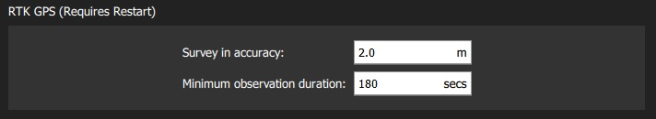

The *Survey-In* process is a startup procedure required by RTK GPS systems to get an accurate estimate of the base station position. The process takes measurements over time, leading to increasing position accuracy. Both of the setting conditions must met for the Survey-in process to complete. For more information see [RTK GPS](https://docs.px4.io/en/advanced_features/rtk-gps.html) (PX4 docs) and [GPS- How it works](http://ardupilot.org/copter/docs/common-gps-how-it-works.html#rtk-corrections) (ArduPilot docs).

The settings are:

* **Survey-in accuracy:** The minimum position accuracy for the RTK Survey-in process to complete.
* **Minimum observation duration:** The minimum time that will be taken for the RTK Survey-in process.

## AutoConnect to the following devices

This section defines the set of devices to which *QGroundControl* will auto-connect.

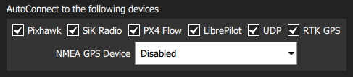

Settings include:

* **Pixhawk:** Autoconnect to Pixhawk-series device
* **SiK Radio:** Autoconnect to SiK (Telemetry) radio
* **PX4 Flow:** Autoconnect to PX4Flow device
* **Libre Pilot:** Autoconnect to Libre Pilot autopilot
* **UDP:** Autoconnect to UDP
* **RTK GPS:** Autoconnect to RTK GPS device
* **NMEA GPS Device:** Autoconnect to an external GPS device to get ground station position ([see below](https://word-edit.officeapps.live.com/we/wordeditorframe.aspx?ui=ko-KR&rs=ko-KR&hid=2mWOPQhL50mMEjYL5cj+yw.0&WOPISrc=https%3A%2F%2Fwopi.onedrive.com%2Fwopi%2Ffiles%2FD12DB2555512DF7%213518&wdnd=1&wdPreviousSession=0e43a0ac-2186-4d7b-a50e-5c8de0ff7e7d&wdNewAndOpenCt=1555562078658&wdo=4&wdOrigin=wacFileNew&wdPreviousCorrelation=09861a00-356b-4040-8a89-e153d9da8134&wde=docx&sc=host%3D%26qt%3DFolders&mscc=1&wdp=0#nmea_gps))

### Ground Station Location (NMEA GPS Device)

*QGroundControl* will automatically use an internal GPS to display its own location on the map with a purple Q icon (if the GPS provides a heading, this will be also indicated by the icon). It may also use the GPS as a location source for *Follow Me Mode* - currently supported on [PX4 Multicopters only](https://docs.px4.io/en/flight_modes/follow_me.html).

You can also configure QGC to connect to an external GPS device via a serial or UDP port. The GPS device must support the ASCII NMEA format - this is normally the case.

A higher quality external GPS system may be useful even if the ground station has internal GPS support.

Use the *NMEA GPS Device* drop-down selector to manually select the GPS device and other options:

* USB connection:

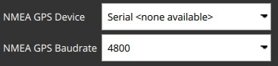

* + **NMEA GPS Device:** *Serial*
  + **NMEA GPS Baudrate**: The baudrate for the serial port

To troubleshoot serial GPS problems: Disable RTK GPS [auto connection](https://word-edit.officeapps.live.com/we/wordeditorframe.aspx?ui=ko-KR&rs=ko-KR&hid=2mWOPQhL50mMEjYL5cj+yw.0&WOPISrc=https%3A%2F%2Fwopi.onedrive.com%2Fwopi%2Ffiles%2FD12DB2555512DF7%213518&wdnd=1&wdPreviousSession=0e43a0ac-2186-4d7b-a50e-5c8de0ff7e7d&wdNewAndOpenCt=1555562078658&wdo=4&wdOrigin=wacFileNew&wdPreviousCorrelation=09861a00-356b-4040-8a89-e153d9da8134&wde=docx&sc=host%3D%26qt%3DFolders&mscc=1&wdp=0#auto_connect), close *QGroundControl*, reconnect your GPS, and open QGC.

* Network connection:

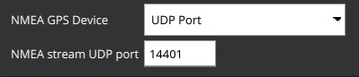

* + **NMEA GPS Device:** *UDP Port*.
  + **NMEA Stream UDP Port**: The UDP port on which QGC will listen for NMEA data (QGC binds the port as a server)

## Video

The *Video* section is used to define the source and connection settings for video that will be displayed in *Fly View*.

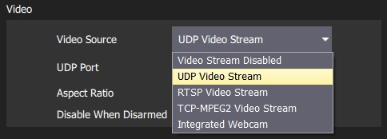

The values displayed in this setting depend on the video source. If no video source is specified then no other video or *video recording* settings will be displayed (above we see the settings when UDP source is selected).

## Video Recording

The *Video Recording* section is used to specify the file format and maximum allocated file storage for storing video. Videos are saved to a sub-directory ("Video") of the [Application Load/Save Path](https://word-edit.officeapps.live.com/we/wordeditorframe.aspx?ui=ko-KR&rs=ko-KR&hid=2mWOPQhL50mMEjYL5cj+yw.0&WOPISrc=https%3A%2F%2Fwopi.onedrive.com%2Fwopi%2Ffiles%2FD12DB2555512DF7%213518&wdnd=1&wdPreviousSession=0e43a0ac-2186-4d7b-a50e-5c8de0ff7e7d&wdNewAndOpenCt=1555562078658&wdo=4&wdOrigin=wacFileNew&wdPreviousCorrelation=09861a00-356b-4040-8a89-e153d9da8134&wde=docx&sc=host%3D%26qt%3DFolders&mscc=1&wdp=0#load_save_path).

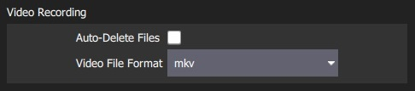

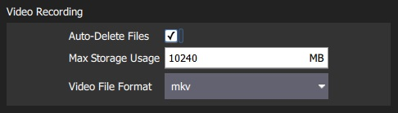

The settings are:

* **Auto-delete Files**: If checked, files are auto deleted when the specified amount of storage is used.
* **Max Storage Usage**: Maximum video file storage before video files are auto deleted.
* **Video file format**: File format for the saved video recording.

## Brand Image

This setting specifies the *brand image* used for indoor/outdoor colour schemes.

The brand image is displayed in place of the icon for the connected autopilot in the top right corner of the toolbar. It is provided so that users can easily create screen/video captures that include a company logo/branding.

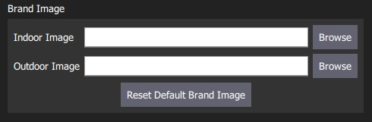

The settings are:

* **Indoor Image**: Brand image used in [indoor color scheme](https://word-edit.officeapps.live.com/we/wordeditorframe.aspx?ui=ko-KR&rs=ko-KR&hid=2mWOPQhL50mMEjYL5cj+yw.0&WOPISrc=https%3A%2F%2Fwopi.onedrive.com%2Fwopi%2Ffiles%2FD12DB2555512DF7%213518&wdnd=1&wdPreviousSession=0e43a0ac-2186-4d7b-a50e-5c8de0ff7e7d&wdNewAndOpenCt=1555562078658&wdo=4&wdOrigin=wacFileNew&wdPreviousCorrelation=09861a00-356b-4040-8a89-e153d9da8134&wde=docx&sc=host%3D%26qt%3DFolders&mscc=1&wdp=0#colour_scheme)
* **Outdoor Image**: Brand image used in [outdoor color scheme](https://word-edit.officeapps.live.com/we/wordeditorframe.aspx?ui=ko-KR&rs=ko-KR&hid=2mWOPQhL50mMEjYL5cj+yw.0&WOPISrc=https%3A%2F%2Fwopi.onedrive.com%2Fwopi%2Ffiles%2FD12DB2555512DF7%213518&wdnd=1&wdPreviousSession=0e43a0ac-2186-4d7b-a50e-5c8de0ff7e7d&wdNewAndOpenCt=1555562078658&wdo=4&wdOrigin=wacFileNew&wdPreviousCorrelation=09861a00-356b-4040-8a89-e153d9da8134&wde=docx&sc=host%3D%26qt%3DFolders&mscc=1&wdp=0#colour_scheme)
* **Reset Default Brand Image**: Reset the brand image back to default.

# **Offline Maps**

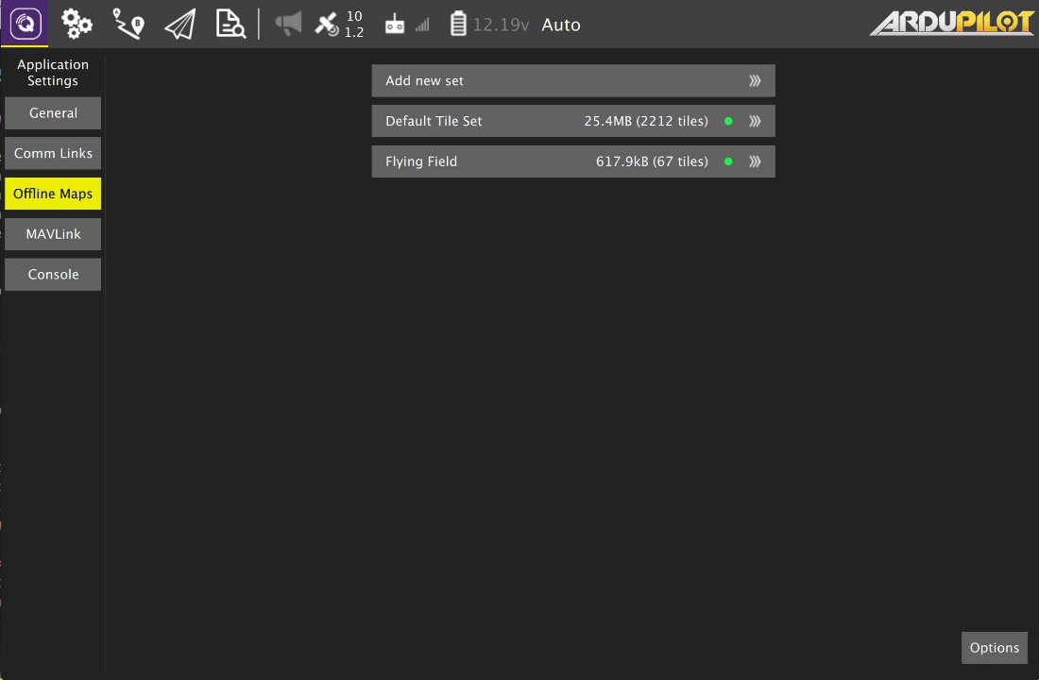

Offline Maps allows you to cache map tiles for use when not connected to the internet. You can create multiple offline sets, each for a different location.

## **Add new set**

To create a new offline map set, click "Add new set". Which will take you to this page: 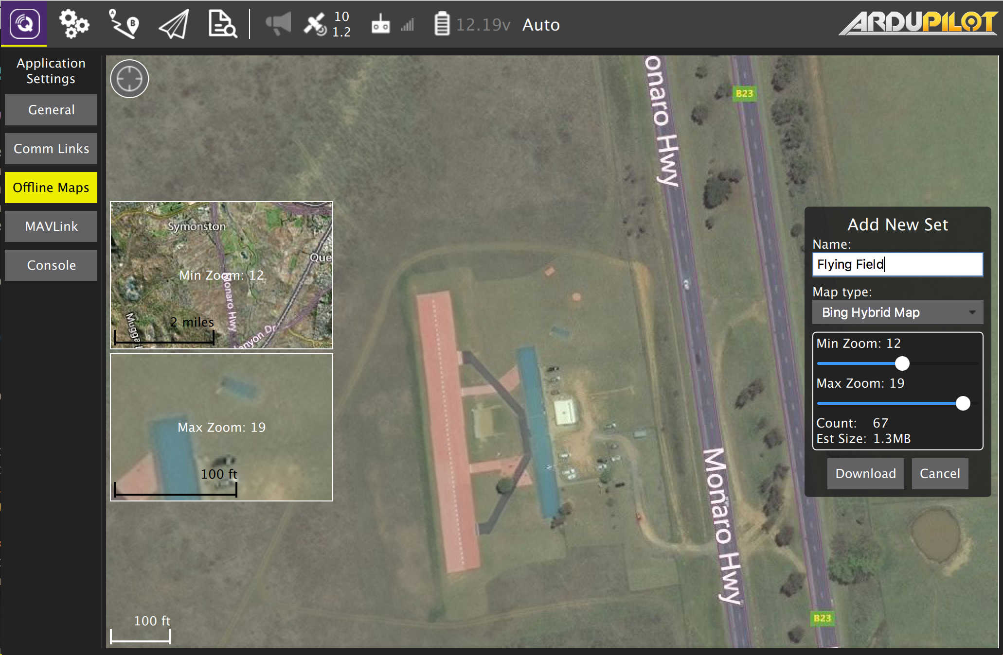

From here you can name you set as well as specify the zoom levels you want to cache. Move the map to the position you can to cache and then set the zoom levels and click Download to cache the tiles.

To the left you can see previews of the min and max zoom levels you have chosen.

# **MAVLink Settings**

The MAVLink settings (**SettingsView > MAVLink**) allow you to configure options and view information specific to MAVLink communications. This includes setting the MAVLink system ID for *QGroundControl* and viewing link quality.

The screen also allows you to manage [MAVLink 2 Log Streaming](https://docs.qgroundcontrol.com/en/SettingsView/MAVLink.html#logging) (PX4 only), including *automating log upload to Flight Review*!

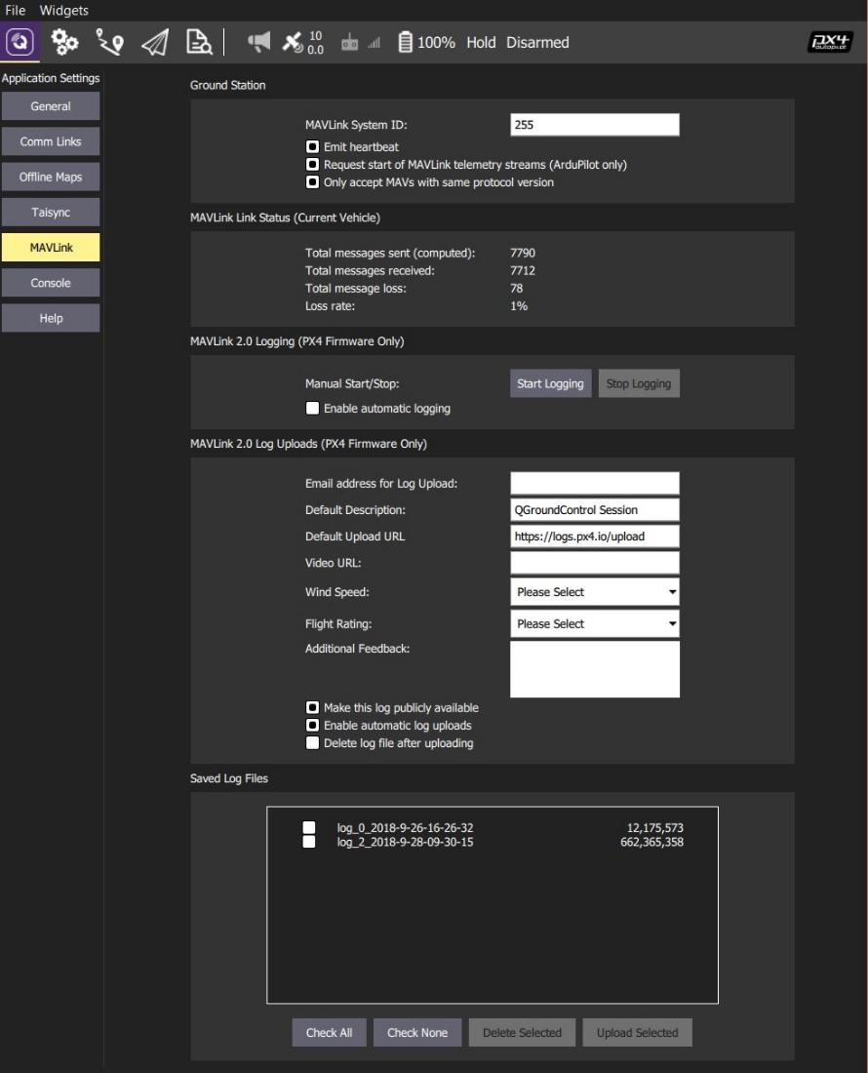

## **Ground Station**

This section sets the MAVLink properties and behaviour of *QGroundControl*.

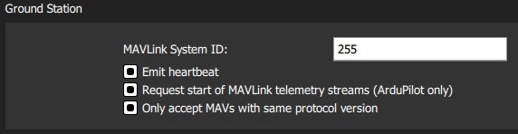

* **MAVLink System ID:** System ID of *QGroundControl* on the MAVLink network (Default: 255). Vehicles are typically allocated IDs from 1. You may have to specify another ID if there are multiple ground stations or MAVLink applications on the network.
* **Emit heartbeat:** Disable emission of regular MAVLink HEARTBEAT message (Default: True). Generally speaking, you should not turn this off.
* **Request start of MAVLink telemetry streams (ArduPilot only):** Enable *QGroundControl* requesting the standard-rate ArduPilot telemetry streams (Default: True). If non-standard rates are required (e.g. if the vehicle is connecting over a slow link) then you can disable starting the standard streams so that the vehicle can control streaming rates.
* **Only accept MAVs with the same protocol version:** Set true to only connect to MAVLink 1 or to MAVLink 2 vehicles (Default: True).

## **Link Status**

This shows the status of MAVLink message transfer over the communications link. A high **Loss rate** may lead to protocol errors for things like parameter download or mission upload/download.

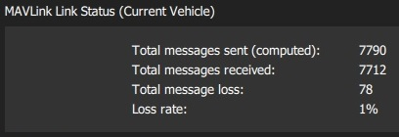

## **MAVLink 2 Logging (PX4 only)**

The *MAVLink 2 Logging* settings (PX4 only) configure real-time log streaming from PX4 to *QGroundControl* and upload of logs to [Flight Review](https://logs.px4.io/).

MAVLink 2 Logging cannot be used on "basic" setups because it requires a constant high-rate MAVLink connection to the vehicle (it *may* work over WiFI but will *not* work over a Telemetry link).

In theory log streaming allows real time analysis of data. At time of writing real-time analysis has not yet been implemented.

The log format is the same as for SD Card logs (downloaded using [Analyze View > Log Download](https://docs.qgroundcontrol.com/en/analyze_view/log_download.html)), but actual data logged may be slightly different because log start/stop time is controlled by *QGroundControl* and because some dropouts may occur when streaming over a lossy channel.

The *MAVLink 2 Logging* section allows you to manually start and stop logging, and to enable automatic capture of logs.

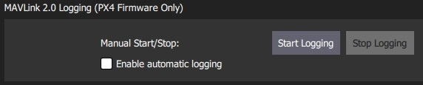

The *MAVLink 2 Log Uploads* section allows you configure uploading of MAVLink logs to [Flight Review](https://logs.px4.io/). You can specify all the fields that you would otherwise have to directly enter in the site, and also choose whether logs are automatically or manually uploaded.

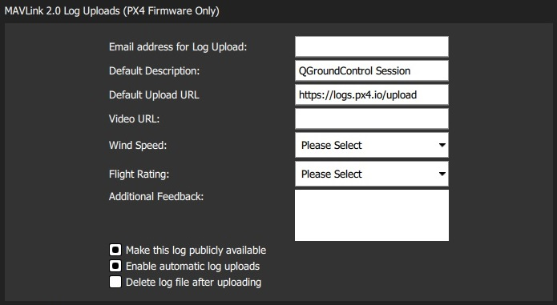

The fields are:

* **Email address for Log Uploads:** *Flight Review* will email you a link to the upload at this address. This is important as otherwise you will have no way to access a non-public log after upload.
* **Default Description:** Description/name of flight used for log.
* **Default Upload URL:** URL for upload of the log/log metadata. This is set by default to the *Flight Review* URL.
* **Video URL:** (Optional) URL for video of flight associated with log. This may be included on the Flight Review page to ease analysis.
* **Wind Speed:** Used to aid debugging and filtering (from multiple flights). Allowed values: *Calm* | *Breeze* | *Gale* | *Storm*.
* **Flight Rating:** Used to aid debugging and filtering (from multiple flights). Allowed values: *Crashed (Pilot Error)* | *Crashed (Software or Hardware Issue)* | *Unsatisfactory* | *Good* | *Great*.
* **Additional Feedback:** (Optional). Enter a more detailed description of the flight or behaviour.
* **Make this log publically available:** If set, the log will be visible and searchable on *Flight Review*. If not set, it will only be available via the link emailed on upload.
* **Enable automatic log uploads:** If set, the log will automatically be uploaded on completion.
* **Delete log file after uploading:** If set, the log will automatically deleted after upload.

The *Saved Log Files* section is used to manually manage log uploads. Use the checkboxes and buttons to select logs, and either delete or upload them.

You can change the parameters in *MAVLink 2 Log Uploads* above to specify separate descriptions for uploaded logs.

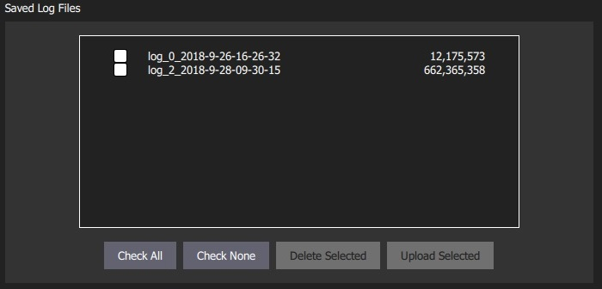

# **Console Logging**

The *Console* can be helpful tool for diagnosing *QGroundControl* problems. It can be found in **SettingsView > Console**.

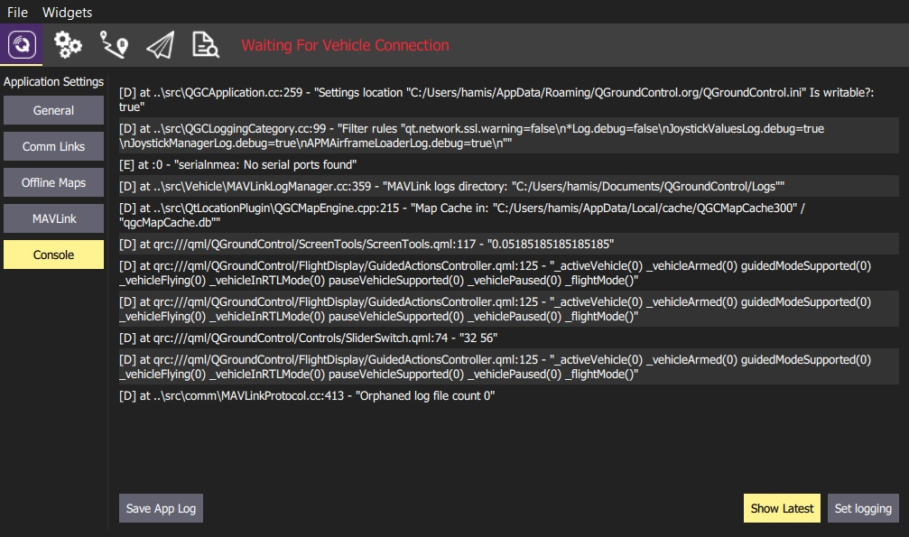

Click the **Set Logging** button to enable/disable logging information displayed by *QGroundControl*.

## **Common Logging Options**

The most commmonly used logging options are listed below.

|  |  |
| --- | --- |
| **Option(s)** | **Description** |
| LinkManagerLog, MultiVehicleManagerLog | Debug connection problems. |
| LinkManagerVerboseLog | Debug serial ports not being detected. Very noisy continuous output of available serial ports. |
| FirmwareUpgradeLog | Debug firmware flash issues. |
| ParameterManagerLog | Debug parameter load problems. |
| ParameterManagerDebugCacheFailureLog | Debug parameter cache crc misses. |
| PlanManagerLog, MissionManagerLog, GeoFenceManagerLog, RallyPointManagerLog | Debug Plan upload/download issues. |
| RadioComponentControllerLog | Debug Radio calibration issues. |

## **Logging from the Command Line**

An alternate mechanism for logging is using the --logging command line option. This is handy if you are trying to get logs from a situation where *QGroundControl* crashes.

How you do this and where the traces are output vary by OS:

* Windows
  + You must open a command prompt, change directory to the **qgroundcontrol.exe** location, and run it from there:

cd "\Program Files (x86)\qgroundcontrol"

qgroundcontrol --logging:full</code>

* + When *QGroundControl* starts you should see a separate console window open which will have the log output
* OSX
  + You must run *QGroundControl* from Terminal. The Terminal app is located in Applications/Utilities. Once Terminal is open paste the following into it:
  + cd /Applications/qgroundcontrol.app/Contents/MacOS/

./qgroundcontrol --logging:full

* + Log traces will output to the Terminal window.
* Linux

./qgroundcontrol-start.sh --logging:full

* + Log traces will output to the shell you are running from.

# **Virtual Joystick (PX4 only)**

*QGroundControl* allows you to control a vehicle with on-screen virtual thumbsticks. These are displayed as shown below in the flight view.

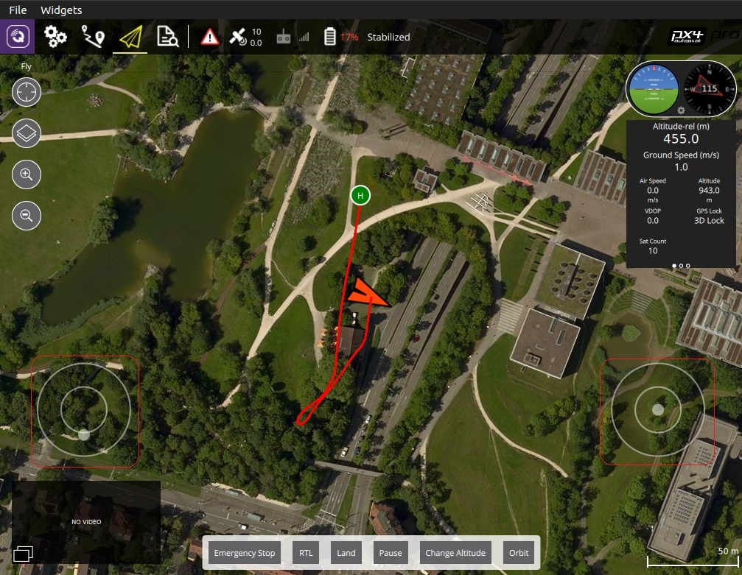

Thumbstick control is not as responsive as using an RC Transmitter (because the information is sent over MAVLink). Another alternative is to use a [USB Joystick/Gamepad](https://docs.qgroundcontrol.com/en/SetupView/Joystick.html).

## **Enable the thumbsticks**

To enable the virtual joysticks:

1. Select the **Q** icon (*Application Settings*) from the top toolbar and then **General** from the sidebar.
2. Select the **Virtual joystick** checkbox

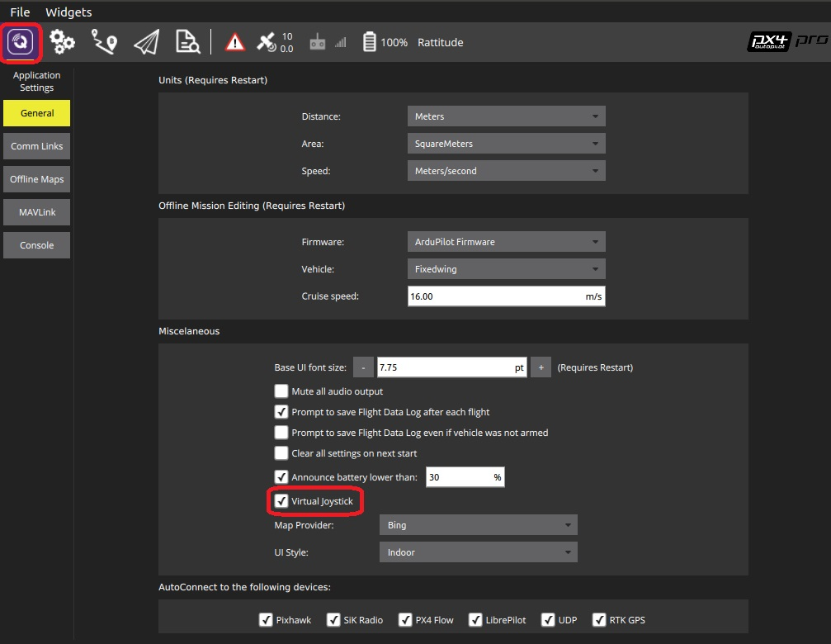

# **Analyze View**

The *Analyze View* is accessed from the main toolbar.

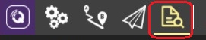

It provides tools to:

* [Download Logs](https://docs.qgroundcontrol.com/en/analyze_view/log_download.html) — List, download and clear logs on the vehicle.
* [GeoTag Images (PX4)](https://docs.qgroundcontrol.com/en/analyze_view/geotag_images.html) — Geotag survey mission images using the flight log (on a computer).
* [MAVLink Console (PX4)](https://docs.qgroundcontrol.com/en/analyze_view/mavlink_console.html) — access the the nsh shell running on the vehicle.

# **Log Download (Analyze View)**

The *Log Download* screen (**Analyze > Log Download**) is used to list (*Refresh*), *Download* and *Erase All* log files from the connected vehicle.

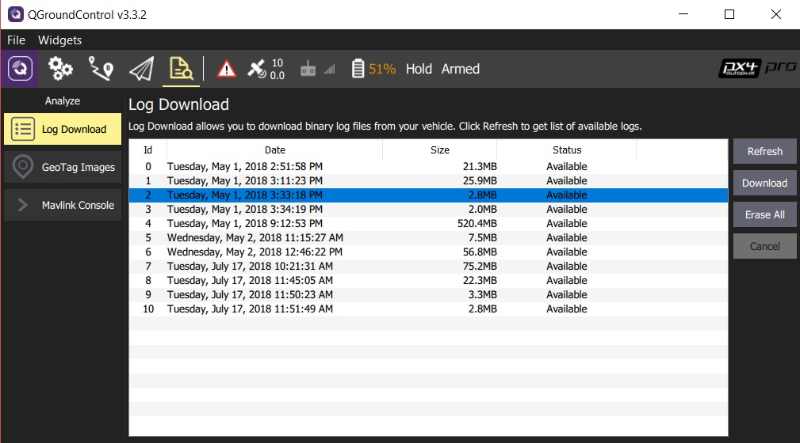

**GeoTag Images (Analyze View)**

The *GeoTag Images* screen (**Analyze > GeoTag Images**) allows you to geotag images from a survey mission using information in the flight log.

This feature only works with *PX4* flight stack logs. ArduPilot is not supported.

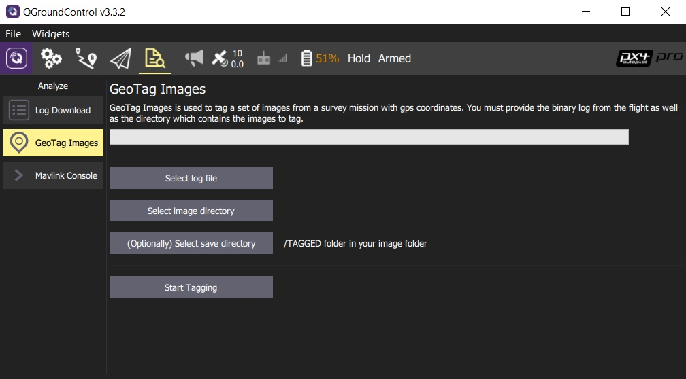

Select the log file, image directory and (optionally) output directory for geotagged images using the buttons provided. Click **Start Tagging** to generate the geotagged images.

# **MAVLink Console (Analyze View)**

The MAVLink Console (**Analyze > Mavlink Console**) allows you to connect to the PX4 [nsh shell](https://dev.px4.io/en/debug/system_console.html) and send commands.

The console only works when connected to *hardware* running the *PX4* flight stack. PX4 SITL and ArduPilot are not supported.

This is a very useful feature for developers as it allows deep access to the system. In particular, if you are connected via Wifi, you can have this same level of access while the vehicle is flying.

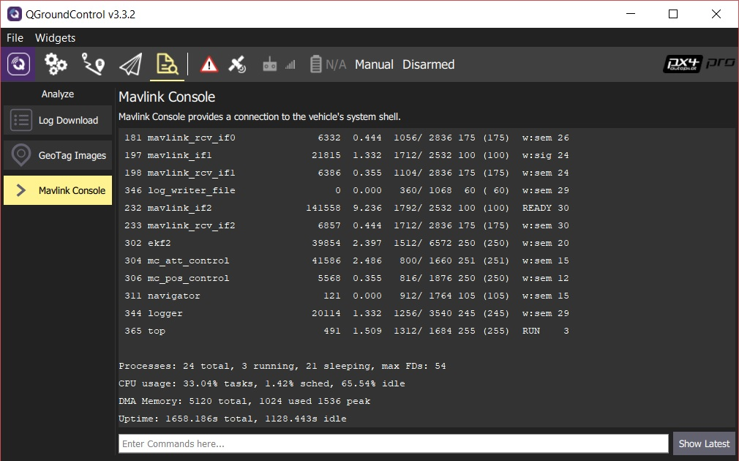

The view does not display any output except in response to commands. Once the vehicle is connected, you can enter commands in the bar provided (for a full list of available commands enter: ?).

Command output is displayed in the view above the command bar. Click **Show Latest** to jump to the bottom of the command output.

# **App Menus**

The App Menus (**File** and **Widget**) provide access to tools that primarily useful for autopilot developers/debugging.

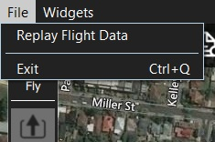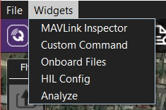

The linked tools are:

* **File**
  + [**Replay Flight Data**](https://docs.qgroundcontrol.com/en/app_menu/replay_flight_data.html) - Replay a telemetry log.
  + **Exit** - Close *QGroundControl*
* **Widgets**
  + [**MAVLink Inspector**](https://docs.qgroundcontrol.com/en/app_menu/mavlink_inspector.html) - Display received MAVLink messages/values.
  + [**Custom Command**](https://docs.qgroundcontrol.com/en/app_menu/custom_command_widget.html) - Load custom/test QML UI at runtime.
  + [**Onboard Files**](https://docs.qgroundcontrol.com/en/app_menu/onboard_files.html) - Navigate vehicle file system and upload/download files.
  + [**HIL Config Widget**](https://docs.qgroundcontrol.com/en/app_menu/hil_config.html) - Settings for HIL simulators.
  + [**Analyze**](https://docs.qgroundcontrol.com/en/app_menu/mavlink_analyzer.html) - MAVLink Analyzer tool can plot trends for message fields.

# **Replay Flight Data**

This feature is intended primarily for **autopilot developers**/**vehicle creators**. It is only supported on desktop builds (Windows, Linux, Mac OS).

The *Replay Flight Data* features allows users to replay a telemetry log, enabling review of past or problematic flights. The flight can be started, paused, stopped, restarted etc.

*QGroundControl* treats flight replay like an active connection. When you pause/stop playing, the ground station will report "Communication Lost" and wait for disconnection or for more messages.

To replay a flight:

1. Disconnect any active connections.
2. Select **File | Replay Flight Data** to toggle the flight replay bar visibility.

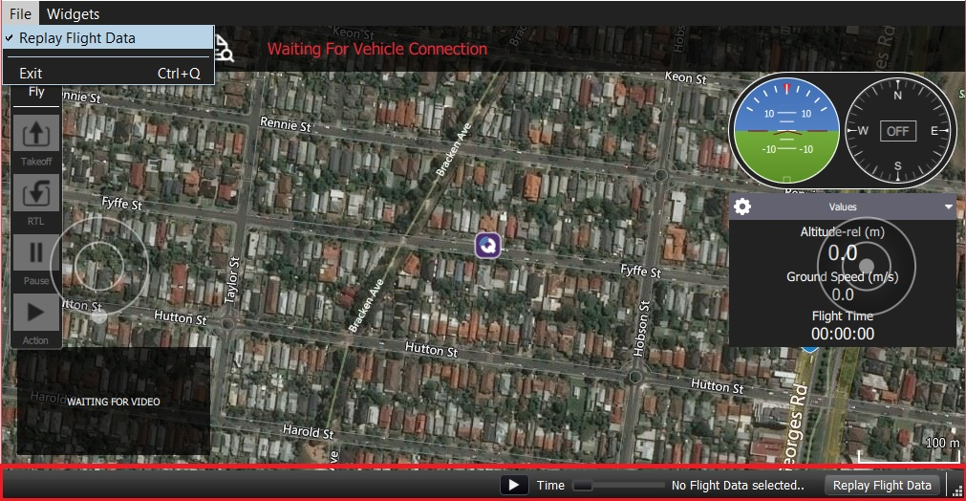

1. Select the **Replay Flight Data** button in the bar to display a *file selection* dialog. Choose a log file to replay from the available telemetry logs.



1. *QGroundControl* will immediately start playing the log.
2. Use the **pause/reset** button to control playing. When paused you can move the slider to a new position in the log.
3. You can pause the flight and select **Disconnect** to stop replay. At this point you can select an alternative log to replay.

You can inspect the running replay in more detail using the [MAVLink Inspector](https://docs.qgroundcontrol.com/en/app_menu/mavlink_inspector.html) or [MAVLink Analyzer (Analyze)](https://docs.qgroundcontrol.com/en/app_menu/mavlink_analyzer.html).

# **Custom Command Widgets**

This feature is intended primarily for **autopilot developers**/**vehicle creators**. It is only supported on desktop builds (Windows, Linux, Mac OS).

The *Custom Command Widget* feature can be used to load QML UIs at runtime (without having to rebuild *QGroundControl* or understand its internal architecture). A single widget can be loaded at a time and will be "remembered" between *QGroundControl* restarts.

The widget can use any feature of the QML language and any vehicle functionality that is exposed to QML (including a lot of useful "standard vehicle information", but not arbitrary MAVLink traffic or custom types).

The feature is primarily intended for creating simple UIs to send custom commands and change parameters.

## **How to load a Custom Widget**

To load a widget:

1. Open the menu **Widget > Custom Command** from any screen.

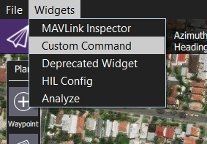

The *Custom Command* selection dialog will be displayed.

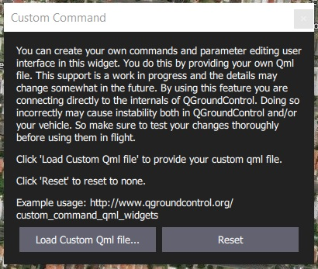

1. Select **Load Custom Qml file...** and then find the QML file for the widget load using the file picker (the image below shows the example widget)

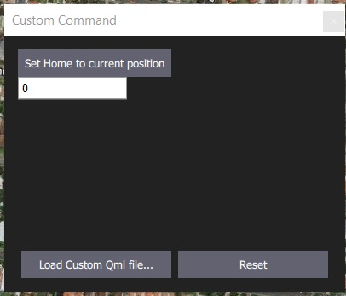

1. Restart *QGroundControl* in order to activate the widget.
2. You can press **Reset** to remove the current widget or **Load Custom Qml file...** to select a new one. If the QML file is invalid, you will get a warning, as shown below.
3. 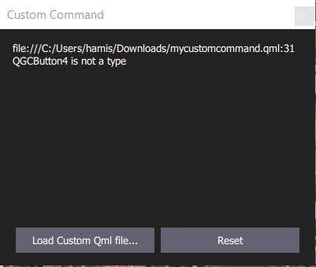

## **Creating a Widget QML file**

The new widget can use any feature of the QML language. The sections below show to address the main (intended) use cases:

* Creating a button to send a custom command (MAVLink COMMAND_LONG message)
* Defining a parameter editor

You must restart *QGroundControl* to pick up any changes in your QML files even if you press **Reset** (these are cached).

### **Sending Custom Commands**

The QGCButton control is provided by QGroundControl.Controls. It is a wrapper around the standard QML Button element, which uses the default QGC font and color palette.

The button connects to the controller.sendCommand() method to send a MAVLink COMMAND_LONG message (in this case, setting the home position).

QGCButton {

text: "Set Home to current position"

// Arguments to CustomCommandWidgetController::sendCommand(MAVLinkCOMMAND_LONG)

// command id

// component id

// confirmation

// param 1-7

onClicked: controller.sendCommand(179, 50, 0, 1, 0, 0, 0, 0, 0, 0)

}

### **Parameter Editors**

The FactTextField control is provided by the [Fact System](https://dev.qgroundcontrol.com/en/fact_system.html) (GroundControl.FactControls). It is a wrapper around the QML TextField element that allows you to bind it directly to any parameter. The parameter is changed automatically when you click **Enter** or click away from the field.

* There is currently no value validation. So you may crash your vehicle by setting a parameter to an incorrect value. Validation will come in the future.
* Be very careful when referencing parameters. If you specify a parameter that does not exist QGroundControl will warn and shutdown.

FactTextField {

// The -1 signals default component id.

// You can replace it with a specific component id if you like

fact: controller.getParameterFact(-1, "MAV_SYS_ID")

}

## **Example QML file**

The example custom command widget QML file below combines the controls documented in the previous section.

import QtQuick 2.2

import QGroundControl.Controls 1.0

import QGroundControl.FactSystem 1.0

import QGroundControl.FactControls 1.0

import QGroundControl.Palette 1.0

import QGroundControl.ScreenTools 1.0

import QGroundControl.Controllers 1.0

Rectangle {

anchors.fill: parent

color: qgcPal.window

CustomCommandWidgetController {

id: controller

factPanel: panel

QGCPalette { id: qgcPal; colorGroupEnabled: enabled }

Column {

spacing: ScreenTools.defaultFontPixelHeight

QGCButton {

text: "Set Home to current position"

// Arguments to CustomCommandWidgetController::sendCommand (MAVLink COMMAND_LONG)

// command id

// component id

// confirmation

// param 1-7

onClicked: controller.sendCommand(179, 50, 0, 1, 0, 0, 0, 0, 0, 0)

// The FactTextField control is bound to the specified parameter. Note that there is no validation.

FactTextField {

// The -1 signals default component id.

// You can replace it with a specific component id if you like

fact: controller.getParameterFact(-1, "MAV_SYS_ID")

}

}

}

# **MAVLink Inspector Widget**

This feature is intended primarily for **autopilot developers**/**vehicle creators**. It is only supported on desktop builds (Windows, Linux, Mac OS).

The *MAVLink Inspector* widget provides information about MAVLink traffic received by *QGroundControl*. For every vehicle it lists all received messages (including their update frequency and command number). You can drill down into any vehicle message to see the content of the last received message.

To use the *MAVLink Inspector*:

1. Select **Widgets | MAVLink Inspector** on any screen.

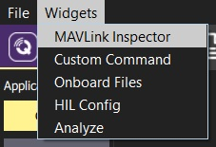

The widget will open displaying all vehicles (for which messages have been received).

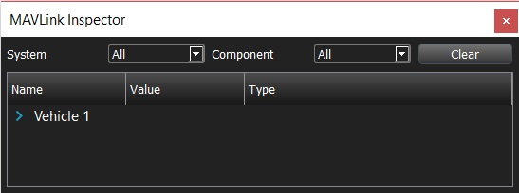

1. Expand the vehicle toggle to see its messages.

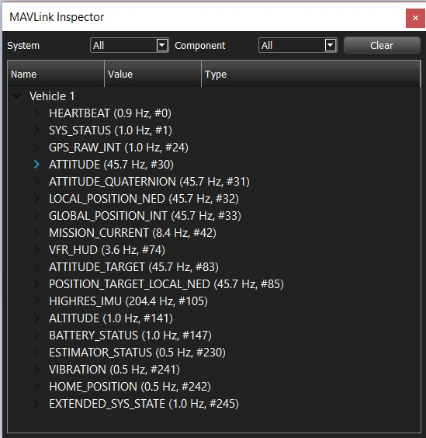

1. Expand a message to see its latest (dynamically updating) value:

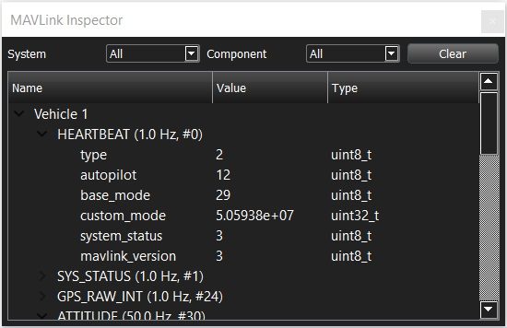

1. You can reset the view by pressing the **Clear** button. The widget will repopulate from new messages.

# **MAVLink Analyzer Widget (Analyze)**

This feature is intended primarily for **autopilot developers**/**vehicle creators**. It is only supported on desktop builds (Windows, Linux, Mac OS). Note that this is distinct from the [Analyze View](https://docs.qgroundcontrol.com/en/analyze_view/).

The *MAVLink Analyzer* widget can be used to show *trend* information for MAVLink traffic received by *QGroundControl*.

For every vehicle it lists all the fields for every received MAVLink message. You can select any set of fields to graph them (using their associated checkbox) and see the trend by time.

To use the *MAVLink Analyzer*:

1. Select **Widgets | Analyze** on any screen.

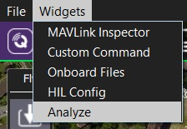

The widget will open displaying all message fields on left, and a graph on the right.

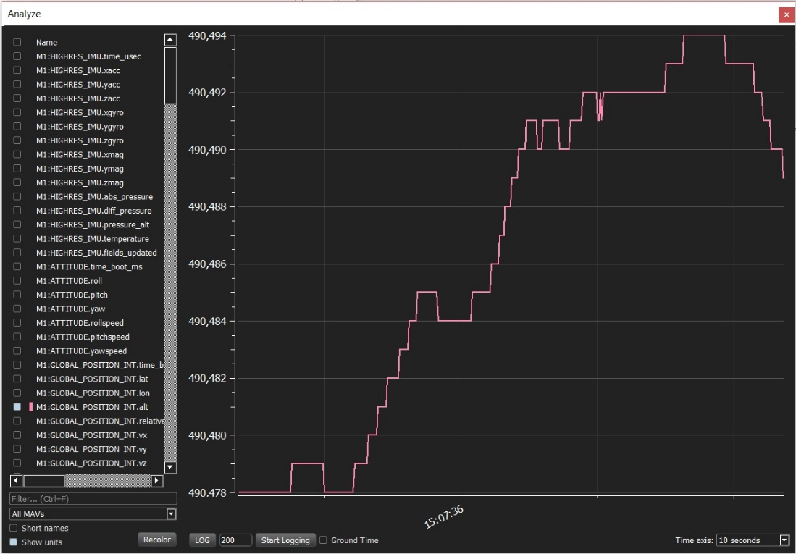

1. Toggle the checkbox to the left of each field to display/hide it on the dynamic plot.
2. Expand the left pane to show values, means and variances.

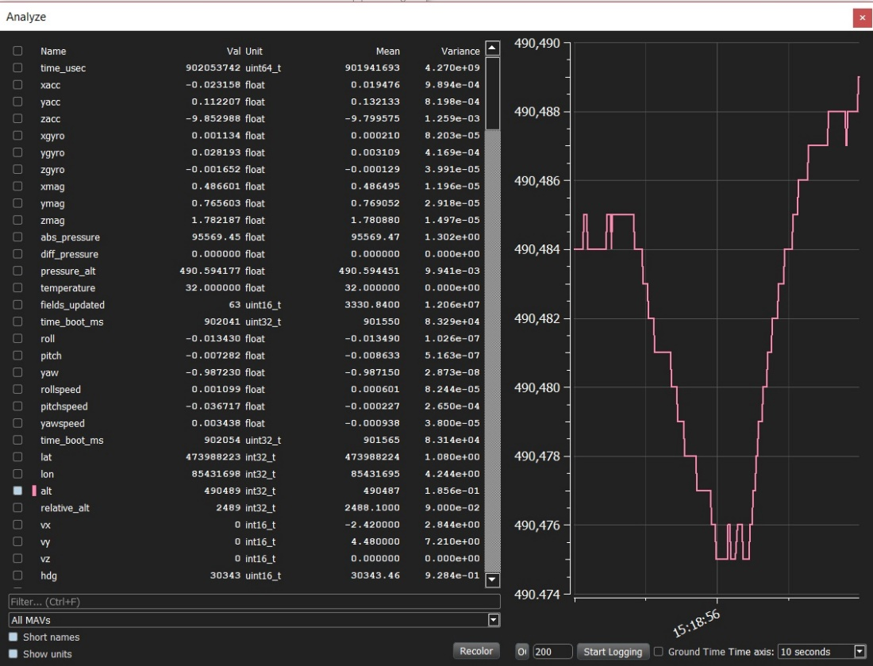

The **Short names** and **Show units** checkboxes can be used to modify information in the table.

# **Onboard Files Widget**

This feature is intended primarily for **autopilot developers**/**vehicle creators**. It is only supported on desktop builds (Windows, Linux, Mac OS).

The *Onboard Files* widget allows you to navigate the file system/SD card on a connected vehicle and upload/download files.

To use the *Onboard Files Widget*:

1. Select **Widgets | Onboard Files** on any screen.

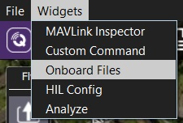

If this is the first time that the widget has been opened for the current connection it will be empty. Press **List Files** to populate the widget with directory/file information.

1. Navigate through the file system.

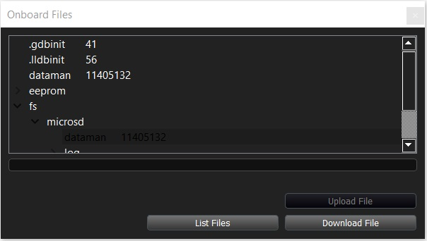

1. To download a file select it and then press **Download File**. You will be prompted to browse for a target folder for the downloaded file.
2. To upload a file navigate to where you want the file to be copied. Press **Upload File** and select the file to upload from the displayed dialog.

# **HIL Config Widget**

This feature is intended primarily for **autopilot developers**/**vehicle creators**. It is only supported on desktop builds (Windows, Linux, Mac OS).

The *HIL Config* widget allows you to specify simulator settings when using Hardware in the Loop simulation.

To use the *HIL Config Widget*:

1. Select **Widgets | HIL Config** on any screen.

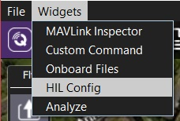

This will open the empty widget.

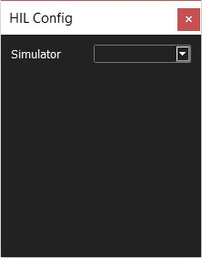

1. Select the target simulator: Flight Gear 3+, XPlane 9, XPlane10
2. The default settings are typically reasonable for each vehicle. Specific additional configuration should be in the autopilot flight stack documentation: [PX4 HITL Simulation](https://dev.px4.io/en/simulation/hitl.html), [ArduPilot HITL Simulators](http://ardupilot.org/dev/docs/hitl-simulators.html)

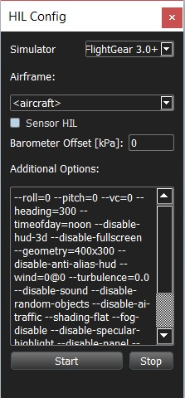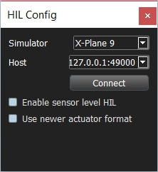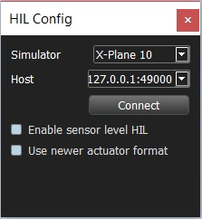

# **Releases**

This section contains information about releases and daily builds.

# **Release Notes**

This topic contains the cumulative release notes for *QGroundControl*.

## Stable Version 3.5 (Current)

This section contains a high level and *non-exhaustive* list of new features added to *QGroundControl* in version 3.5. Not to mention the large number of bug fixes in each stable release.

* **Overall**
  + Added Airmap integration to QGC. OSX build only.
  + Bumped settings version (now 8). This will cause all settings to be reset to defaults.
  + Added Chinese and Turkish localization and partial German localization.
  + Added support for the Taisync 2.4GHz ViUlinx digital HD wireless link.
  + Fix loading of parameters from multiple components. This especially affected WiFi connections.
  + **ArduPilot** Support for ChibiOS firmware connect and flash.
* **Settings**
  + **RTK** Add support for specifying fixed RTK based station location in Settings/General.
  + **GCS Location**
    - Added UDP Port option for NMEA GPS Device.
    - GCS heading shown if available
* **Plan**
  + **Polygons** Support loading polygons from SHP files.
  + **Fixed Wing Landing Pattern** Add stop photo/video support. Defaults to on such that doing an RTL will stop camera.
  + **Edit Position dialog** Available on polygon vertices.
* **Fly**
  + **Camera Page** Updated support for new MAVLInk camera messages. Camera select, camera mode, start/stop photo/video, storage mangement...
  + **Orbit** Support for changing rotation direction.
  + **Instrument Panel**
    - Added ESTIMATOR_STATUS values to new estimatorStatus Vehicle FactGroup. These are now available to display in instrument panel.
    - Make Distance to GCS available for display from instrument panel.
    - Make Heading to Home available for display from instrument panel.

## Stable Version 3.4

This section contains a high level and *non-exhaustive* list of new features added to *QGroundControl* in version 3.4. Not to mention the large number of bug fixes in each stable release.

* **Settings**
  + **Offline Maps**
    - Center Tool allows you to specify a map location in lat/lon or UTM coordinates. Making it easier to get to the location you want to create an offline map for.
    - Ability to pre-download terrain heights for offline use.
  + **Help** Provides links to QGC user guide and forums.
* **Setup**
  + **Firmware** Ability to flash either PX4 or ArduPilot Flow firmware.
  + PX4 Pro Firmware
    - **Flight Modes** Specify channels for all available transmitter switches.
    - **Tuning: Advanced** Initial implementation of vehicle PID tuning support. Note that this is a work in progress that will improve in 3.5 daily builds.
  + ArduPilot Firmware
    - **Power/Safety** Support for new multi-battery setup.
    - **Trad Heli** New setup page.
* **Plan**
  + **File Load/Save** New model for Plan file loading which matches a standard File Load/Save/Save As user model.
  + **Load KML** Ability to load a KML file directly from the Sync menu. You will be prompted for what type of Pattern you want to create from the KML if needed.
  + **Survey** Better support for irregular shaped polygons.
  + [**Corridor Scan**](https://word-edit.officeapps.live.com/PlanView/pattern_corridor_scan.html) - Create a flight pattern which follows a poly-line. For example can be used to survey a road.
  + [**Fixed Wing Landing Pattern**](https://word-edit.officeapps.live.com/PlanView/pattern_fixed_wing_landing.html)
    - Landing area visually represented in Plan.
    - Landing position/heading can be copied from Vehicle position/heading.
  + **Terrain**
    - Height of mission items can be specified as height above terrain.
    - Survey and Corridor Scan can generate flight plans which follow terrain.
    - This feature does not support [ArduPilot terrain following](http://ardupilot.org/copter/docs/common-terrain-following.html).
    - +
  + **Edit Position** Set item position from vehicle position.
* **Fly**
  + **Pre-Flight Checklist** You can turn this on from Settings. It provides a generic checklist to follow prior to flight. Expect more feature to appear for this in 3.5 daily builds.
  + **Instrument Panel**
    - Many new values available for display.
    - New Camera page which provides full camera control. Requires a camera which support new MavLink camera specification.
  + **ArduPlane** Much better support for guided commands including QuadPlane support.
  + **High Latency Links** Support for high latency links such as satellite connections. Limits the traffic from QGC up to Vehicle on these links to reduce cost. Supports HIGH_LATENCY MavLink message. Supports failover back/forth from high latency to normal link with dual link setup.

## Stable Version 3.3

More detailed release notes for version 3.3 can be found [here](https://word-edit.officeapps.live.com/we/stable_v3.3_long.html).

+

This section contains a high level and *non-exhaustive* list of new features added to *QGroundControl* in version 3.3. Not to mention the large number of bug fixes of this release.

* **Settings**
  + Local NMEA GPS device support.
  + Video Recording save settings.
* **Setup**
  + **Parameter Editor** - Searching updates as you type characters for near immediate response to searches.
  + **Joystick** - Android joystick support.
* **Plan**
  + **NEW - Structure Scan Pattern** - Create a multi-layered flight pattern that captures images over vertical surfaces (polygonal or circular). Used for 3d model generation or vertical surface inspection.
  + **Fixed Wing Landing Pattern** - You can now adjust the distance from the loiter to land point by either distance or glide slope fall rate.
  + PX4 GeoFence and Rally Point support.
  + Terrain height display in lower Mission Item altitude display
* **Fly**
  + Start/Stop video recording.
  + Better display of vehicle icons when connected to multiple vehicles.
  + Multi-Vehicle View supports commands which apply to all vehicles.
  + Displays vehicles reported from ADS-B sensor.
* **Analyze**
  + **Mavlink console** - New support for communicating with Mavlink console.
  + **Log Download** - Moved from Menu to Analyze view.

## Stable Version 3.2

More detailed release notes for version 3.2 can be found [here](https://word-edit.officeapps.live.com/we/stable_v3.2_long.html).

This section contains a high level and *non-exhaustive* list of new features added to *QGroundControl* in version 3.2.

* **Settings**
  + **File Save path** - Specify a save path for all files used by QGC.
  + **Telemetry log auto-save** - Telemetry logs are now automatically saved without prompting.
  + **AutoLoad Plans** - Used to automatically load a Plan onto a vehicle when it first connects.
  + **RTK GPS** - Specify the Survey in accuracy and Minimum observation duration.
* **Setup**
  + ArduPilot only
    - **Pre-Flight Barometer and Airspeed calibration** - Now supported
    - **Copy RC Trims** - Now supported
* **Plan View**
  + **Plan files** - Missions are now saved as .plan files which include the mission, geo-fence and rally points.
  + **Plan Toolbar** - New toolbar which shows you mission statistics and Upload button.
  + **Mission Start** - Allows you to specify values such as flight speed and camera settings to start the mission with.
  + **New Waypoint features** - Adjust heading and flight speed for each waypoint as well as camera settings.
  + **Visual Gimbal direction** - Gimbal direction is shown on waypoint indicators.
  + **Pattern tool** - Allows you to add complex patterns to a mission.
    - Fixed Wing Landing (new)
    - Survey (many new features)
  + **Fixed Wing Landing Pattern** - Adds a landing pattern for fixed wings to your mission.
  + **Survey** - New features
    - **Take Images in Turnarounds** - Specify whether to take images through entire survey or just within each transect segment.
    - **Hover and Capture** - Stop vehicle at each image location and take photo.
    - **Refly at 90 degree offset** - Add additional pattern at 90 degree offset to original so get better image coverage.
    - **Entry location** - Specify entry point for survey.
    - **Polygon editing** - Simple on screen mechanism to drag, resize, add/remove points. Much better touch support.
* **Fly View**
  + **Arm/Disarm** - Available from toolbar.
  + **Guided Actions** - New action toolbar on the left. Supports:
    - Takeoff
    - Land
    - RTL
    - Pause
    - Start Mission
    - Resume Mission - after battery change
    - Change Altitude
    - Land Abort
    - Set Waypoint
    - Goto Location
  + **Remove mission after vehicle lands** - Prompt to remove mission from vehicle after landing.
  + **Flight Time** - Flight time is shown in instrument panel.
  + **Multi-Vehicle View** - Better control of multiple vehicles.
* **Analyze View** - New
  + **Log Download** - Moved to Analyze view from menu
  + **Mavlink Console** - NSH shell access
* **Support for third-party customized QGroundControl**
  + Standard QGC supports multiple firmware types and multiple vehicle types. There is now support in QGC which allows a third-party to create their own custom version of QGC which is targeted specifically to their custom vehicle. They can then release their own version of QGC with their vehicle.

## Stable Version 3.1

New Features

* [Survey](https://word-edit.officeapps.live.com/PlanView/pattern_survey.html) mission support
* [GeoFence](https://word-edit.officeapps.live.com/PlanView/PlanGeoFence.html) support in Plan View
* [Rally Point](https://word-edit.officeapps.live.com/PlanView/PlanRallyPoints.html) support in Plan View (ArduPilot only)
* ArduPilot onboard compass calibration
* Parameter editor search will now search as you type for quicker access
* Parameter display now supports unit conversion
* GeoTag images from log files (PX4 only)
* System health in instrument panel
* MAVLink 2.0 support (no signing yet)

Major Bug Fixes

* Fixed crash after disconnect from Vehicle
* Fixed android crash when using SiK Radios
* Many multi-vehicle fixes
* Bluetooth fixes

# **QGroundControl v3.3 Release Notes (Detailed)**

This topic contains a high level and *non-exhaustive* list of new features added to *QGroundControl* in version 3.3.

## **Detailed Notes**

### **Settings View**

#### NMEA GPS Device support

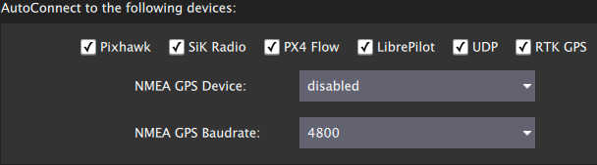

You can specify a connection to one of these devices on the General page. The GPS information will then be used for ground station location and in turn follow me support.

For more information see [Settings > General (AutoConnect to the following devices)](https://docs.qgroundcontrol.com/en/SettingsView/General.html#auto_connect).

#### Video Recording

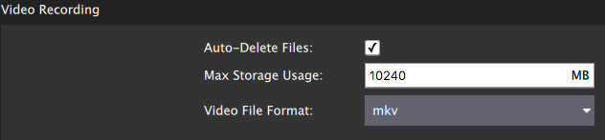

Videos will be saved to the Video directory of your QGC file save path. You can also specify the maximum amount of space you want video files to consume. After that size if exceeded the oldest video files will be removed. Video Recording is turned on/off from the Video widget in the Fly View.

For more information see [Settings > General (Video / Video Recording)](https://docs.qgroundcontrol.com/en/SettingsView/General.html#video).

### **Plan View**

#### Structure Scan

A Structure Scan allows you to create a grid flight pattern that captures images over vertical surfaces (polygonal or circular). These are typically used for the visual inspection or creation of 3d models of structures.

Details [here](https://docs.qgroundcontrol.com/en/PlanView/pattern_structure_scan.html).

#### New MAVLink GeoFence, Rally Point support

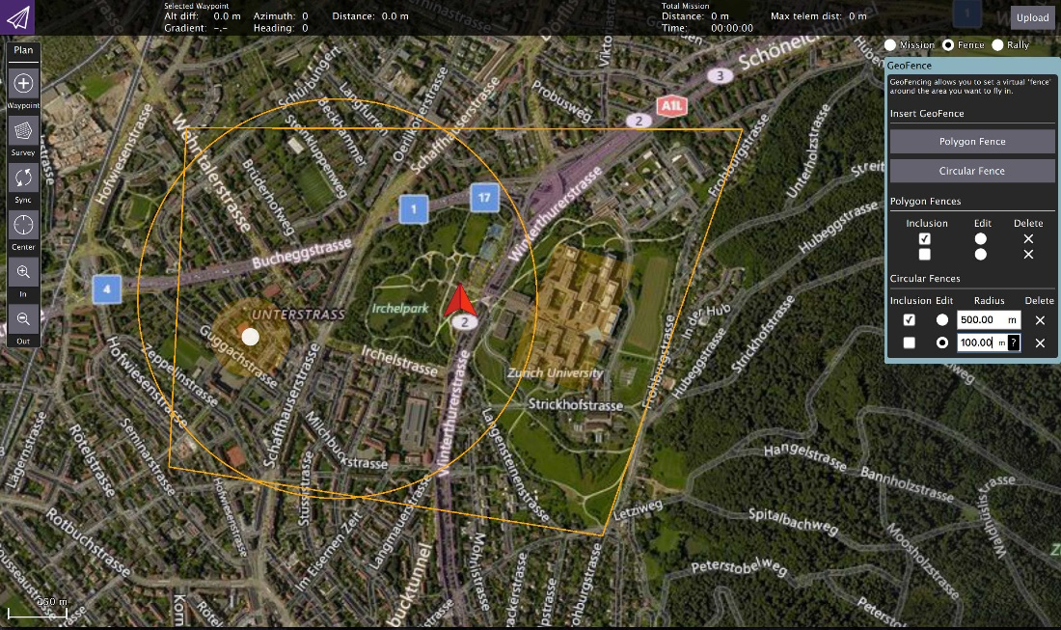

QGC supports the new MAVLink GeoFence and Rally Point specification/protocol. This new system supports multiple polygonal and/or circular fences which can be specified as an exclusion or an inclusion fence.

The fence which is currently selected by the "Edit" radio button will show the on screen editing controls such as the drag points for polygon editing.

**Note** Only PX4 Pro firmware supports the new specification. ArduPilot does not yet support the new spec. Support for GeoFence/Rally is temporarily disabled in QGC until QGC ArduPilot code is reworked to the new architecture.

#### Edit Position Dialog

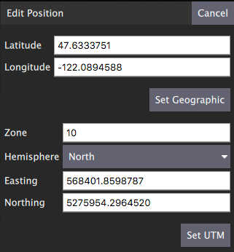

The Edit Position Dialog allows you to specify a detailed position for an item in either Geographic or UTM coordinate systems. It is available from the Polygon Tools menu as well as the hamburger menu of any mission item which specifies a coordinate:

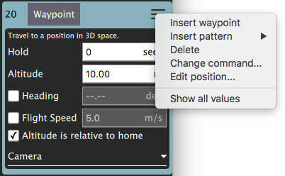

#### Polygon Tools

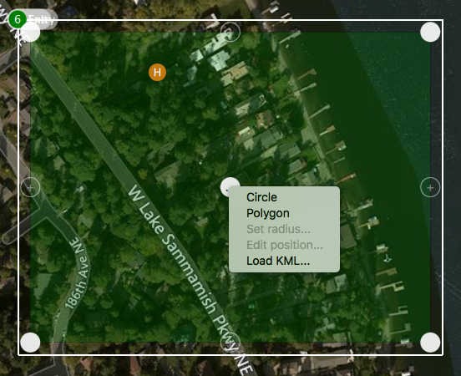

You can now also click on the polygon center drag handle to bring up a set of polygon manipulation tools. The tools are available anywhere polygon editing is supported: Survey, Structure Scan, GeoFence, ...

* Circle - Converts the polygon to a circular polygon.
* Polygon - Changes a circular polygon back to a rectangular polygon.
* Set radius - Set radius for circular polygons.
* Edit position - Displays the edit position dialog to specify a detailed position for the circular center.
* Load KML - Set polygon to polygon loaded from KML file.

Circular polygon example:

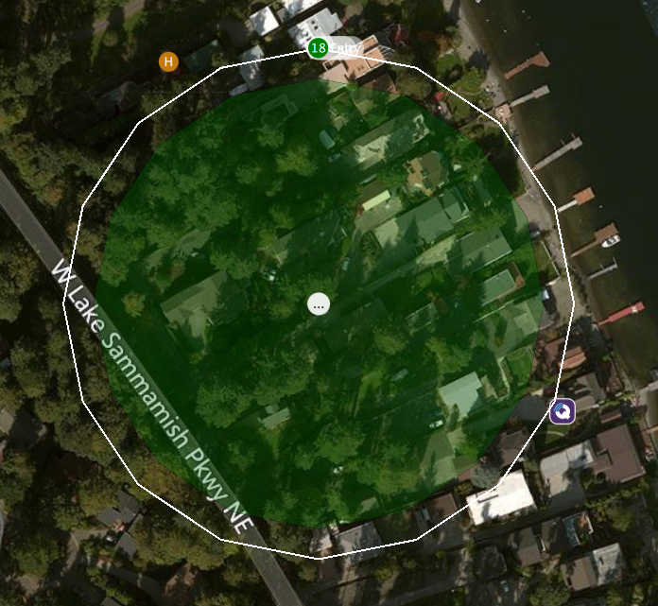

### **Fly View**

#### Start/Stop Video Recording

This is now a video record button in the video window. Settings for saved videos are available from General Page of Setup view.

#### Multi-Vehicle vehicle indicators

When you are connected to multiple vehicles the vehicle id will be shown below the vehicle icon. The active vehicle will be opaque and the inactive vehicles will be semi-transparent.

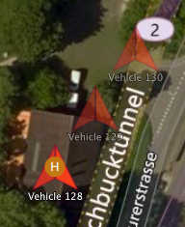

#### Multi-Vehicle View supports batch commands

The multi-vehicle list now supports commands which apply to all vehicles.

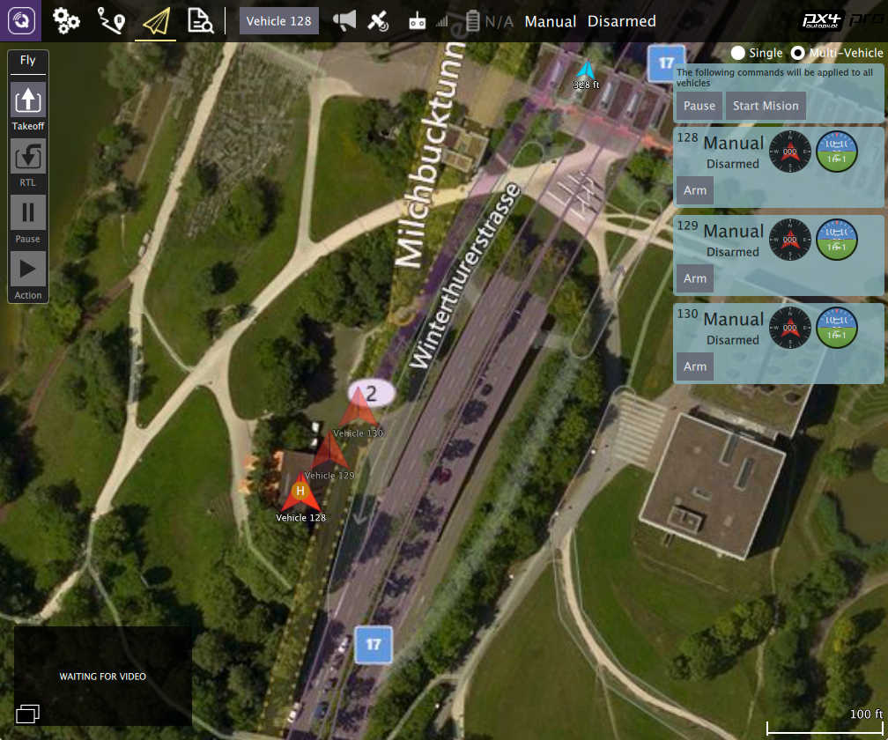

The current list of available commands are Pause and Start Mission but that will be exapanded upon with further development.

#### ADS-B sensor vehicle display

Vehicle reported by ADS-B sensor on vehicle are shown on map as smaller blue icons with altitude and callsign below the icon.

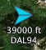

# QGroundControl v3.2 Release Notes (Detailed)

This topic contains a high level and *non-exhaustive* list of new features added to *QGroundControl* in version 3.2.

## Settings

### Telemetry log auto-save

If you have *Save telemetry log after each flight* turned on you will no longer be prompted as to where to save the log each time the vehicle disarms. Logs will automatically be saved to the [Application Load/Save Path](https://word-edit.officeapps.live.com/SettingsView/General.html#load_save_path)

For more information see [Settings > General (Miscellaneous)](https://word-edit.officeapps.live.com/SettingsView/General.html#autosave_log).

### AutoLoad plans

If this setting is turned on, *QGroundControl* will automatically upload a plan to the vehicle when it connects. The plan file must be named **AutoLoad#.plan** where the # is replaced with the vehicle id. The plan file must be located in the [Application Load/Save Path](https://word-edit.officeapps.live.com/SettingsView/General.html#load_save_path).

For more information see [Settings > General (Miscellaneous)](https://word-edit.officeapps.live.com/SettingsView/General.html#autoload_missions).

### Application Load/Save Path

You can now specify a save path which QGC will use as the default location to save files such as Parameters, Telemetry or Mission Plans.

For more information see [Settings > General (Miscellaneous)](https://word-edit.officeapps.live.com/SettingsView/General.html#load_save_path).

### RTK GPS

You can now specify the *Survey in accuracy* and *Minimum observation duration* for use with a connected RTK GPS.

For more information see [Settings > General (Miscellaneous)](https://word-edit.officeapps.live.com/SettingsView/General.html#rtk-gps).

Setup

### ArduPilot - Pre-Flight Barometer and Airspeed calibration

This is now supported from the Sensors page.

### ArduPilot - Copy RC Trims

This is now supported from the Copy Trims button on the Radio setup page.

## Plan View

### Plan Files

Previous version of *QGroundControl* saved missions, geo-fences and rally points in separate files (**.mission**, **.fence**, **.rally**). QGC now save all information related to a flight plan into a single file called a *Plan File* with a file extension of **.plan**.

Information about the format can be found in [Plan File Format](https://dev.qgroundcontrol.com/en/file_formats/plan.html) (QGC Developer Guide).

### Plan Toolbar



The new *Plan Toolbar* is displayed at the top of the [PlanView](https://word-edit.officeapps.live.com/PlanView/PlanView.html). It shows you information related to the currently selected waypoint as well as statistics for the entire mission.

When connected to a vehicle it also shows an **Upload** button, which can be used to upload the plan to the vehicle.

### Mission Settings

The [Mission Settings](https://word-edit.officeapps.live.com/PlanView/PlanView.html#mission_settings) panel allows you to specify values which apply to the entire mission, or settings you want to control right at the beginning of a mission. This is the first item in the mission list on the right of the screen.

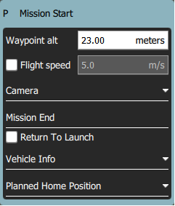

#### Mission Defaults

##### Waypoint alt

This specifies the default altitude for newly added mission items. If you update this value while you have a mission loaded it will prompt you to update all the the waypoints to this new altitude.

##### Flight speed

This allows you to set the flight speed for the mission to be different than the default mission speed.

##### RTL after mission end

Check this if you want your vehicle to RTL after the final mission item.

#### Camera section

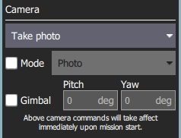

The camera section allows you to specify a camera action to take, control the gimbal and set your camera into photo or video mode.

The camera actions available are:

* Continue current action
* Take photos (time)
* Take photos (distance)
* Stop taking photos
* Start recording video
* Stop recording video

#### Vehicle Info section

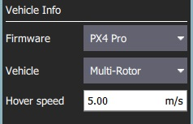

When planning a mission the firmware being run on the vehicle as well as the vehicle type must be known in order for QGroundControl to show you the mission commands which are appropriate for your vehicle.

If you are planning a mission while you are connected to your vehicle the Firmware and Vehicle Type will be determined from the vehicle. If you are planning a mission while not connected to a vehicle you will need to specify this information yourself.

The additional value that can be specified when planning a mission is the vehicle flight speed. By specifying this value, total mission or survey times can be approximated even when not connected to a vehicle.

#### Planned Home Position

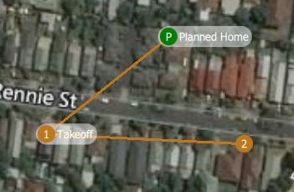

The planned home position allows you to simulate the vehicle's home position while planning a mission. This way you see the waypoint trajectory for your vehicle from takeoff to mission completion. Keep in mind that this is only the "planned" home position and you should place it where you plan to start the vehicle from. It has no actual impact on flying the mission. The actual home position of a vehicle is set by the vehicle itself when arming.

### New Waypoint features

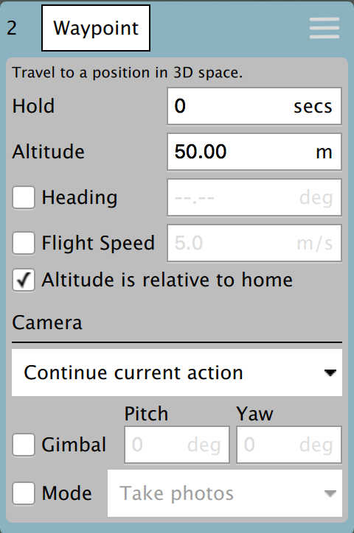

* You can now adjust heading and flight speed for each waypoint.
* There is a camera section available for camera changes on each waypoint. Explanation of Camera Section can be read under Mission Settings above.

### Visual Gimbal direction

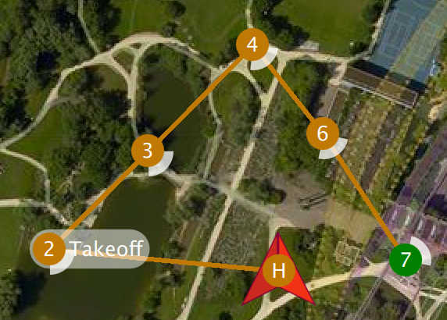

If you specify gimbal yaw changes on waypoints, both the plan and fly views will show you a visual representation of the gimbal direction.

### Pattern tool

There is a new *Pattern tool*. The following patterns are supported:

* Fixed Wing Landing (new)
* Survey (with new features)

#### Fixed Wing Landing Pattern



This adds a landing pattern for fixed wings to your mission. The first point of the pattern is the loiter point which commands to vehicle to loiter to a specific altitude. Once that altitude is reached, the vehicle will begin the landing sequence and fly down to the specified landing spot.

Both the loiter and land points can be dragged to adjust. Also all the various values associated with the pattern can be adjusted.

For more information see [Fixed Wing Landing Pattern](https://word-edit.officeapps.live.com/PlanView/pattern_fixed_wing_landing.html).

#### Survey (new features)

* Images are not automatically taken in the turnaround zone outside of the polygonal survey area.
* There is a new *Hover and Capture* option which can be used to capture the highest quality image at each image location. The vehicle will stop at each image location prior to taking the image such that the vehicle is stable while the image is taken.
* There is a new option to re-fly the survey grid at a 90 degree angle to the previous pass. This allows you to generate much denser coverage for the images.

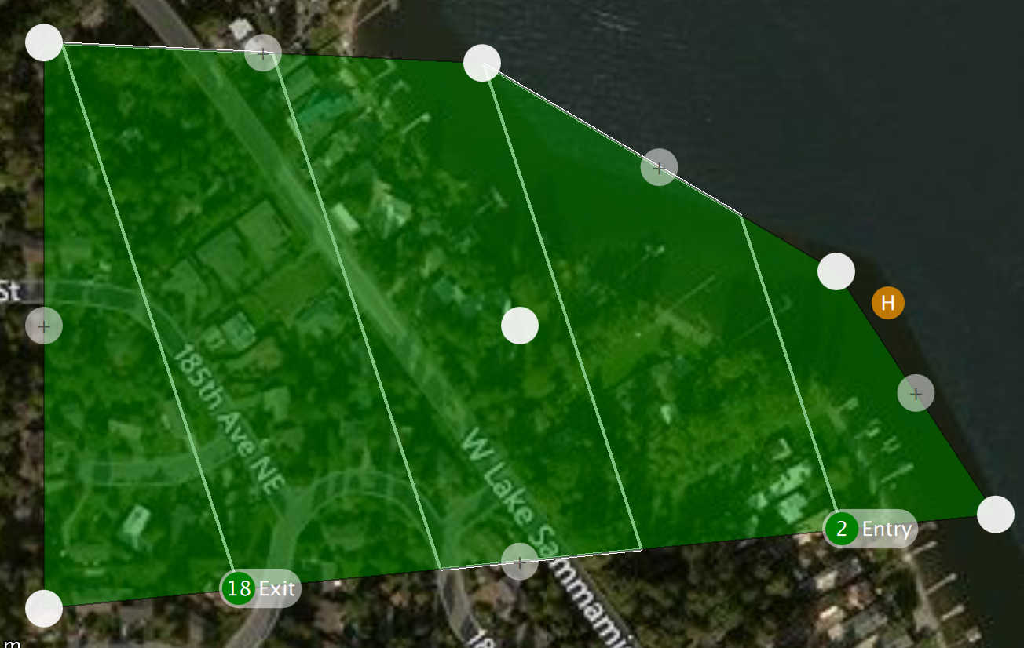

Manipulating the survey area polygon is now easier to use on tablets with touch screens:

* You can drag the entire polygon to a new location by dragging the center point handle.
* Each polygon vertex can be dragged to a new location.
* To remove a polygon vertex, simple click on the drag handle for it.
* Click on the **+** handles to add a new vertex between two existing vertices.

## Fly View

### RTK GPS

RTK status is now shown in the toolbar.

### Arm/Disarm

There is an armed/disarmed indicator in the toolbar. You can click it to arm/disarm your vehicle. If you click Disarm in the toolbar while your vehicle is flying you will provided the option to Emergency Stop your vehicle.

### Guided Actions

* Takeoff
* Land
* RTL
* Pause
* Actions
  + Start Mission
  + Resume Mission
  + Change Altitude
  + Land Abort
* Direct interaction with map
  + Set Waypoint
  + Goto Location

#### Resume Mission

The Resume Mission guided action is used to resume a mission after performing an RTL from within the mission to perform a battery change. After the vehicle lands from RTL and you have disconnected the battery **do not** disconnect QGC from the Vehicle. Put in your new battery and QGC will detect the vehicle again and automatically restore the connection. Once this happens you will be prompted with a Resume Mission confirmation slider. If you want to resume the mission, confirm this and the mission will be rebuilt from your last waypoint traveled through. Once the mission is rebuilt you will be presented with another Resume Mission slide which allows you to review the rebuilt mission before starting it again. Confirm this Resume Mission slider to continue on with the mission.

###### How resume mission rebuilding works

In order to resume a mission you cannot simply continue it from the last mission item the vehicle ran. The reason is is that may skip over important change speed commands or camera control commands which are prior to that item in the mission. If you skipped over those the remainder of the mission will not run correctly. In order to make resume mission work correctly QGC rebuilds the mission looking backwards from the last mission item flown and automatically appends relevant commands to the front of the mission. By doing this the state of the mission prior to the resume point is restore. The following mission commands are the ones scanned for:

* MAV_CMD_DO_CONTROL_VIDEO
* MAV_CMD_DO_SET_ROI
* MAV_CMD_DO_DIGICAM_CONFIGURE
* MAV_CMD_DO_DIGICAM_CONTROL
* MAV_CMD_DO_MOUNT_CONFIGURE
* MAV_CMD_DO_MOUNT_CONTROL
* MAV_CMD_DO_SET_CAM_TRIGG_DIST
* MAV_CMD_DO_FENCE_ENABLE
* MAV_CMD_IMAGE_START_CAPTURE
* MAV_CMD_IMAGE_STOP_CAPTURE
* MAV_CMD_VIDEO_START_CAPTURE
* MAV_CMD_VIDEO_STOP_CAPTURE
* MAV_CMD_DO_CHANGE_SPEED
* MAV_CMD_NAV_TAKEOFF

### Remove mission after vehicle lands

You will be prompted to remove the mission from the vehicle after the mission completes and the vehicle lands and disarms. This is meant to prevent issues where stale missions are unknowingly left on a vehicle cause unexpected behavior.

### Instrument panel

#### Camera trigger

#### Flight Time

Flight time is now available for display in the instrument panel. For new users, flight time will be shown by default. For existing users who have already modified their instrument panel values you will have to add it yourself if you want to use it.

## [Analyze View](https://word-edit.officeapps.live.com/analyze_view/)

* [Log Download](https://word-edit.officeapps.live.com/analyze_view/log_download.html) moved to *Analyze View* from menu.
* New [GeoTag Images](https://word-edit.officeapps.live.com/analyze_view/geotag_images.html) support for PX4 Pro firmware
* New [MAVLink Console](https://word-edit.officeapps.live.com/analyze_view/mavlink_console.html) which provides access the the *nsh shell* running on the vehicle.

## Multi-Vehicle View

There is a new view available when you have multiple vehicles connected to QGC. It will only show up when more than one vehicle is connected. When that happens you will see an additional set of radio button at the top right of the Plan view.

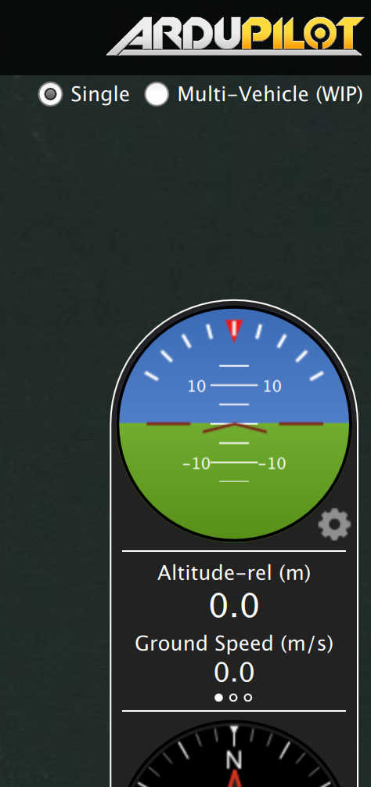

Click the **Multi-Vehicle** radio button to replace the instrument panel with the multi-vehicle list:

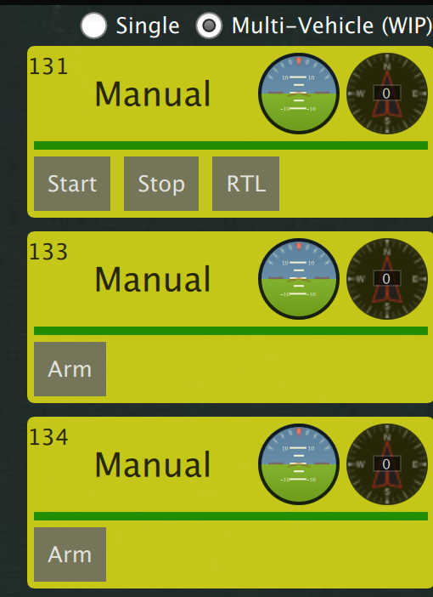

The example above shows three vehicles. The numbers are the vehicle id. In the large font is the current flight mode. You can click the flight mode name to change to a different flight mode. To the right are small version of the instruments for each vehicle. You can command the vehicle to do the following actions from the control panel:

* Arm/Disarm
* Start/Stop a mission
* Return to Launch
* Take Control back of the vehicle by returning to manual control from a mission.

### Multi-Vehicle Gotchas - Unique vehicle ids

Each vehicle connected to QGC must have a unique id. Otherwise QGC will think the vehicles are actually the same vehicle. The symptom of this is the Plan view jerking around as it tries to position itself to one vehicle and then the next. For PX4 Pro firmwares this is the MAV_SYS_ID parameter. For ArduPilot firmwares it is the SYSID_THISMAV parameter.

## Support for third-party customized QGroundControl

Standard QGC supports multiple firmware types and multiple vehicle types. There is now support in QGC which allows a third-party to create their own custom version of QGC which is targeted specifically to their custom vehicle. They can then release their own version of QGC with their vehicle.

# **Daily Builds**

Daily Builds of *QGroundControl* have the absolute latest set of [new features](https://docs.qgroundcontrol.com/en/releases/daily_build_new_features.html).

Daily Builds are less tested than stable builds. Use at your own risk!

These can be downloaded from the links below (install as described in [Download and Install](https://docs.qgroundcontrol.com/en/getting_started/download_and_install.html)):

* [Windows](https://s3-us-west-2.amazonaws.com/qgroundcontrol/builds/master/QGroundControl-installer.exe)
* [OS X](https://s3-us-west-2.amazonaws.com/qgroundcontrol/builds/master/QGroundControl.dmg)
* [Linux](https://s3-us-west-2.amazonaws.com/qgroundcontrol/builds/master/QGroundControl.AppImage)
* [Android](https://play.google.com/store/apps/details?id=org.mavlink.qgroundcontrolbeta) (Google Play)
* iOS currently unavailable

**Daily Build Major Changes**

This topic contains a high level and *non-exhaustive* list of new features added to *QGroundControl* since the last [stable release](https://docs.qgroundcontrol.com/en/releases/release_notes.html). These features are available in [daily builds](https://docs.qgroundcontrol.com/en/releases/daily_builds.html).

* [Structure Scan V2](https://docs.qgroundcontrol.com/en/PlanView/pattern_structure_scan_v2.html) - The previous *Structure Scan* code had major issues. This new version addresses those problems and includes new features.

**Privacy Policy**

*QGroundControl* may require access to personal and/or sensitive user data. None of this data is used outside of *QGroundControl*.

The list below explains how some of the data is used:

* Camera sensor: This is used for the purpose of overlaying the video with flight telemetry data.
* Location: This is used for tracking current user position on the map.

# **Support**

This user guide is meant to be the main provider of support for *QGroundControl*. If you find incorrect or missing information please report an [Issue](https://github.com/mavlink/qgc-user-guide/issues).

*Questions* about *QGroundControl* should be raised in the associated flight stack's discussion server at the links below:

* [PX4 Flight Stack](http://discuss.px4.io/c/qgroundcontrol/qgroundcontrol-usage) (discuss.px4.io).
* [ArduPilot Flight Stack](http://discuss.ardupilot.org/c/ground-control-software/qgroundcontrol) (discuss.ardupilot.org).

## **Developer Chat**

The *QGroundControl* developers as well as many *QGroundControl* users can be found on the [#QGroundControl channel on Slack](https://px4.slack.com/) or the [Gitter](https://gitter.im/mavlink/qgroundcontrol) channel. If you are a heavy user of *QGroundControl* and want to keep up to date on the latest information or help with *QGroundControl* we suggest monitoring that channel.

## **GitHub Issues**

Issues are used to track bugs against *QGroundControl* as well as feature requests for later versions. The current list of issues can be found on [GitHub here](https://github.com/mavlink/qgroundcontrol/issues).

Please contact our developers using the [IM](https://docs.qgroundcontrol.com/en/Support/Support.html#developer_chat) channels **before** creating GitHub issues!

### **Feature Requests**

Feature Requests should first be discussed on a [developer IM](https://docs.qgroundcontrol.com/en/Support/Support.html#developer_chat) channel. The developer team will direct you to create a feature request on Github if necessary (or refer you to the appropriate existing feature).

### **Reporting Bugs**

Bug reports should first be discussed on a [developer IM](https://docs.qgroundcontrol.com/en/Support/Support.html#developer_chat) channel (there are many cases where something that seems like a bug is actually a vehicle setup problem). The developer team will direct you to create an issue if necessary.

If you are directed to create an issue, please provide all information needed to reproduce the problem (OS, *QGroundControl* version/build, Autopilot version/release etc). The sections below explain how to get additional information that can help with debugging issues.

#### Console Logging

*Console Logs* can be helpful when diagnosing *QGroundControl* problems. For more information see: [Console Logging](https://docs.qgroundcontrol.com/en/SettingsView/console_logging.html).

#### Reporting Crashes from Windows Builds

When QGC crashes a crash dump file will be place in the Users LocalAppData directory. To navigate to that directory use the Start/Run command. You can bring this up window WinKey+R. Type into that %localappdata% for Open and click Ok. Crash dumps will be in a QGCCrashDumps folder in that directory. You should find a new **.dmp** file there. Add a link to that file in a GitHub Issue when reporting you problem.

#### Reporting Hangs from Windows Builds

If Windows is telling you the *QGroundControl program is unresponsive* use the following steps to report the hang:

1. Open *Task Manager* (right-click TaskBar, select **Task Manager**)
2. Switch to the Processes tab and local **qgroundcontrol.exe**
3. Right-click on **groundcontrol.exe** and select **Create Dump File**
4. Place the dump file in a public location
5. Add a link to the **.dmp** file and above details in the GitHub issue.

## **Troubleshooting**

Troubleshooting information is provided in two topics:

* [QGC Installation/Configuration Problems](https://docs.qgroundcontrol.com/en/Support/troubleshooting_qgc.html) - problems/solutions related to **running** *QGroundControl* on the host computer.
* [QGC/Vehicle Interaction Problems](https://docs.qgroundcontrol.com/en/Support/CommonProblems.html) - problems/solutions related to **using** *QGroundControl* to interact with a vehicle.

## **Help Improve these Docs!**

Just like *QGroundControl* itself, the user guide is an open source, user created and supported GitBook. We welcome [Pull Requests](https://github.com/mavlink/qgc-user-guide/pulls) against the guide for fixes and/or updates.

# **QGC Installation/Configuration Problems**

This topic lists troubleshooting information related to **running** *QGroundControl* on the host computer (e.g. QGC setup and configuration issues).

Problems when **using** *QGroundControl* to interact with a vehicle are covered in: [QGC/Vehicle Interaction Problems](https://docs.qgroundcontrol.com/en/Support/CommonProblems.html).

## **64-bit Windows: Audio in Unexpected Language**

On Windows 64-bit machines *QGroundControl* may sometimes play audio/messages in a language that does not match the *Text-to-speech* setting in **Control Panel > Speech** (e.g. audio spoken in German on an English machine).

This can occur because 64-bit Windows only displays 64-bit voices, while *QGroundControl* is a 32-bit application (on Windows) and hence can only run 32-bit voices.

The solution is to set the desired *32-bit voice* for your system:

1. Run the control panel application: **C:\Windows\SysWOW64\Speech\SpeechUX\sapi.cpl**.
2. Make your desired *Voice selection* and then click **OK** at the bottom of the dialog. 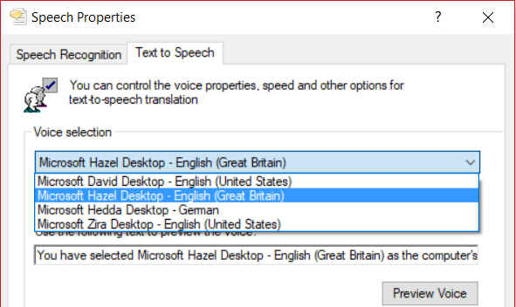

Additional information about the Windows speech APIs can be found [here](https://www.webbie.org.uk/blog/microsoft-speech/).

## **Windows: UI Rendering/Video Driver Issues**

If you experience UI rendering issues or video driver crashes on Windows, this may be caused by "flaky" OpenGL drivers. *QGroundControl* provides 3 shortcuts that you can use to start *QGroundControl* in "safer" video modes (try these in order):

* **QGroundControl:** QGC uses OpenGL graphics drivers directly.
* **GPU Compatibility Mode:** QGC uses ANGLE drivers, which implement OpenGL on top of DirectX.
* **GPU Safe Mode:** QGC uses a software rasterizer for the UI (this is very slow).

## **Windows: Waiting For Vehicle Connection over WiFi**

If *QGroundControl* sits forever *Waiting For Vehicle Connection* when trying to connect to the vehicle over Wifi, a possible cause is that IP traffic is being blocked by firewall software (e.g. Windows Defender, Norton, etc.).

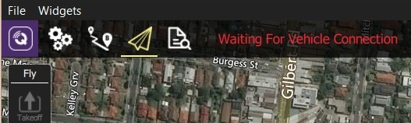

The solution is to allow the *QGroundControl* app through the firewall.

If using *Windows Defender*:

* In the **Start** bar, enter/select: *Firewall & Network Protection* (System Settings).
* Scroll to and select the option: *Allow an app through firewall*.
* Select *QGroundControl* and change the *Access* selector to **Allow**.
* Programs are listed in alphabetical order by description (not filename). You'll find QGC under **O**: *Open source ground control app provided by QGroundControl dev team*

## **Ubuntu: Video Streaming Fails**

On Ubuntu you must install *Gstreamer* components in order to see video streams. If these are not installed *QGroundControl* is unable to create the gstreamer nodes and fails with:

VideoReceiver::start() failed. Error with gst_element_factory_make(‘avdec_h264’)

The [download/install instructions for Ubuntu](https://docs.qgroundcontrol.com/en/getting_started/download_and_install.html#ubuntu) include *GStreamer* setup information.

**QGC/Vehicle Interaction Problems**

This section covers a number of common problems related to **using** *QGroundControl* to interact with a vehicle:

* [Parameter Download failures](https://docs.qgroundcontrol.com/en/Support/ParameterDownload.html)
* [Plan Upload/Download failures](https://docs.qgroundcontrol.com/en/Support/PlanUploadDownload.html)
* [Resume Mission failures](https://docs.qgroundcontrol.com/en/Support/ResumeMission.html)

Problems with **installing/running** *QGroundControl* on the host computer are covered in [QGC Installation/Configuration Problems](https://docs.qgroundcontrol.com/en/Support/troubleshooting_qgc.html).

**Parameter Download failures**

The majority of parameter download failures are caused by a communication link which is noisy and has a high loss rate. Although the parameter protocol has retry logic for such a case it will eventually give up. At which point you will get an error stating that QGC was unable to retrieve the full set or parameters.

Although you can still fly the vehicle in this state it is not recommended. Also the vehicle setup pages will not be available.

You can see the loss rate for your link from the [Settings View > MAVLink](https://docs.qgroundcontrol.com/en/SettingsView/MAVLink.html) page. Even a loss rate in the high single digits can lead to intermittent failures of the plan protocols. Higher loss rates could leads to 100% failure.

There is also the more remote possibility of either firmware or QGC bugs. To see the details of the back and forth message traffic of the protocol you can turn on [Console Logging](https://docs.qgroundcontrol.com/en/SettingsView/console_logging.html) for the Parameter Protocol.**Mission Upload/Download failures**

Although the protocol for uploading and download Plans (Mission, GeoFence, Rally Points) to a vehicle includes retry logic it can still fail over a communication link which is running at a high loss rate.

For more information see: [Plan View > Mission (Plan) Upload/Download Failures](https://docs.qgroundcontrol.com/en/PlanView/PlanView.html#plan_transfer_fail)

# **Resume Mission Failures**

The process of resuming a mission after a battery swap is a fairly complex process within QGC.

The two main areas that are most problematic are:

* The *Resume Mission* dialog doesn't display when it should and you are just left with a Start Mission slider.
* The new mission generated from *Resume Mission* is not quite correct with respect to recreation of waypoints and/or camera commands.

In order for the *QGroundControl* development team to debug these issues the following information **must be supplied** in any github issue entered against *Resume Mission*.

## **Common Steps for Resume Mission Dialog/Generation**

The following steps are required for debugging both types of problems:

1. Restart QGC
2. Turn on [console logging](https://docs.qgroundcontrol.com/en/SettingsView/console_logging.html) with the log option: GuidedActionsControllerLog.
3. Enable [telemetry logging](https://docs.qgroundcontrol.com/en/SettingsView/General.html#miscellaneous) (**Settings > General**).
4. Start the mission.
5. Fly till you need a battery swap.

Alternatively you can attempt to reproduce the problem by manually RTL from the middle of the middle of the mission (though this may not always reproduce the problem).

1. Once the vehicle lands and disarms you should get the *Resume Mission* dialog.

If not there is a possible bug in QGC.

### **Resume Mission Dialog Problems**

For *Resume Mission Dialog* problems follow the [common steps above](https://docs.qgroundcontrol.com/en/Support/ResumeMission.html#common_steps), and then:

1. Save the *Console Log* to a file.
2. Place the *Console Log*, *Telemetry Log* and *Plan File* someplace which you can link to in the issue.
3. Create the issue with details and links to all three files.

## **Resume Mission Generation Problems**

For *Resume Mission Generation* problems follow the [common steps above](https://docs.qgroundcontrol.com/en/Support/ResumeMission.html#common_steps), and then:

1. Click **Resume Mission**.
2. The new mission should be generated.
3. Go to [Plan View](https://docs.qgroundcontrol.com/en/PlanView/PlanView.html).
4. Select **Download** from the *File/Sync* menu.
5. Save the *Modified Plan* to a file.
6. Save the *Console Log* to a file.
7. Place the *Console Log*, *Telemetry Log*, *Original Plan* file and *Modified Plan* file someplace which you can link to in the issue.
8. Create the issue with details and links to all four files.